#### Contacts and Further Information

This report was drafted by the West Sussex Public Health and Social Research Team with support from colleagues from across the council and local organisations.

#### JSNA Website

We place full reports, information and links on the West Sussex JSNA website. <https://jsna.westsussex.gov.uk/>

#### Posters available

We are keen to disseminate the information from the JSNA. For some subjects we have drafted posters which can be downloaded from the website.

#### West Sussex Life

The current version of West Sussex Life can be found on the West Sussex website. (<https://www.westsussex.gov.uk/campaigns/west-sussex-life/>)

# Introduction

## What is a JSNA?

The West Sussex Joint Strategic Needs Assessment (JSNA) sets out the health and wellbeing needs of the population of West Sussex. It is not a single document or piece of analysis but encompasses a range of work, including detailed needs assessments relating to specific subjects or communities, evaluations of new programmes or activities, local surveys, and a range of briefings and ad hoc analyses. **This summary is a brief run-through of the data available.**

#### Scale, Direction and Significance

Being presented with a lot of facts and figures can be overwhelming. We recommend keeping three things in mind when assessing quantitative data:

* Develop a clear understanding of the **SCALE** of an issue in understanding population level needs. *F*or example, in West Sussex there are approximately 160-200 teenage pregnancies in a year.
* Look at the trend or **DIRECTION** - if you have a good time series of data, look at the short, medium and long term. *F*or example, in relation to teenage pregnancy, there is a long downward trend locally and nationally.
* Finally, look at **SIGNIFICANCE** - is one year different to the next, or one place compared with another? In this summary we use the term significant to mean *statistically* significant (meaning a difference that isn’t due to random chance). *For example, locally there was a rise in teenage pregnancy between 2016 and 2017 but this was small and not significant.*

Data in this summary are compared in a number of ways: over time, between different groups in the population, or by area. We frequently compare information with England and with "comparable local authorities". The Chartered Institute of Public Finance and Accounting (CIPFA) group local authorities by looking at population characteristics (such as population, socioeconomic indicators, household and mortality characteristics).

For West Sussex our current (January 2020) comparable authorities are:

3

* Cambridgeshire
* Devon
* East Sussex
* Essex
* Gloucestershire
* Hampshire
* Kent
* North Yorkshire
* Northamptonshire
* Oxfordshire
* Somerset
* Staffordshire
* Suffolk
* Warwickshire
* Worcestershire

## West Sussex Health and Wellbeing Strategy Priorities 2019-2024

One of the key functions of the JSNA is to inform the local Health and Wellbeing Strategy. Past JSNA summariesm have informed the **West Sussex Health and Wellbeing Strategy 2019-2024**. The Strategy adopts a lifecourse approach.

Following consultation and wider engagement, the West Sussex Health and Wellbeing Board board identified priorities across three themes - Starting Well, Living and Working Well and Ageing well.

### Start Well Priorities

* Improved mother and baby health and wellbeing, especially for those in most need
* Children growing in a safe & healthy home environment with supporting and nurturing parents and carers
* Good mental health for all children
* Children and young people leaving care are healthy and independent

### Live Well Priorities

* Individuals, families, friends and communities are connected
* People have access to good quality homes providing a secure place to thrive and promote good health, wellbeing and independent living
* People are able to look after their own health
* People live, work and play in environments that promote health and wellbeing

### Age Well Priorities

* Fewer older people feel lonely or socially isolated
* There is a reduction in the number of older people having falls
* Older adults stay healthier, happier and independent for longer
* People receive good quality end of life care and have a good death

Partly in response to the priorities set out in the strategy, we have undertaken some focussed and more detailed analysis including detailing social mobility and multiple deprivation, mental health and wellbeing, emergency admissions, falls, self-care and self-management.

## Impact of Covid-19 on Public Health Outcomes

The Office of Health inequalities and disparities (OHID) have identified a number of existing Fingertips indicators that can be used to demonstrate the onging effects of Covid on population health in West Sussex. Figure [fig:covid-impacts] shows these indicators and the impact that Covid-19 has had and will continue to have across the life course.

@M4mmM26mmM30mmM30mmM30mmM80mmM26mm@  & **Pregnancy** & **Infancy** & **Childhood** & **Adolescence** & **Adulthood** & **Elderly**  
& Reduced antenatal care & Perinatal mental health & ’Hidden’ safeguarding issues & Increased negative health behaviours & Increased negative health behaviours (e.g. substance misuse, alcohol, smoking, gambling, inactivity) & Social isolation and loneliness  
 & Perinatal mental health & Breastfeeding support & Developmental and mental health checks not completed & Deferred sexual health services & Paused commissioned lifestyle services, deferred cancer screening/NHS health checks, reduced health seeking for urgent issues, ’hidden’ safeguarding issues & Limited physical activity  
 &  & Immunisation uptake& Adverse childhood experiences & Low mood and high anxiety & Economic uncertainty &    
 &  & Non-accidental injuries &  &  & New anxiety and worsening existing mental illness, PTSD for carers/health workers and families &    
(r)2-7 & Safeguarding risks & Unplanned pregnancies & Adverse childhood experiences & Increased demand for mental health services & Fewer recovering from substance misuse, increased BBV infections, adults smoking, adults overweight/obese & Dementia diagosis  
 & Risky behaviours (Smoking, alcohol, substance misuse) & Admissions for gastrointestinal and respiratory infections &  & Unwanted pregnancies & Cancer screening coverage (breast, cervical, bowel) and late presentation & Injuries due to falls  
 &  & Population vaccination coverage reduced and outbreaks& & STI diagnoses & Increased demand for grief and bereavement services, employment/training support, claiming out of work benefits & Fuel poverty  
 &  &  &  &  & People with high anxiety&    
(r)2-7 & Low birthweight & Higher risk of poor mental health and physical health & School readiness & Alcohol and substance misuse admissions under 18s & Increased demand for mental health services & Increased morbidity and mortality  
 & Poor attachment & Higher risk of poor social and educational outcomes &  & Obese children & Under 75s mortality from cardiovascular and liver disease and cancer &    
 & Admissions for deliberate or intentional harm &  &  & Admissions for self harm & Worsening social inequalities &    
 & Smoking at time of delivery &  &  &  & Suicide&  

## West Sussex in Outline

The population of West Sussex is approx 867,600 and has increased by 2% over the last 5 years. This is broadly in line with increases seen at a national and regional level, with the largest increase, of over 6%, in the 65+ age group.

The population in West Sussex is projected[1] to increase by a further 8% from 2021 to 2031 with larger increases projected in the 65+ age group (23%+) and notably in the 85+ age group (28%), in the same 10 year period.

There are over 325 schools; 83 GP practices grouped into 19 Primary Care Networks (PCN); 160 community pharmacies; hospitals with A&E departments at Chichester and Worthing, and additional NHS hospital sites across the county; 36 libraries; and numerous museums, galleries, theatres and historic properties.

West Sussex has a large number and variety of organisations, groups and associations that are fundamental in the delivery of services that support health and wellbeing; these support individuals, families and communities, and enhance the vibrancy and quality of life in the county.

Overall, in West Sussex, people enjoy a good quality of life, and have a longer life expectancy when compared with England; life expectancy for men is 80.3 years and 83.9 years for women (2020). However the average in West Sussex masks considerable inequality, and differences between areas and between different groups within the population. **Some neighbourhoods in Arun and Crawley now rank amongst the poorest 10% of all areas in England**, and there remain considerable differences between the life expectancy of the wider population and people with mental health problems and those with disabilities, including learning disabilities.

### West Sussex as Home

**Although home ownership rates are high, West Sussex is an increasingly costly place to live.** The ratio of lower quartile[2] house prices to lower quartile earnings stands at 11:1 in Worthing, and over 14:1 in Chichester (2021).

Rents have also been increasing, with median rent at £900 per month across West Sussex overall (October 2020 to September 2021), and ranging from £830 in Arun to £1050 in Horsham.

In 2020/21 there were almost 8,600 households on council waiting lists in West Sussex.[3]

* **448 households were accepted as homeless and in priority need.**
* **114 households with one or more dependent children** were accepted as homeless and in priority need (subset of the above).
* **395 households were recognised as homeless but not in priority need**[4].
* **1,138 households**[5] **and 999 children were in temporary accommodation.** 291 of these were in Crawley and 186 in Arun.
* **Over 27,000 households claimed Housing Benefit**, a third of which were in private rented accommodation.

**Estimates of the number of people who are rough sleeping need to be treated with some caution;** rough sleeping is notoriously difficult to count and numbers fluctuate. As a broad estimate, in 2021 there were an estimated 58 rough sleepers in West Sussex[6].

## Protected characteristics

The Equality Act 2010 consolidated and replaced previous legislation in a Single Act. Public bodies must have due regard to: eliminate discrimination advance equality of opportunity foster good relations between different people when carrying out their activities There are nine protected characteristics; it is against the law to discriminate against someone because of a protected characteristic. A high level description of protected characteristics in West Sussex is shown, with the key source used. Data are collected from a wide range of surveys and services. The ONS undertake regular audits of data sources for different purposes (for example work, health, education etc). This looks at data on protected characteristics and some of the vulnerable groups listed below.

Overall, West Sussex has an older population compared with England. In 2020, 24% of the population (204,500 people) were aged 65 years or over, compared with 18% nationally. A notable exception below county level is Crawley, where less than 14% of the population is 65+ years and 22% are aged 0-15 years. [7]

51% of the West Sussex population is female, reflecting the longer life expectancy of women. In the older age groups the gap is greater, with 55% of 65+ year-olds and 63% of 85+ year-olds being female. [8]

Under the Act, a person has a disability if they have physical or mental impairment which has a substantial and long-term adverse effect on that person’s ability to carry out normal day-to-day activities. There is a strong relationship with age. Using data from a national survey, this equates to 21% of the total population, ranging from 3% of 0-4 year-olds to 60% of people aged 80+ years.[9]

Data are collected across organisations and services, although completion is often poor. Population level data are available from the Census. In 2011, 89% of the county population were White British, higher than England (80%). Crawley is, again, notably different from the rest of the county, with 72% White British and 5.2% and 4.3% from Indian and Pakistani backgrounds respectively.[10]

Data on religion are collected infrequently and the census (where the question was voluntary) remains the most comprehensive source. 66% of people stated they had a religious belief in West Sussex (lower than England - 68%). Crawley had a higher percentage of people who stated their religion as Hindu (5%) or Muslim (7.5%).[11]

Data are collected infrequently, usually as part of national surveys such as the Annual Population Survey. In 2020, ONS estimated that 3.1% of the UK population aged 16 years and over identified as lesbian, gay or bisexual (LGB) in 2020, an increase from 2.7% in 2019 and almost double the percentage from 2014 (1.6%). Using this assumption, this represents 22,000 people aged 16+ in West Sussex.[12]

There is an absence of reliable data at a national or local level relating to the number of people who have/are seeking gender re-assignment or identify with a different gender than they were assigned at birth. Nationally the Government have stated a tentative estimate of 200,000 to 500,000 people broadly described as transgender.[13]

Data are published regularly by the ONS, using data collected from Registrars, but this information is not broken down into sub-national areas. The Census 2011 described the marital/civil partnership status of residents. In West Sussex, 51% of people aged 16+ were married or in civil relationships, 29% single, 10% divorced, 8% widowed, and 2% separated. [14]

Various data are available but often at NHS maternity system level, NHS provider level, or relating to births as opposed to mothers or maternities. In West Sussex, in 2020, there were 8,001 births, 29 of which were to mothers aged 18 years or under. [15]

### Other vulnerable groups in the population

Although not covered by the Equality Act, it is important to recognise that there are other groups in the population which are at known higher risk of poorer health and wellbeing outcomes. These include:

* Carers (notably those caring for 50+ hours a week)
* People living in poverty
* Homeless people
* Children in care or leaving care
* Military veterans (notably younger veterans leaving service early)
* Gypsy, traveller and show people
* Refugees, asylum seekers or undocumented, forced, smuggled or trafficked migrants
* People in detention

## Population estimates

Table [tab:population] on page  shows the population estimates by age group for West Sussex from 2011 to 2020. These are ONS Mid-Year Estimates, which are published every year (usually in June). On the same table we have included the ONS Sub-National Population projections for the years 2021 to 2025.

**Note:** WSCC also produce population projections which incorporate local information on housing development. The ONS projections have been used to provide a strategic level summary of population change. *All data are rounded to the nearest 100.*

l l l l l l l l l l l

& & & & & & & & & &

& & & & & & & & & &

& & & & & & & & & &

& & & & & & & & & &

& & & & & & & & & &

& & & & & & & & & &

& & & & & & & & & &

& & & & & & & & & &

& & & & & & & & & &

& & & & & & & & & &

& & & & & & & & & &

& & & & & & & & & &

& & & & & & & & & &

& & & & & & & & & &

& & & & & & & & & &

& & & & & & & & & &

& & & & & & & & & &

& & & & & & & & & &

& & & & & & & & & &

& & & & & & & & & &

## Natural Assets

**West Sussex is a large and diverse county, covering over 750 square miles.**

The West Sussex environment, natural and built, is a great asset, with historic coastal resorts, seaside attractions, beautiful countryside and lively market towns and villages. Places in West Sussex frequently feature in the national press as highly desirable places to live, work or retire. A large part of the county is within the South Downs National Park.

The natural environment has a big impact on our physical and mental wellbeing, so maximising health benefits of the West Sussex environment is important.

However when surveyed, **only 20% of West Sussex residents said that, in the previous week, they had utilised the outdoors for health reasons**[16]**.** We also know that people in poorer health, people with a disability and people from more deprived communities are less likely to utilise the outdoors for recreational and health purposes.

Nationally, walking, in terms of frequency and distance, is declining, with some increase in the level of cycling. Wherever possible, incorporating exercise into the daily routine, including walking or cycling as part of the journey to work, is a good way to maintain physical activity levels. **In West Sussex, 16.6% of adults walk at least 5 times a week**[17] for "travel purposes"[18] such as walking to work, but this ranges from 19% of adults in Mid Sussex and Worthing, down to 14% in Arun. 68% of adults walk for leisure at least once a month.

**At present there are ten Air Quality Management Areas (AQMA) in West Sussex.** This includes three separate AQMAs within the city of Chichester. All relate to annual exceedance of $NO_{2}$ and all cite road transport as the source of pollution. Arun is the only district within West Sussex without an AQMA (as of December 2019). In 2020, 5.8% of all mortality in West Sussex was estimated to be attributable to anthropogenic particulate air pollution[19].

### Healthy Environments – The Access to Health and Hazards Index

The environments in which we live, work, shop and travel etc. impact our health; they can act to promote good health or can adversely affect our health and restrict the choices we make.

Providing a summary measure of how healthy an environment is is challenging; areas may have positive attributes alongside negative ones. Rural areas, for example, may provide good access to green spaces but have poorer access to health services. Providing a summary value at a local authority level is also problematic, as we experience environments at a localised/neighbourhood level.

The Access to Healthy Assets and Hazards (AHAH) is an index which ranks neighbourhoods (at Lower Super Output Area) on four domains:

1. **access to retail services** (fast food outlets, gambling outlets, pubs, bars, nightclubs, off licences, tobacconists)
2. **access to health services** (GP surgeries, A&E hospitals, pharmacies, dentists and leisure centres)
3. **the physical environment** (Blue Space, Green Space - Active, Green Space - Passive)
4. **and air pollution** (NO2 level, PM10 level, S02 level).

The Consumer Data Research Centre have produced very accessible outputs at neighbourhood level.

Data are freely accessible in map form <http://maps.cdrc.ac.uk/>. AHAH and data behind the maps can be downloaded from the same website.

## Poverty

### Poverty and Poor Health

We know that people from lower income groups are more likely to be in poorer health and more likely to have a limiting long term illness and lower life expectancy.

**On average in West Sussex, men in the most deprived areas die almost 7 years earlier than men in the least deprived areas; women in the most deprived areas die 6 years earlier than their least deprived counterparts**[20]**.**

The relationship between poverty and poor health is a complex one. Being in poor health, having a disability or being a carer can affect your ability to get or maintain a job.

People in poorer health or who have a disability may also face higher living costs, such as higher transports costs, heating costs or costs to access specialist provision e.g. specialist child care or equipment.

### Income Deprivation in West Sussex

Tables [tab:incomedep:popn], [tab:incomedep:kids], and 3 are calculated from data published in the Index of Deprivation 2019. Note that these measure low income for people who are out-of-work and those in work but on low earnings (and who satisfy the respective means tests). The individual totals are derived from the sum of the 7 non-overlapping welfare benefits.[21]

The proportion of all those AGED 60 YEARS OR OVER who experience income deprivation.

|  | Number | Percentage |
| --- | --- | --- |
| Adur | 6,800 | 10.8 |
| Arun | 16,100 | 10.4 |
| Chichester | 9,300 | 7.9 |
| Crawley | 12,200 | 11.0 |
| Horsham | 7,600 | 5.6 |
| Mid Sussex | 7,800 | 5.3 |
| Worthing | 10,900 | 10.1 |
| West Sussex | 70,700 | 8.4 |

The proportion of all those AGED 60 YEARS OR OVER who experience income deprivation.

|  | Number | Percentage |
| --- | --- | --- |
| Adur | 1,600 | 14.3 |
| Arun | 3,400 | 13.6 |
| Chichester | 2,100 | 10.7 |
| Crawley | 3,700 | 15.6 |
| Horsham | 1,700 | 6.6 |
| Mid Sussex | 1,800 | 6.5 |
| Worthing | 2,400 | 12.5 |
| West Sussex | 16,700 | 11.0 |

The proportion of all those AGED 60 YEARS OR OVER who experience income deprivation.

|  | Number | Percentage |
| --- | --- | --- |
| Adur | 2,200 | 11.8 |
| Arun | 5,800 | 10.8 |
| Chichester | 3,200 | 8.2 |
| Crawley | 2,700 | 13.7 |
| Horsham | 2,500 | 6.6 |
| Mid Sussex | 2,600 | 6.8 |
| Worthing | 3,400 | 11.5 |
| West Sussex | 22,400 | 9.5 |

## Inequality in life expectancy

Overall, life expectancy has increased in West Sussex and remains higher for both men and women compared to the life expectancy in England. However, there remain considerable differences in life expectancy between males and females[22] and between people from the most deprived and least deprived areas[23].

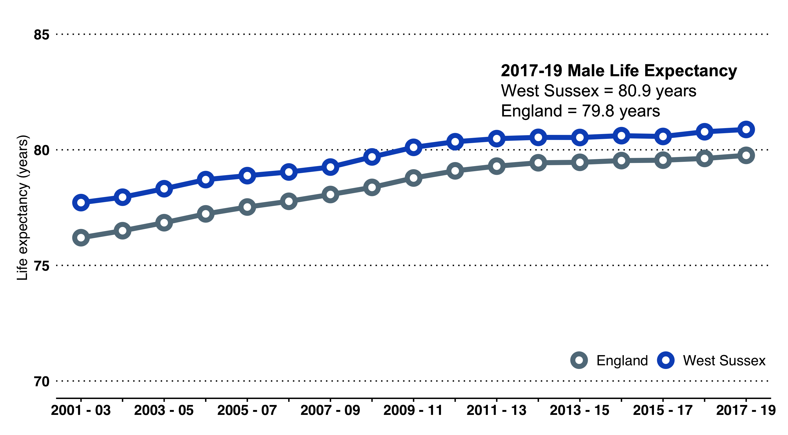 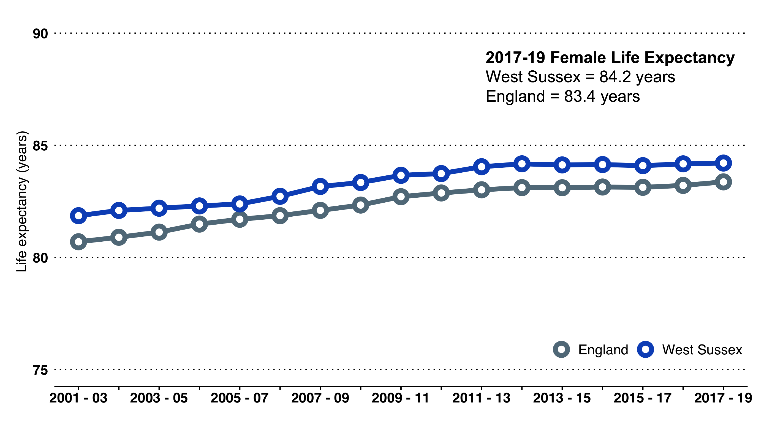

Difference in years of life expectancy between the least deprived and most deprived areas in West Sussex (2017-2019): Males from the most deprived area live on average 7 years fewer than males from the least deprived areas. Females from the most deprived areas live on average 6 years fewer than females from the least deprived areas.

For both men and women, circulatory causes (including stroke and heart disease) account for approximately a quarter of the difference, with cancers a further fifth of the difference[24].

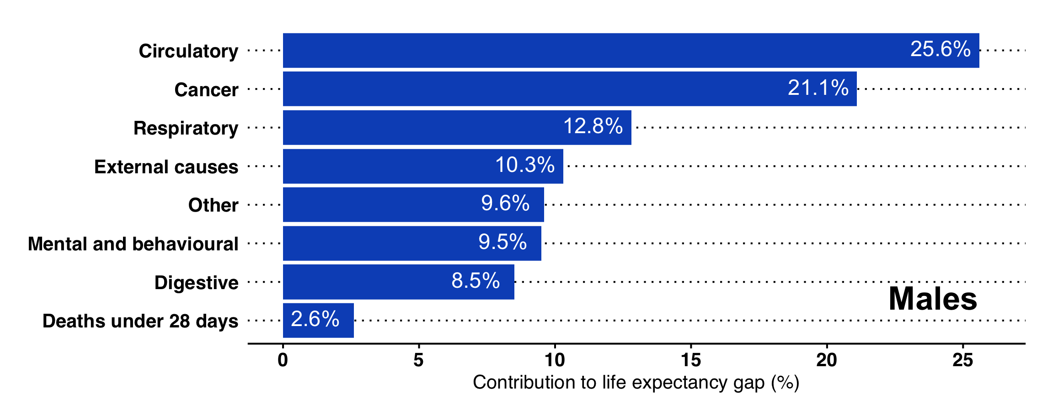 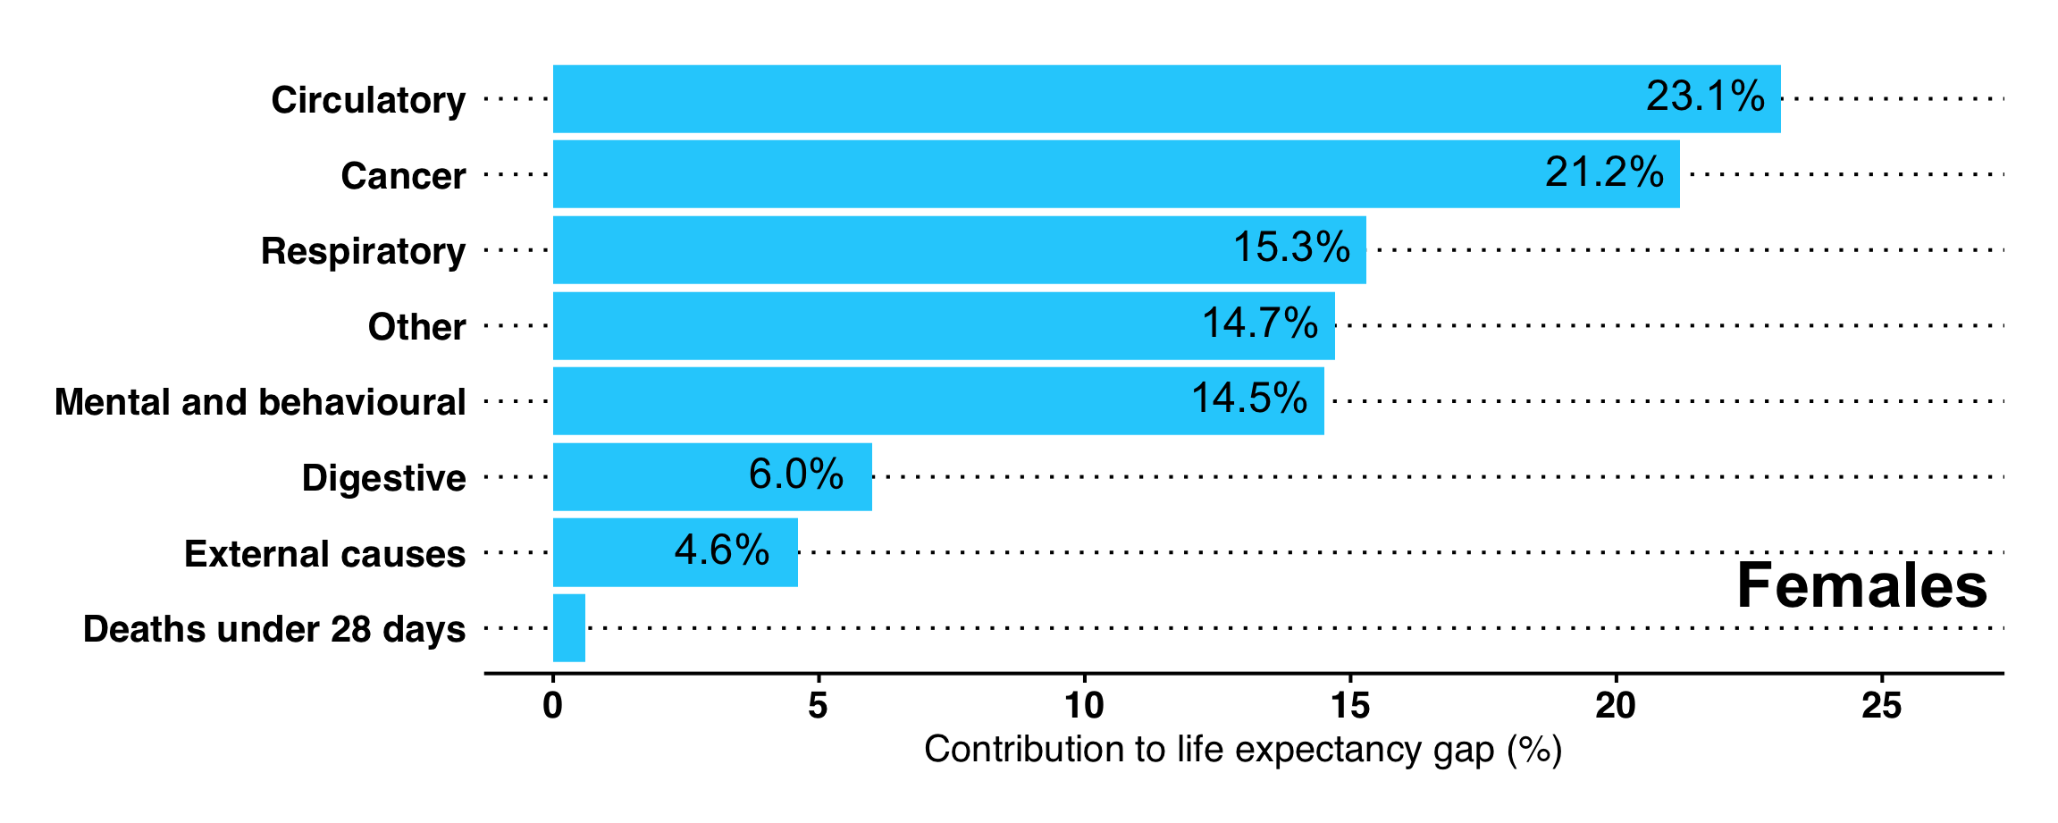

Respiratory includes flu, pneumonia, and chronic obstructive respiratory disease. Digestive includes alcohol-related conditions such as chronic liver disease and cirrhosis. External includes deaths from injury, poisoning and suicide. Mental and behavioural includes dementia and Alzheimer’s disease. Percentages may not sum to 100 due to rounding.

PHE publish a segmentation tool to examine differences in life expectancy. Data are available at lower tier LA level <https://connect.healthdatainsight.org.uk/health_inequalities/segment_tool/>.

# Starting Well

## Summary

**The early years of life lay foundations for lifelong physical, emotional and mental health, wellbeing and resilience. In tackling inequalities, action taken in the early years of life can have lifelong benefit, with many interventions being highly cost-effective.**

There are 193,200 children and young people aged 0-19 years in West Sussex, with approximately 8,000 births a year. Across the county overall, 22% of the population are 0-19 years, which is lower compared with England (24%). Within the county, Crawley has a much younger population, with 26% of residents aged 0-19 years.

Overall measures of infant and maternal health in West Sussex are good, but inequalities are apparent across the county and in relation to specific groups.

* The infant mortality rate remains below the national rate (3.6 per 1,000 live births compared with 3.9 nationally)[25], we have fewer low birth weight babies, a lower percentage of women who smoke at the time of delivery, and a higher proportion of children who are assessed as having a good level of development at their two year check.

However there remain challenges in the early years of life.

* Many immunisation rates, whilst higher than national levels, remain below target levels.
* Measures relating to child readiness for school have improved in recent years but remain lower than many comparable authorities and for children eligible for a free school meal. For example, in 2018/19, approximately 72% of children achieved a good level of development at the end of Reception whilst only 51% were assessed as having a good level of development, the third lowest of comparable authorities.

We continue to observe a strong social gradient across many indicators and outcomes. Children living in poverty and from deprived areas are more likely to be overweight or obese; less likely to attain the expected level of attainment across educational key stages; more likely to admitted to hospital for self-harm; more likely to become pregnant as a teenager; and more likely to grow up in a household where someone smokes.

In West Sussex, almost 17,000 children live in poverty. Children in poverty are more likely to come from single parent/carer families, be disabled or live in a household with an adult who is disabled. Poverty can transmit across generations and there are specific concerns about low social mobility in some parts of the county.

It is also important to recognise that, on average, children who are in care or are care leavers have significantly poorer health and educational outcomes than their peers.

Emotional and mental health are instrinically linked to physical wellbeing and longer term outcomes. Children who are happier and more emotionally resilient tend to have better physical health. Local survey data has highlighted the importance of cognitive reappriasal (reframing problems in a positive way) and expressive suppression (burying negative feelings/avoidance) in predicting life satisfaction and overall happiness[26].

## Infant and Maternal Health

Key demographic information and health indicators are summarised in the West Sussex Local Health Profiles for Children and Young People 2020, available on the JSNA website.

### Infant and Maternal Health

**In 2020 there were 8,001 births,** the lowest number in West Sussex since 2006. The infant mortality rate[27] in 2018-2020 was 3.6 per 1,000 live births, lower than the national rate of 3.9 per 1,000, although a slight increase on the previous three years.

The **neonatal mortality rate** (defined as the number of deaths under 28 days, per 1,000 live births) has remained stable over the past 10 years, although there has been a slight rise in both 2017-2019 and 2018-2020. The rate in West Sussex 3.6 per 1,000 live births, in line with the England rate (3.9 per 1,000) and below the median of the south east region.

**The percentage of term babies with low birth weight (less than 2500g;** [28]**) remains steady**, at 2.04% in 2020, and significantly lower than England (2.9%) and in the lowest three of CIPFA neighbours.

In 2018-20, there were **78.6 premature births (less than 37 weeks gestation) per 1,000** live births and still births, which is the lowest it has been since 2011-13 (76.6 per 1,000). The rate in West Sussex has followed national trends, and is in line with the England rate of 79.1 per 1,000.

The multiple birth rate (the number of maternities with multiple births per 1,000 total maternities) in 2020 was 11.0 (**87 multiple births**), lower than the England rate of 14.4.

**In 2020/21, 34.1% of births were by caesarean section in West Sussex.** This proportion has been increasing over the last 5 years and is significantly higher compared to England (32.5%) and is also the second highest among five comparable authorities[29].

**The percentage of women smoking at the time of delivery**[30] **remained low in 2020/21 at 8.5% (approximately 678 maternities)**, lower than the national rate and the second lowest of comparable authorities.

In 2019/20, 55.7% of women breastfed (wholly or partly) at 6-8 weeks[31]. Nationally, the figure was 48%. West Sussex was the second highest of comparable authorities. Note that this indicator is not available for 2020/21 due to data quality issues.

In 2020/21, 91.5% of New Birth Visits (NBVs)[32] were completed within 14 days this has increased to be above the England rate (88.0%).

In 2020/21, 84% of children assessed achieved a good level of development at 2-2½ years[33], comparing well with England (82.9%), and making West Sussex the fifth highest amongst comparable local authorities.

Uptake of the flu vaccine in 2-3 year-olds[34] in 2020/21 was 67.5% and was significantly higher than England (56.7%) and the $≥$ 65% benchmark.

### Maternal Mental Health

In relation to maternal mental health, it is estimated that between 10% and 20% of women will be affected by mental health problems, either during their pregnancy or in the first year post delivery. Local data are scarce but using synthetic estimates provided by Public Health England, the number of mothers with specific problems are shown below (note some women will be affected by one or more problems):

* Postpartum psychosis: 20
* Chronic Severe Mental Illness: 20
* Severe depressive illness: 250
* Mild-moderate depressive illness and anxiety: 830 (lower estimate) to 1,245 (upper estimate)
* PTSD: 250
* Adjustment disorders and distress: 1,245 (lower estimate) to 2,485 (upper estimate)

## West Sussex Childhood Vaccine and Immunisation Coverage Rates

See Table [tab:childhoodimms] on page .

| Immunisation | Detail | Year | % Coverage | Lower CI | Upper CI |
| --- | --- | --- | --- | --- | --- |
| Hepatitis B | % of children at age 12 months who have received the complete course (3 doses) of hepatitis B vaccine | 2020/21 | 87.5% | 52.9% | 97.8% |
| DTaP / IPV / Hib | % of children who received 3 doses of DTaP/IPV/Hib vaccine at any time by their first birthday | 2020/21 | 95.5% | 95.0% | 95.9% |
| MenB | % of children who received the MenB vaccine at any time before their first birthday | 2020/21 | 95.8% | 95.3% | 96.2% |
| Rotavirus | % of children who have received the rotavirus vaccine by 6 months of age | 2020/21 | 93.3% | 92.7% | 93.8% |
| PCV | % of children who received two doses of PCV at any time before their first birthday | 2019/20 | 95.8% | 95.3% | 96.2% |
| Hepatitis B | % of children at age 24 months who have received the complete course (4 doses) of hepatitis B vaccine | 2020/21 | 66.7% | 39.1% | 86.2% |
| DTaP / IPV / Hib | % of children who received 3 doses of DTaP/IPV/Hib at any time before their 2nd birthday | 2020/21 | 96.1% | 95.7% | 96.5% |
| MenB booster | % of children who received a booster dose of MenB at any time before their 2nd birthday | 2020/21 | 94.0% | 93.5% | 94.5% |
| MMR one dose | % of children who received one dose of MMR on or after their first birthday and at any time before their 2nd birthday | 2020/21 | 94.5% | 94.0% | 95.0% |
| PCV booster | % of children who received a booster dose of PCV at any time before their 2nd birthday | 2020/21 | 94.6% | 94.1% | 95.0% |
| Flu | % of children aged 2-3 years old, who received the Flu vaccination (1st Sept to the end of Feb) in a primary care setting | 2020/21 | 67.5% | 66.8% | 67.3% |
| Hib / Men C booster | % of children who received a booster dose of Hib/MenC at any time before their fifth birthday | 2020/21 | 94.6% | 94.1% | 95.0% |
| DTaP / PPV | % of children who received a booster dose of DTaP/PPV at any time before their fifth birthday | 2020/21 | 91.40% | 90.8% | 91.9% |
| MMR for one dose | % of children who received one dose of MMR on or after their first birthday and at any time before their fifth birthday | 2020/21 | 96.1% | 95.8% | 96.5% |
| MMR for two doses | % of children who received two doses of MMR on or after their first birthday and at any time before their fifth birthday | 2020/21 | 93.0% | 92.4% | 93.4% |
| Flu | % of primary school aged children from reception to year 6 age receiving the flu vaccine | 2020/21 | 67.0% | 66.6% | 67.3% |
| HPV - one dose | % of females in school year 8 (aged 12-13) who have received the first dose of HPV vaccine | 2019/20 | 14.9% | 13.9% | 15.9% |
| HPV - one dose | % of males in school year 8 (aged 12-13) who have received the first dose of HPV vaccine | 2019/20 | 10.7% | 9.9% | 11.6% |
| HPV - two doses | % of females in school year 8/9 (aged 13-14) who have received the second (completing) dose of HPV vaccine | 2019/20 | 11.3% | 10.4% | 12.3% |
| Men ACWY | % of 14-15 year olds (Year 9/10) receiving the Meningococcal ACWY conjugate vaccine | 2019/20 | 87.9% | 87.2% | 88.5% |

## Hospital admissions

#### Emergency admissions

In 2020/21, West Sussex had among the highest emergency hospital admission rates in the South East, and rates were higher than national rates:

* **Under 1 years old – 2,500 admissions,** a rate of 253.4 per 1,000 population.
* **0-4 year olds – 4,880 admissions,** a rate of 107.4 per 1,000 population.
* **Under 18s – 9,480 admissions,** a rate of 53.4 per 1,000 population.

#### Admissions to hospital - 0-19 year olds

* **Asthma – 100 admissions (2020/21)**, a rate of 53.8 per 100,000 population, lower than England and comparable authorities.
* **Diabetes – 115 admissions (2019/20)**, a rate of 62.2 per 100,000 higher than England and comparable authorities.
* **Epilepsy – 125 admissions (2019/20)**, a rate of 67.6 per 100,000, similar to England and comparable authorities.

## Disability through the life course

#### Overall Disability Assumption

The term "disability" is frequently used but often poorly defined, and estimating the prevalence and type of disability within a population is difficult. The purpose of a definition (for example, for deciding educational support vs. eligibility for welfare benefits), as opposed to a "formal diagnosis" can mean that different sources can often provide very different pictures of the local population.

The Family Resources Survey (FRS) is a national, continuous household survey that collects data on a wide range of information including disability[35], caring, tenure and income. One of the main functions of the survey is to inform the Department of Work and Pensions (DWP) of the living conditions and economic circumstances of different households. Small sample size means that data are not published below regional level. Using the results from the latest national survey and applying the prevalence to the local population provides a local estimate of disability by age groups. Given that West Sussex overall has a relatively healthy and wealthy population, these estimates may be higher than expected and should be treated as possibly high estimates.

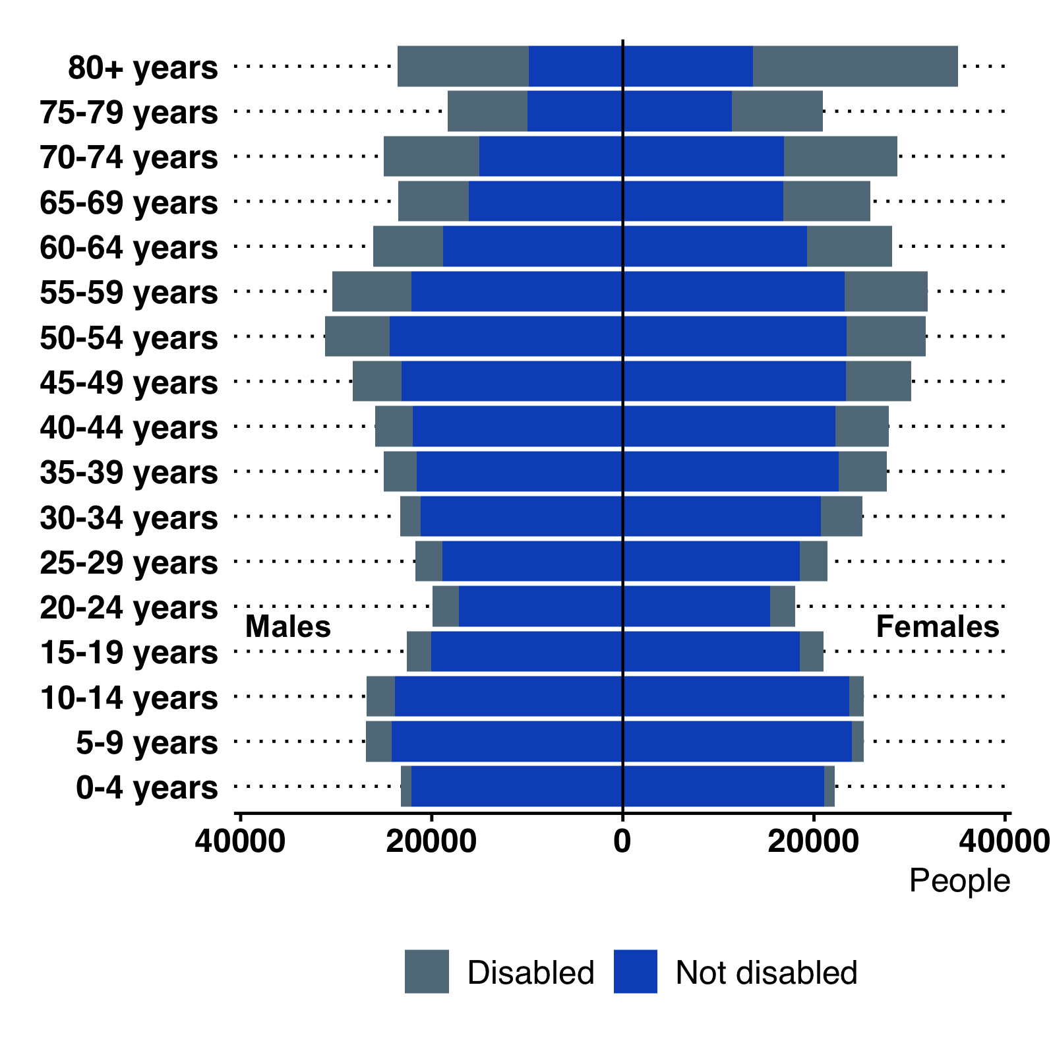

#### FRS Type of Impairment

Of people who described themselves as being disabled, data were also collected on the nature of their impairment. As people are able to state multiple impairments, figures in Table 4 do not sum 100.

Nationally it is noted that the proportion of FRS respondents who reported a mental health impairment has been rising in recent years, from 22% in 2015/16 to 25% in 2017/18.

Note again that, given West Sussex overall has a relatively healthy and wealthy population, these estimates may be higher than expected and should be treated as possibly high estimates.

FRS Type of Impairment

|  |  |  |  |  |
| --- | --- | --- | --- | --- |
| Impairment | All Disabled | Children | Working | State |
| type (%) | People |  | age | Pension |
| Mobility | 49 | 19 | 41 | 67 |
| Stamina, breathing & fatigue | 37 | 24 | 32 | 46 |
| Dexterity | 26 | 11 | 23 | 34 |
| Mental health | 25 | 23 | 38 | 9 |
| Memory | 16 | 11 | 16 | 17 |
| Hearing | 14 | 8 | 8 | 23 |
| Vision | 12 | 9 | 9 | 18 |
| Learning | 13 | 36 | 14 | 8 |
| Social/behavioural | 9 | 43 | 10 | 2 |
| Other | 17 | 18 | 18 | 15 |

## Mental Health and Wellbeing

**Major national surveys remain the best source of evidence on the prevalence of mental health disorders among children and young people.**

In 2004, ONS conducted a national survey to estimate the prevalence of mental health conditions in children aged 5-16[36]. Public Health England has applied the survey results to local populations taking into account age, sex and socio-economic classification[37]. In 2015, 8.4% of children and young people aged 5-16 were estimated to have a mental health condition in West Sussex. This equates to around 9,500 children. Since there is evidence to suggest that prevalence of mental health conditions among children and young people has increased, it is possible that this represents an underestimate.

Estimates from the 2004 Survey applied to 2015 Population

|  |  |  |
| --- | --- | --- |
| Type of | Estimated 2015 | Number of CYP |
| disorder | prevalence among CYP |  |
| Mental health | 8.4% | 9,490 |
| Emotional | 3.2% | 3,655 |
| Conduct | 5.0% | 5,635 |
| Hyperkinetic | 1.3% | 1,515 |

The 2004 survey has now been updated with a new series of data collection completed in 2017[38]. NHS Digital released the findings from this survey in 2019. This goes beyond the 2004 survey, providing estimates of the prevalence of mental health disorder in 2 to 4 year olds, and spans the transition into adulthood covered by 17 to 19 year olds.

The main findings from the 2017 survey include:

* **One in eight (12.8%) 5 to 19 year olds and one in eighteen (5.5%) preschool children assessed had at least one mental health disorder**
* **Rates of mental health disorders increased with age.** Young people aged 17 to 19 were three times more likely to have a mental health disorder (16.9%) than preschool children aged 2 to 4 (5.5%), although data collection methods varied by age
* **Young women were identified as a high a risk group in relation to mental health,** with nearly one in four (23.9%) 17 to 19 year old girls identified as having a mental disorder
* **Prevalence of mental disorders also varied by ethnicity** (higher in White British children) and by socioeconomic status (higher among children living in lower income households)
* **Emotional disorders were the most prevalent type of disorder experienced** by 5 to 19 year olds in 2017 (8.1%)
* **Behavioural disorders were the most prevalent (2.5%) for preschool children**
* **Trend analyses revealed a slight increase over time in the prevalence of mental disorder** in 5 to 15 year olds
* **Emotional disorders have become more common in 5 to 15 year-olds,** whilst prevalence of other mental health disorders have remained similar over time
* **Most children with a disorder who had used professional services tended to view them as helpful.** Primary care was the service most likely to be rated as unhelpful; 17.0% of 5 to 19 a year olds with a disorder who had contact with a primary care a professional due to worries about mental health described the contact as unhelpful or very unhelpful.

#### Wave 2 follow up to the 2017 survey

Published in September 2021, the wave 2 follow up to the 2017 survey[39] examined the mental health of 6 to 23 year olds living in England in 2021 and describes their experiences of family life, education, and services during the coronavirus (COVID-19) pandemic. Comparisons were made between 2017 and 2020 (where possible), to monitor changes over time.

The key findings were:

* Probable mental disorder: Rates of probable mental disorder increased between 2017 and 2021; in 6 to 16 year olds from one in nine (11.6%) to one in six (17.4%), and in 17 to 19 year olds from one in ten (10.1%) to one in six (17.4%). Rates in both age groups remained similar between 2020 and 2021.
* Change in mental health: Looking at individual-level change, 39.2% of those aged 6 to 16 years in 2021 had experienced deterioration in mental health since 2017, and 21.8% experienced improvement. Among those aged 17 to 23 years in 2021, 52.5% experienced deterioration, and 15.% experienced improvement.
* Eating problems: The proportion of children and young people with possible eating problems increased between 2017 and 2021, from 6.7% to 13.0% in 11 to 16 year olds and from 44.6% to 58.2% in 17 to 19 year olds.
* Sleep problems: In 2021, problems with sleep on three or more nights of the previous seven affected over a quarter (28.7%) of 6 to 10 year olds, over a third (38.4%) of 11 to 16 year olds, and over half (57.1%) of 17 to 23 year olds. Across all age groups figures were much higher in those with a probable mental disorder (59.5%, 74.2%, 86.7% respectively).
* School absence: Overall, 10.6% of 6 to 16 year olds missed more than 15 days of school during the 2020 Autumn term. Children with a probable mental disorder were twice as likely to have missed this much school (18.2%) as those unlikely to have a mental disorder (8.8%).
* Learning resources: The proportion of 6 to 16 year olds with a laptop or tablet they could work on at home, increased from 89.0% in 2020 to 94.4% in 2021. The proportion receiving regular support from school or college also increased, from 73.7% in 2020 to 79.9% in 2021.

#### Estimated prevalence by CAMHS "Tier" in West Sussex

Mental health services are often described in terms of tiers, where services become more specialised, from emotional wellbeing services at Tier 1 to highly specialist outpatient teams and inpatient provision at Tier 4. Prevalence estimates (population aged 17 and under) based on findings published in "Treating Children Well"[40] are shown in Table 6 against each of the tiers. These provide an estimate of the number of West Sussex children and young people who may at any one time, need a service response or support.

Estimated prevalence by CAMHS tier

|  |  |  |
| --- | --- | --- |
| Tier - service | Prevalence | Estimated number |
| provision | assumption | of children |
| Tier 4 | 0.075% | 130 |
| Tier 3 | 1.85% | 3,230 |
| Tier 2 | 7.00% | 12,225 |
| Tier 1 | 15.00% | 26,200 |

## Autism

There are a number of problems estimating the number of people who have autism:

* There is no single source or register, and setting one up would be difficult to maintain.
* Not all people will have been diagnosed and some people may have been misdiagnosed.
* There are inconsistencies in how agencies record autism.
* Much of the existing work on prevalence has been undertaken in relation to children; there may be enduring problems of childhood misdiagnosis or some people only being diagnosed in adulthood.
* There is some evidence of poor identification of adults with autism compared with children.

**In the 2019 school census, there were 1,317 school pupils with special educational needs who had primary need of autism spectrum conditions** in West Sussex. A major survey[41] of the mental health of children and young people identified autism spectrum conditions in 1.2% of 5 to 19 year olds. Due to the small number of cases identified in this sample and the sampling method used (such as self-report only for 17-19 year olds), it is possible that this reflects an underestimate. **Applying this prevalence estimate to the local population of 5 to 19 year olds in West Sussex suggests that there are around 1,700 autistic children and young people in the county.**

#### Statement from the West Sussex Autism Partnership Board

In collating and publishing data for the JSNA summary it is important to acknowledge that for some health issues and conditions there is a lack of robust local and/or national data; this can have implications in terms of accessing services and receiving appropriate support. A statement from the West Sussex Autism Partnership Board is included below:

*’The Autism Partnership Board acknowledges that there is a lack of accurate data about the actual numbers of autistic adults and our concern is that if there is under- reporting this will result in not enough support services being commissioned to meet need. The Board felt that the method of researching prevalence exacerbates the issue of underreporting and potentially discriminates against autistic individuals and others with communication differences.*

Autistic adults face many challenges. Often, they also have co-occurring conditions such as a learning disability or mental health problems. For some they feel they have a ’hidden’ condition which is not easily recognised or understood by professionals or the public. Locally, two of the key issues for autistic adults are the 20 month waiting time for a diagnosis and the risk of falling into the gap between learning disability and mental health services so that people could struggle to get the help they need. The Neurodevelopmental services report that receiving a diagnosis can be transformation for many individuals who experience mental health problems as a result of their needs in relation to autism not being understood. A diagnosis can have a preventative function in this regard in addition to leading to reasonable adjustments that improve mental health outcomes.

Commissioners require a more robust understanding of the numbers of autistic people - for example those registered with a GP - and an understanding of how well people’s needs, of all ages, are being met and what outcomes are being achieved, for example in employment and housing, and in Public Health data on higher mortality rates and poorer physical health outcomes’.

## Health Related Behaviours and Healthy Weight

#### Health-related behaviour of young people

Using the data from the 2014/15 national What About Youth (WAY) survey, 10.6% of 15 year-olds in West Sussex stated that they were current smokers[42]. This is higher than England (8.2%) and high amongst comparable authorities, although some caution is needed, given the lack of trend data and small sample sizes.

**There were 195 hospital admissions for alcohol-specific conditions (of under 18s) in the period from 2018/19 to 2020/21. This is a rate of 36.9 per 100,000, which is significantly higher than the England rate of 29.3. These admissions have been increasing and are now at their highest level since 2011/12 to 2013/14, even as rates in England have fallen.**

The chlamydia detection rate[43] remains below the England rate. In 2020, the rate was 1,003 per 100,000 15-24 year-olds and low compared with similar authorities.

West Sussex has a low teenage pregnancy rate[44], at 12.6 per 1,000 15-17 year-olds (179 conceptions) in 2019. This rate was slightly higher than in 2016 but remains low compared with England (rate of 15.7).

**The number of births to teenage mothers is less than a quarter of what it was ten years ago,** falling from 103 in 2010/2011 to 25 in 2020/21. 0.3% of all births are to women in their teenage years.

47.3% of children aged 5-16 met the recommendations for physical activity in 2020/21[45], in line with England and national benchmark. The only lower tier authority in West Sussex with a sufficient sample size was Crawley, with 49.6% of children which is also similar to the national figure.

### Healthy Weight - Reception and Year 6 Pupils

In England in 2020/21, over a fifth of reception children were overweight or obese, increasing to over a third in Year 6. In West Sussex, the prevalence of obesity was lower than national levels, with 19.2% of reception age children (4- 5 years old) and 28.8% of Year 6 children (10-11 years old) measured as overweight or obese[46].

Inequalities in childhood obesity persist. For both school year groups, prevalence of excess weight among children living in the most deprived areas of West Sussex is greater than those living in the least deprived areas.

The Research Unit has drafted a briefing on data from the National Child Measurement Programme. This is available on the JSNA website.

### Education

#### Early Years Provision, Education, NEET & Progression to Higher Education

Note: Unless stated, data for this section have been taken from the Department for Education Local authority interactive tool (LAIT). This is an interactive online tool. <https://www.gov.uk/government/publications/local-authority-interactive-tool-lait>

77% of 2 year-olds in West Sussex benefited from funded early years (2 year-olds) in 2019. This is higher than the England rate and that of comparable authorities.

55% of 2, 3 and 4 year-olds are in funded early provision with staff who have graduate status, similar to the England rate.

#### Special Educational Needs

In January 2021 3.1% of pupils attending a West Sussex school had a statement or Education, Health and Care (EHC) plan. This percentage is similar to regional and national percentages. The number of children on such plans has been increasing since 2018.

As at 31 December 2021, 92.4% of 16 and 17 year olds with SEN in West Sussex were in Education or Training. This is higher than both England and the average of the county’s statistical neighbours.

#### 16-17 year-olds not in education, employment or training (NEET)

Compared to other authorities in the South East, West Sussex has the third highest proportion of 16-17 year-olds not in education, employment or training, at 7.7% in 2020 (England 5.5%, South East 6.4%)[47]. This represents 1320 young people in West Sussex.

Broken down, 5.5% of this group has unknown status which, while lower than than in recent years is higher than both the average of statistical neighbours (3.4%) and England (2.7%).

#### School readiness

Overall, West Sussex compares poorly or similarly to the England level for school readiness measures[48], and performs significantly worse for children with free school meal status. West Sussex has been improving in recent years for these measures, however, and remains broadly comparable to statistical neighbours.

At Key Stage 2 (children aged 10-11 years), attainment is notably low, with 63% of pupils achieving the expected standard in reading, writing and maths in 2019, and only 7% of pupils attaining the higher standard (compared with 11% nationally).

These figures have not been updated since the previous JSNA summary.

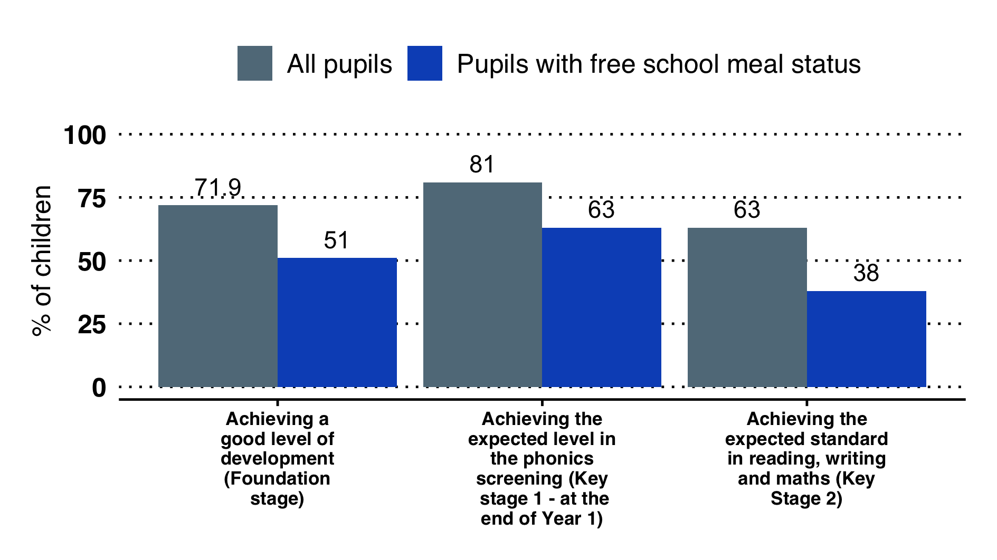

School readiness in West Sussex (2019)

At Key Stage 4 (GCSE level), attainment is above England overall (on the average P8 score measure) and in line with comparable authorities.

#### Progression to Higher Education (HE)

40% of all pupils progressed to higher education by age 19 in 2017/18, lower than England (43%) and statistical neighbours (40.1%). **Significantly fewer pupils on free school meals progressed to HE, at 19%** (England 27%, statistical neighbours 16.5%).

Data from the Office for Students shows some areas in West Sussex (including Littlehampton) are ranked in the lowest national quintile for progression to HE[49].

### Social Care and Community Safety

#### Social Care and Criminal Justice

As at 31 March 2021 there were 891 children looked after, a rate of 50 per 10,000. The rate in West Sussex remains lower than England, but similar to statistical neighbours. 80 children were unaccompanied asylum seeking children.

#### Outcomes for Children Looked After and Children Leaving Care

In 2021, 8% of care leavers were not in touch with the local authority. This was higher than England but similar to comparable local authorities. 31% of children looked after are noted as "persistent absentees".

In relation to the emotional and mental wellbeing of children in care, in 2020/21, a higher percentage (50.6%) of children in West Sussex were children with a ’cause for concern’[50] (whereby they scored 17 or above on the Strengths and Difficulty questionnaire, which asks questions on a range of issues relating to emotional and mental wellbeing). This was significantly higher than England (36.8%).

#### Criminal Justice

First time entrants to the criminal justice system declined in the county, down to 74 per 1,000 10-17 year-olds in 2020, making the rate in West Sussex significantly lower than that of England (169.2) and the lowest in the South East (156.7).

#### Children in Need (CiN)

The Children in Need rate, as at 31 March 2021, was 330.0 per 10,000. This is lower than England but broadly in line with comparable authorities. As at March 2021, there were 5,853 children in need.

6.7% of Children in Need had a recorded disability. This is much lower than the England rate of 12.7%.

The rate (per 10,000) of referrals to social services increased year on year between 2014 and 2018, although it declined slightly in 2019 and 2020 to 516.0. This rate is similar to England but higher than comparable local authorities. In total there were 8,803 referrals.

Section 47 enquiries[51] (started within year) remain fairly steady, at 188.8 per 10,000. This was higher than England and comparable authorities.

#### Children subject to a Child Protection Plan (CPP)

In 2021, the rate of children subject to a CPP was 53.8 per 10,000, higher than England and comparable authorities. The percentage of children who became subject to a CPP for a second or subsequent time held steady at approximately 25%. This is higher than comparable authorities and England.

### Transition to Adult

Some young people, including those in care and young people with health needs and disabilities, require additional support as they enter adulthood. Many young people will have on-going services and this can be a time of considerable anxiety.

National research shows disabled young people aged 16-24 are less satisfied with their lives than their peers. There is a tendency for support to fall away at key transition points as young people move from child to adult services.

Following transition from a residential school, young people may experience good access to frontline health and social services, but also very few opportunities to enter employment or further education; no additional improvements in communication, self-care or behaviours that challenge; a reduction in good support for behaviours that challenge and increased reliance on restrictive practices; limited access to specialist services; and living at distance from the family home.

# Living Well

## Summary

Foundations and behaviours established in childhood and the wider determinants of health (such as education, housing, income and the natural and built environment) impact health and wellbeing in adulthood. In the past 10 years, the UK has experienced a considerable increase in people aged 65 years and over and can expect greater increases to come, as the sustained baby-boom of the late 1950s to mid-1960s starts to enter older age groups in the next 10-20 years.

Action to improve mid-life, so that people enter older age healthier and happier, becomes increasingly important. This is not just to reduce pressure on health and social care services, but to sustain the ability to work and overall economic productivity, as the age-dependency ratio increases.

Having a good job has been found to be good for physical and mental wellbeing. West Sussex has high employment rate, with over 79% of 16-64 year-olds in employment, 4% higher than the England rate. However, wage rates in part of the county are relatively low, when compared with regional and national rates. Large gaps also remain in the employment rates for people with health problems or long-term conditions and the wider population. In 2020/21 the employment gaps were:

* 9.9% between those with a long-term health condition and the overall employment rate, statistically comparable to the England average
* a 78.6% between adults with a learning disability and the overall employment rate, which is significantly greater than in England
* 68.7% between those in contact with secondary mental health services and the overall employment rate.

Having access to good quality, affordable housing is also crucial to health. In West Sussex, as in many parts of the UK, there is increased pressure on housing and costs have risen. Although data are limited, the number of people sleeping rough continues to increase.

In recent years, improvements in healthy life expectancy have stalled, particularly in women, where healthy life expectancy was lower in the period of 2016-18 compared with 2009-2011 and continues to plateau. However, there are likely to be many complex and inter-related reasons for this.

Four behaviours (tobacco smoking, alcohol consumption, diet and physical activity) continue to have a considerable impact on physical and mental health. Increased clustering of these behaviours, notably amongst people from the most deprived communities, are acting to increase health inequalities. Tackling these behaviours requires a whole system approach, working at population, community and individual level.

* The overall smoking rate in West Sussex is 11.2%. People in lower socio-economic groups are 3 times more likely to smoke, however.
* The rate of hospital admissions for alcohol-related conditions for people under 40 is similar to England, with over 500 admissions in 2020/21.[52]
* Over 60% of adults are estimated to be overweight or obese.
* An estimated 21% of adults are physically inactive, engaging in less than 30 minutes of physical activity per week.

Emotional and mental wellbeing is as important, and intrinsically linked, to physical wellbeing. Between 14-16% of adults in West Sussex are estimated to have common mental health problems, such as anxiety or depression. Over 8,300 people in the county have a recorded severe mental illness such as schizophrenia, bipolar affective disorder and other psychoses.

## Life expectancy

### Healthy Life Expectancy at birth

Healthy life expectancy is the number of years a person can expect to live in good health (i.e without a disability and not in poor health)[53].

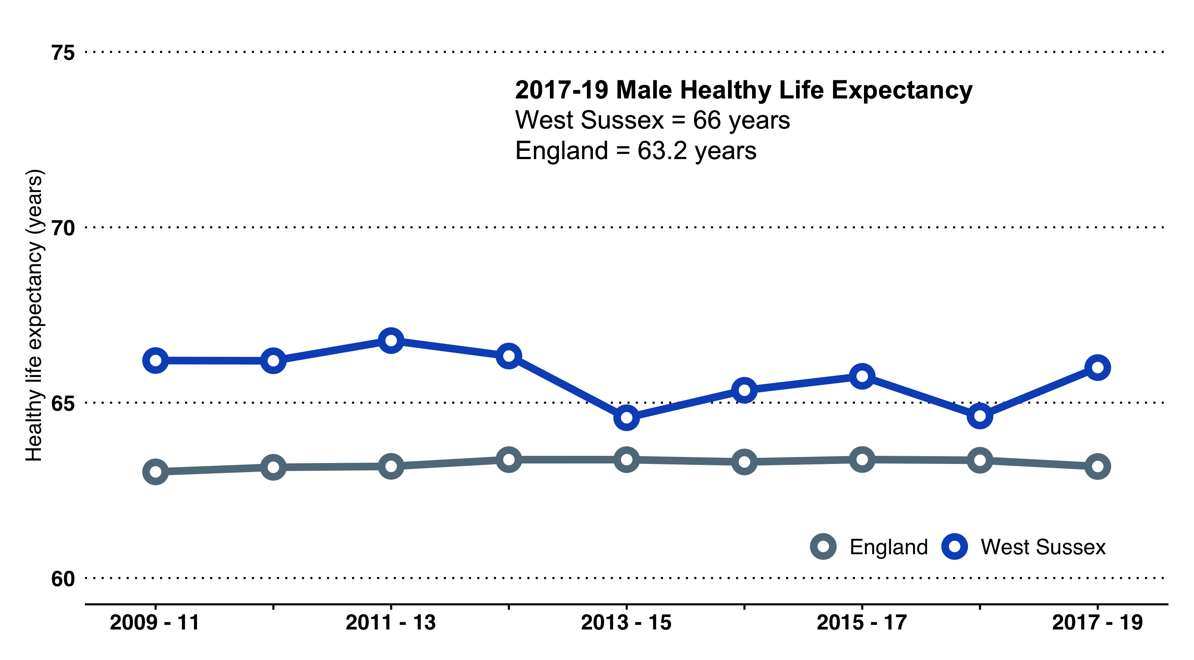 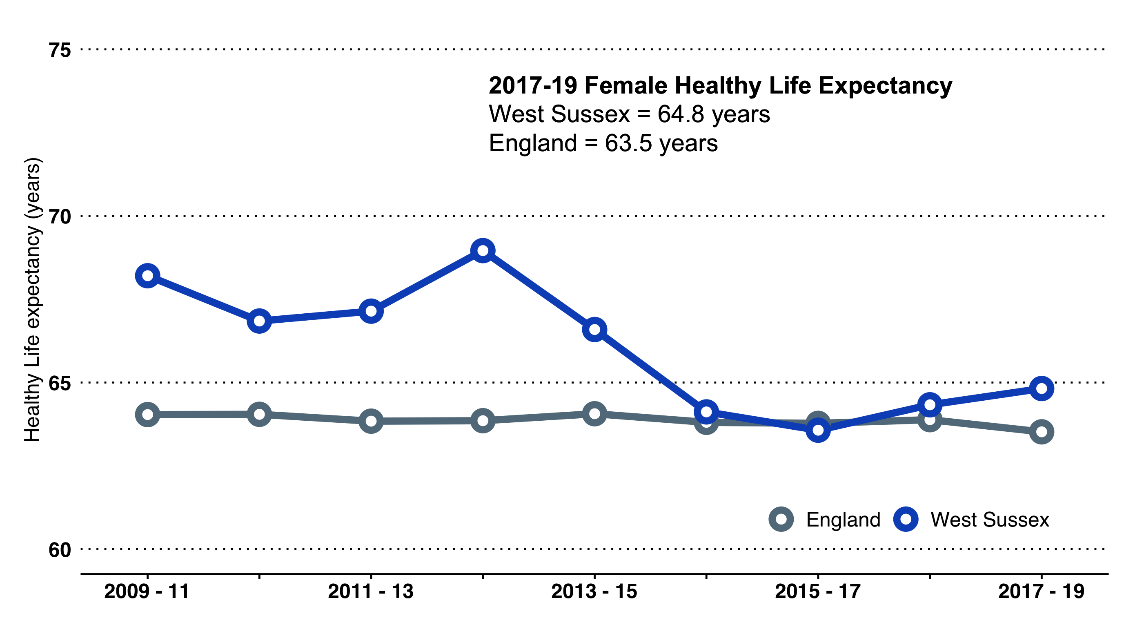

Healthy life expectancies in West Sussex are comparable to England. In 2017-19, the male healthy life expectancy was 66.0 years and the female healthy life expectancy 64.8 years.

#### Female Life Expectancy - Changes between 2011-13 and 2017-19

Female healthy life expectancy has fallen considerably in recent years. In 2011-2013, West Sussex ranked 2nd amongst CIPFA comparators but by 2016-18 it had fallen to the second lowest amongst comparable local authorities. In the period 2017-19, West Sussex ranked 10th among comparable local authorities.

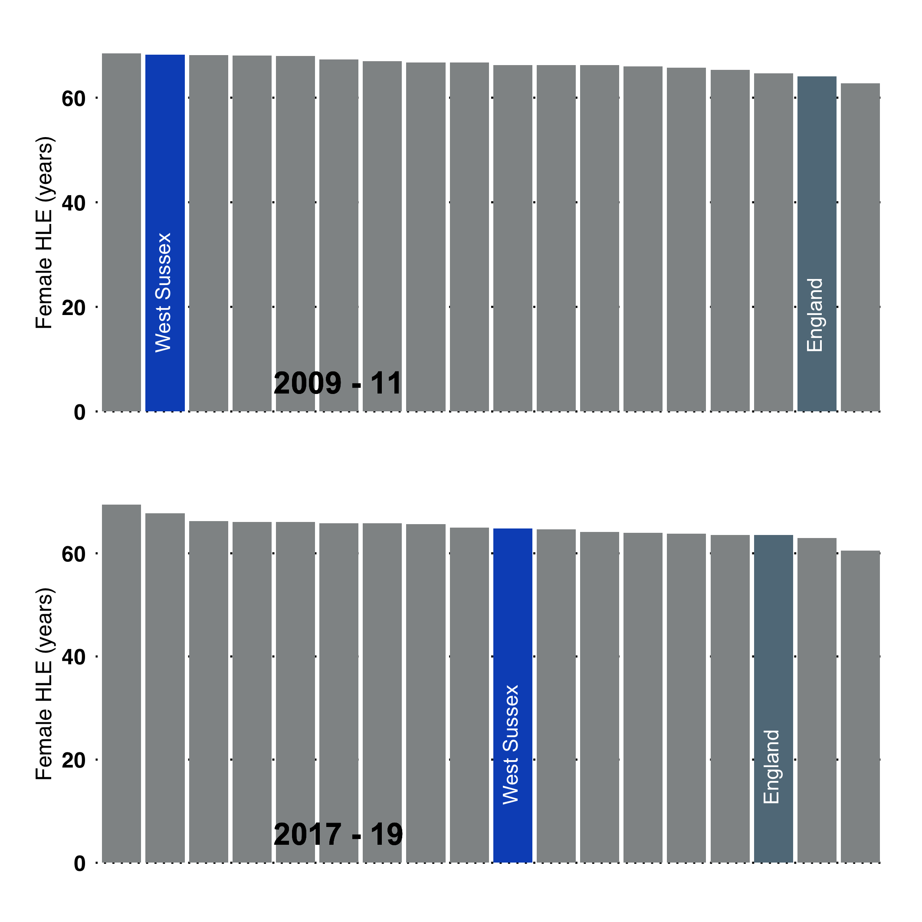

As an example, NHS Choices details the benefits of regular activity. For adults aged over 18 years, 150 minutes of moderate activity or 75 minutes intense activity per week is recommended. Ideal moderate activity is brisk walking and cycling, which could be incorporated into active travel.

It is estimated that people who do regular physical activity have up to a:

* 35% lower risk of coronary heart disease and stroke
* 50% lower risk of type 2 diabetes
* 50% lower risk of colon cancer
* 20% lower risk of breast cancer
* 30% lower risk of early death
* 83% lower risk of osteoarthritis
* 68% lower risk of hip fracture
* 30% lower risk of falls (among older adults)
* 30% lower risk of depression
* 30% lower risk of dementia

For West Sussex, if all adults were physically active, this would translate to:

* 10,000 fewer people on coronary heart disease GP register
* 23,000 fewer people on diabetes GP register
* 20,000 fewer people on depression GP register
* 2,500 fewer people on dementia GP register
* 175 fewer cases of breast cancer per year
* 210 fewer cases of colon cancer per year
* 845 fewer emergency admissions for hip fracture in those aged 65 and over

## Years of Potential Life Lost - West Sussex Primary Care Networks

Years of Potential Life Lost (YPLL) is a measure of premature mortality.

If the average life expectancy in an area is 80 years and a death occurs at 50 we can describe the 30 year difference as "potential life years" lost to the population. By summing all the life years lost of people who have died prematurely we can calculate a summary for an area/group. People who die at a younger age contribute greater number of years; for example, a young person who dies at 20 in a car accident will have 60 years of life lost, whereas someone who dies at 72 would have 8 years of life lost. In using this measure, we look at the overall level of premature mortality (as a rate per 10,000 population) and at the cause of premature mortality so that we can identify the key causes of premature mortality.

For comparison with the previous JSNA summary, we have again looked at deaths under the age of 75 by Primary Care Networks in West Sussex. We have summed the total years of life lost for deaths between 2017 and 2021 (5 years of data), calculated as a rate per PCN population aged under 75 years. (Figure [fig:ypll])

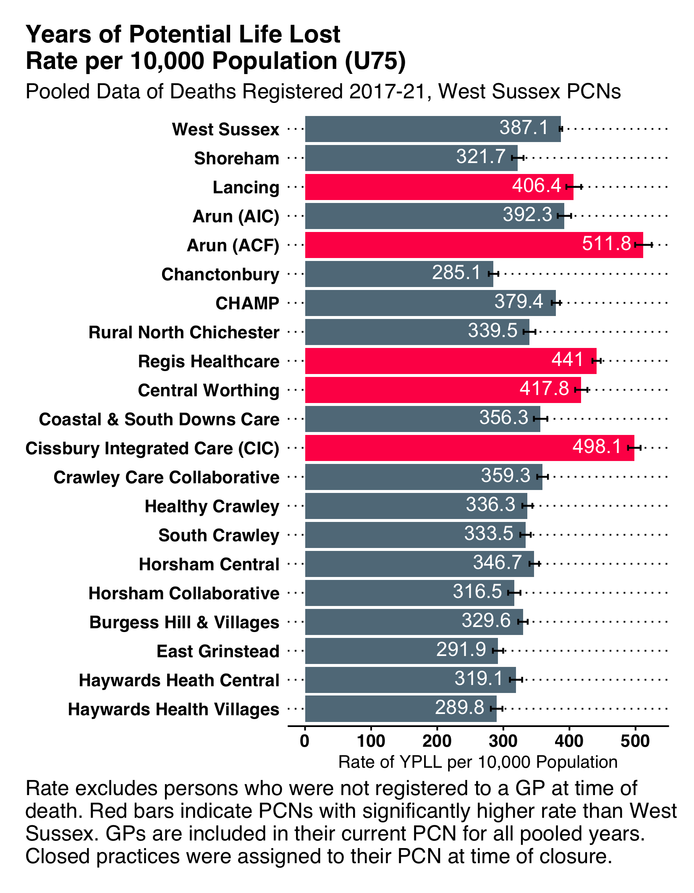

Five PCNs have rates significantly higher compared with the West Sussex overall rate. These are Lancing, Arun (Neighbourhood 1), Regis (Neighbourhood I - Central Regis) and Cissbury.

The top 5 causes of years of potential life lost are common across all the PCNs: cancer, diseases of the circulatory, respiratory and digestive systems, and external causes (such as accidents).

## Employment and Unemployment

#### Economic Inactivity

In West Sussex 92,900 people aged 16-64 years are estimated to be economically inactive (April 2020 to March 2021). Of these, over 68,500 are not seeking a job; with 16,000 people with long term sickness, 14,900 looking after the home or family, and 15,700 retired.

#### Long-term claimants of Jobseeker’s Allowance

The rate per 1,000 16-64 year-olds claiming Jobseeker’ Allowance long-term (i.e. for more than 12 months) has improved in West Sussex in recent years, decreasing from 4.9 per 1,000 in 2012 to 1.8 per 1,000 in 2018 (a decrease of 1,455 people in this time period). The West Sussex rate is in line with CIPFA neighbours and below England (3.8 per 1,000 in 2018).

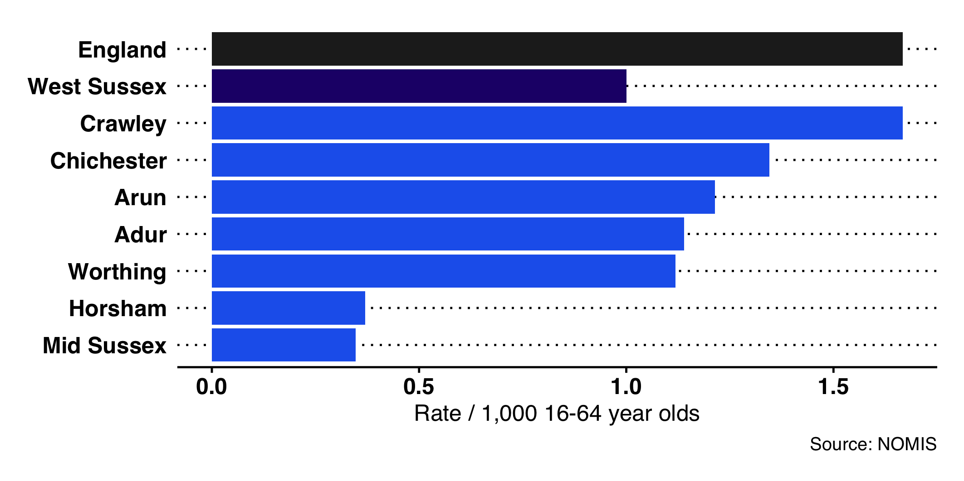

Long-term claimants of Jobseeker’ Allowance by West Sussex Local Authorities, 2020

#### Out-Of-Work Benefits

In West Sussex, there are a similar proportion of claimants to the South East region as a whole (3.2% compared to 3.3%), this was approximately 16,300 people in March 2022. The number of claimants was higher during the first Covid lockdown (at a peak of 27,500 in May 2020) but has fallen since.[54]

The Claimant Count is the number of people claiming benefit principally for the reason of being unemployed. This is measured by combining the number of people claiming Jobseeker’s Allowance (JSA) and National Insurance credits with the number of people receiving Universal Credit principally for the reason of being unemployed. Claimants declare that they are out of work, capable of, available for and actively seeking work during the week in which the claim is made. Note that the Claimant Count is currently designated as an experimental statistic.

#### Employment Rate Gap of Vulnerable Groups

The employment rate gap looks at the difference in the percentage of people who are part of a vulnerable group who are employed, compared to the percentage of all respondents in the Labour Force Survey classed as employed (aged 16-64)[55].

In 2019/20, the employment rate gap for people with learning disability was significantly greater in West Sussex (78.6%) compared to the overall rate across England (70.6%).

In 2019/20, for both people with a long-term health condition, and people in contact with secondary mental health services, the employment rate gaps were similar in West Sussex compared with the overall rates across England.

The rate gap for people with a long term health condition has improved, decreasing from 14.3% in 2018/19 to 9.9% in 2019/20, similar to the England rate (67.2%)[56].

The rate gap for people in contact with secondary mental health services has remained at a similar level, decreasing from 69.1% in 2018/19 to 68.7% in 2019/20, similar to the England rate (67.2%).

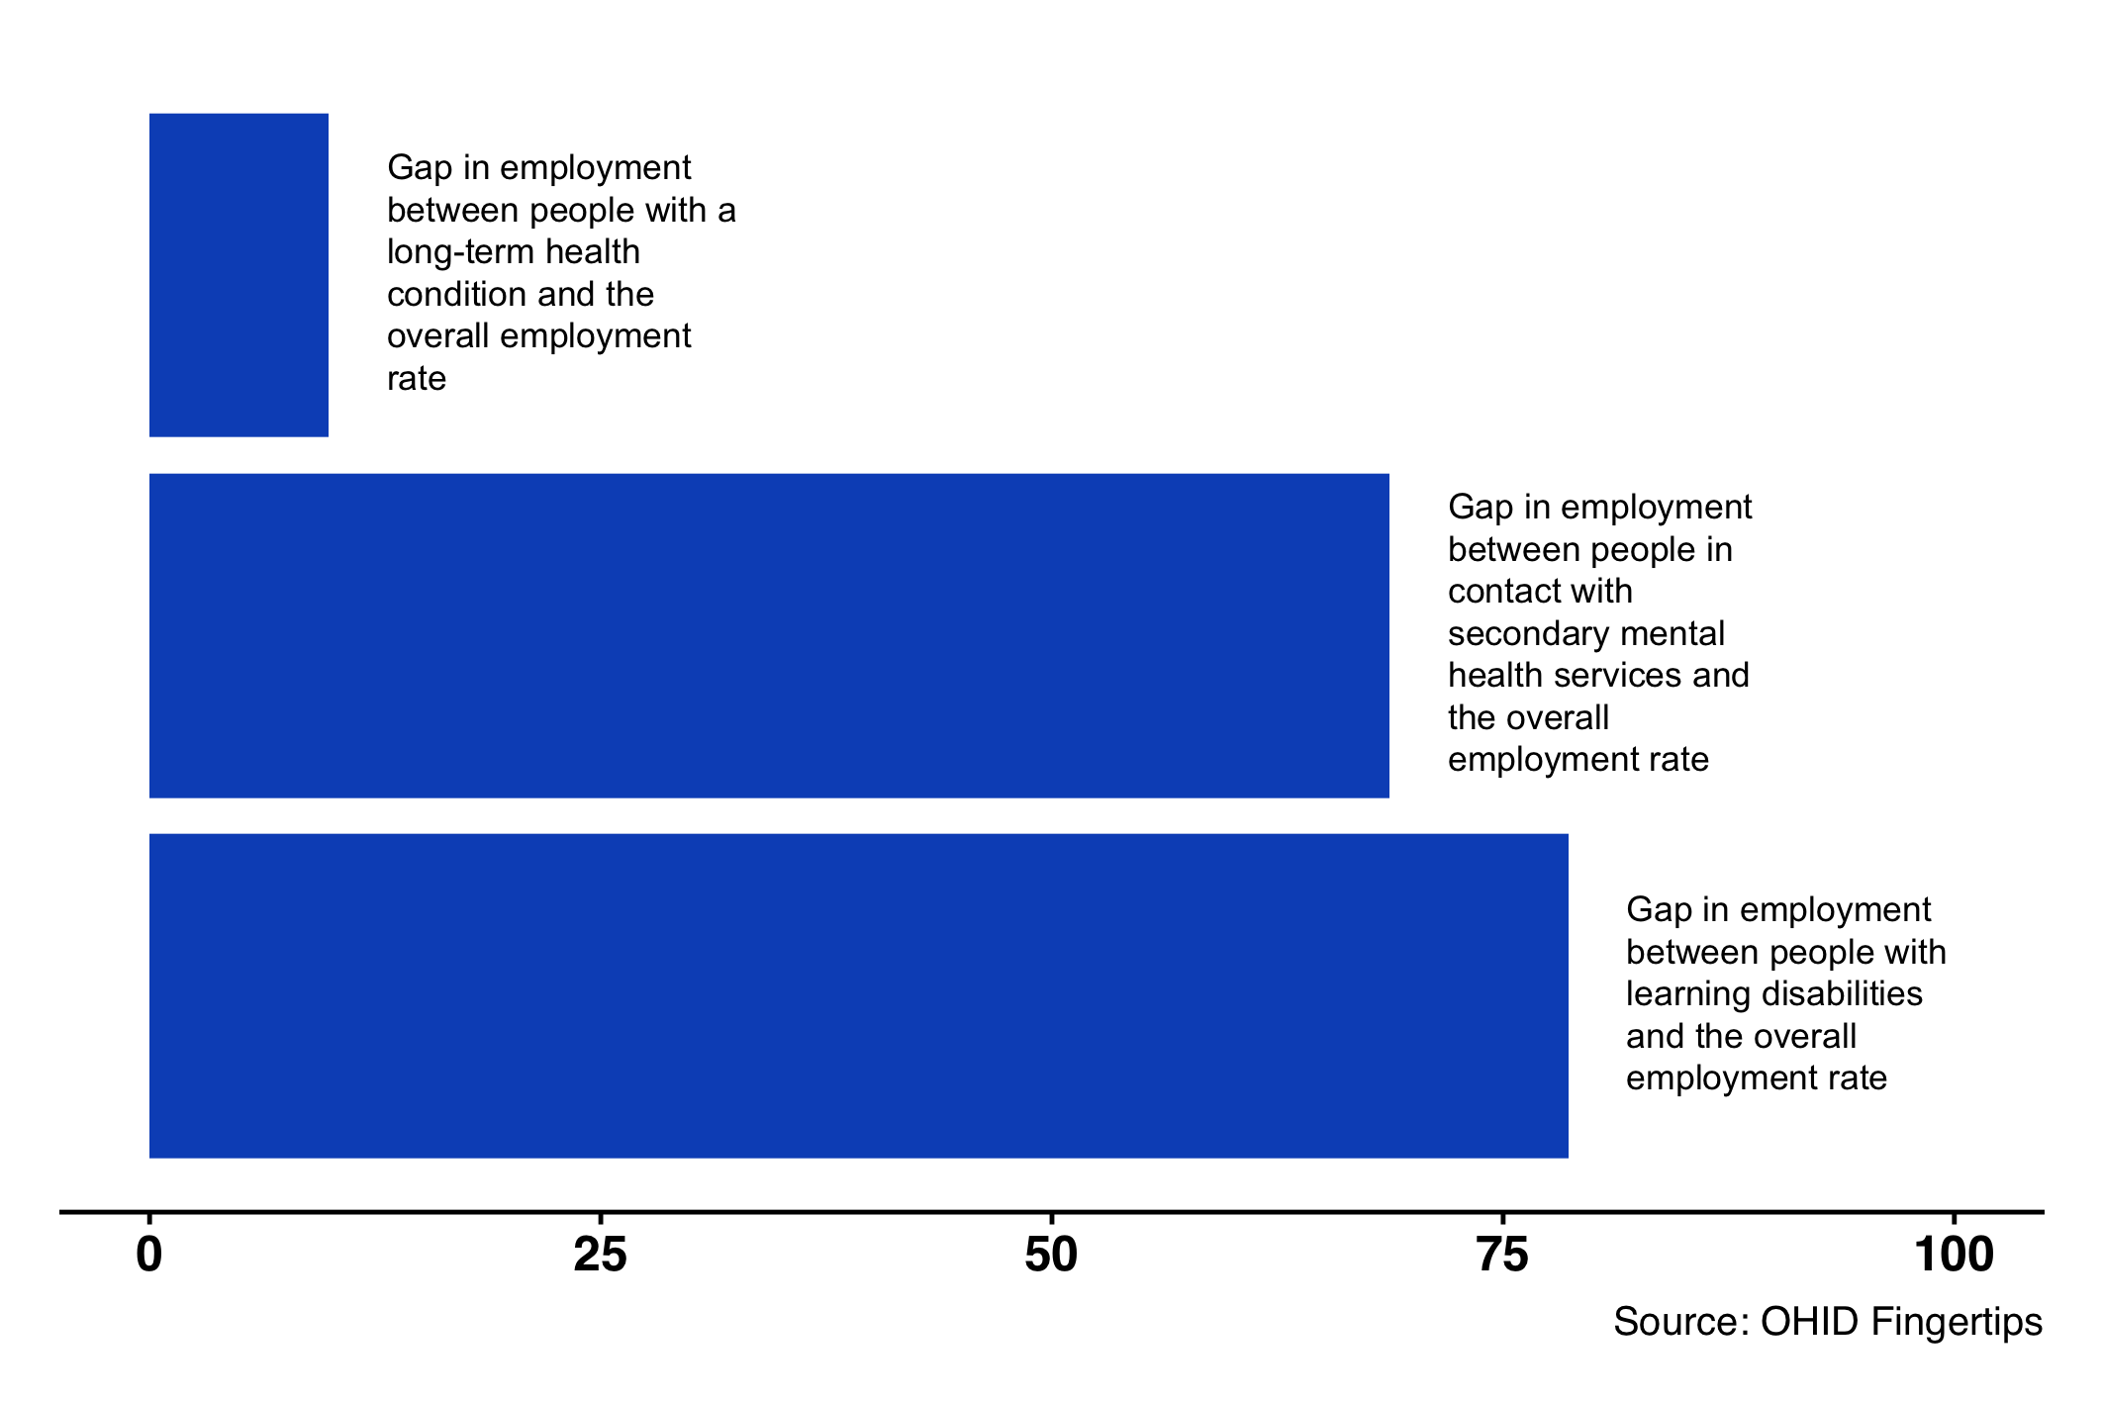

Gaps in employment rate for people with long term health conditions, people in contact with secondary mental health services, and people with learning disabilities. West Sussex, 2019/20.

#### Employment Deprived

As part of the Index of Deprivation 2019, the employment domain provides information on the proportion of the working age population in an area that are involuntarily excluded from the labour market. These are people who would like to work but are unable to, including those unemployed, ill, disabled or who have caring responsibilities.

The proportion of working age population in West Sussex local authorities that are involuntarily excluded from the labour market. The England rate is 9.9%.

|  | Number | Percentage |
| --- | --- | --- |
| Adur | 3,100 | 8.9 |
| Arun | 7,000 | 9.0 |
| Chichester | 3,900 | 6.4 |
| Crawley | 5,200 | 7.7 |
| Horsham | 3,800 | 5.1 |
| Mid Sussex | 3,700 | 4.6 |
| Worthing | 5,400 | 9.0 |
| West Sussex | 32,100 | 7.0 |

### Health and Social Care Workforce - Primary Care

#### Primary Care Staffing

By West Sussex Clinical Commissioning Group (CCG). Data are estimated provided as of March 2022 by NHS Digital.[57]

Primary Care Staffing in NHS West Sussex CCG, March 2022.

| Staff Role | FTE | Headcount |
| --- | --- | --- |
| All GPs | 474 | 647 |
| Fully qualified GPs (excludes Registrars) | 575 | 404 |
| Qualified permanent GPs (excludes Registrars and Locums) | 567 | 400 |
| Nurses | 340 | 230 |
| Direct patient care staff | 350 | 233 |
| Admin / non-clinical staff | 1572 | 1090 |

## Health and Social Care Workforce - Social Care / Care Benefits

Data from Skills for Care[58]:

* Adult Social Care Workforce Data Set (ASC-WDS) (as at February 2022)
* Independent sector employees as at September 2021

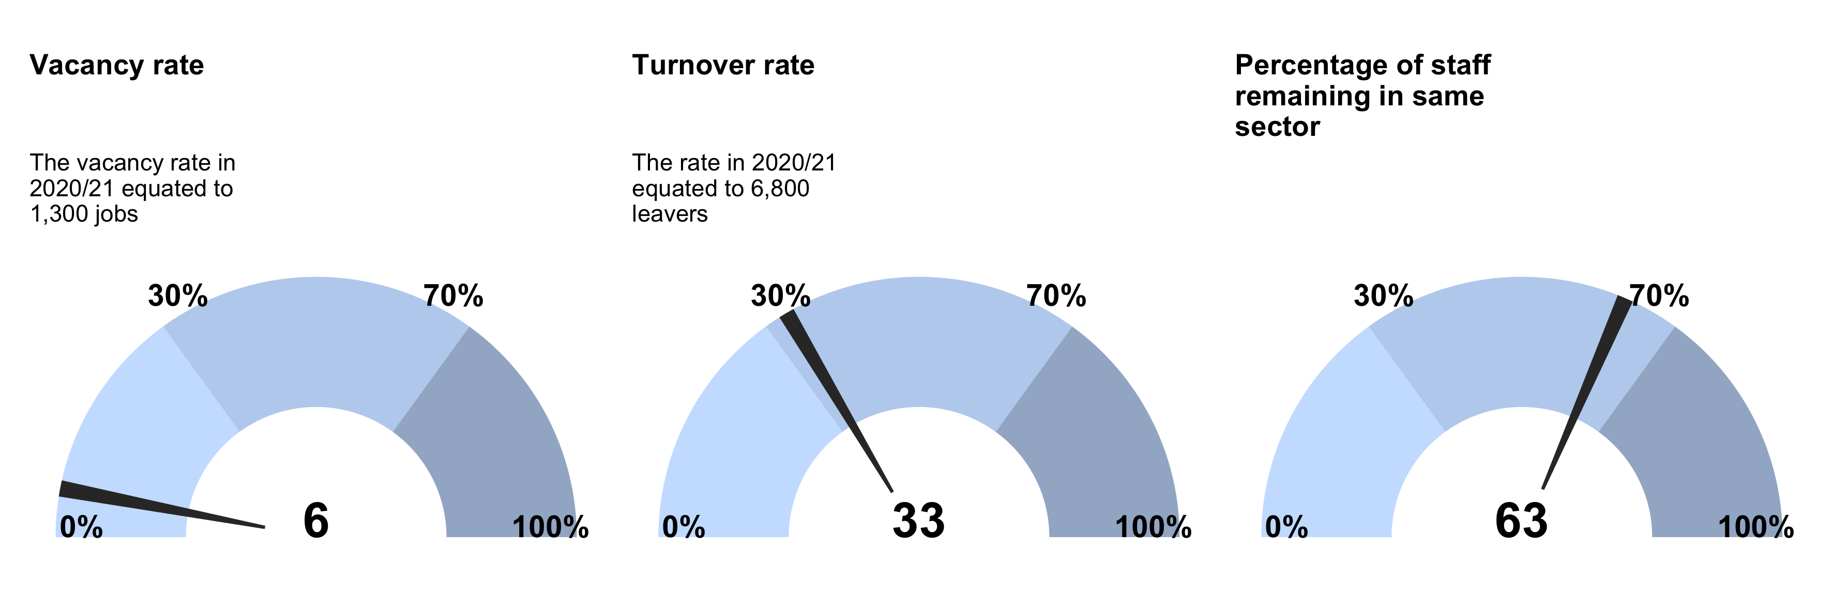

* Vacancy rate - The vacancy rate in 2020/21 equated to 1,300 jobs - 6%
* Turnover Rate - The rate in 2020/21 equated to 6,800 leavers - 33%
* Percentage of staff remaining in same sector - 66%

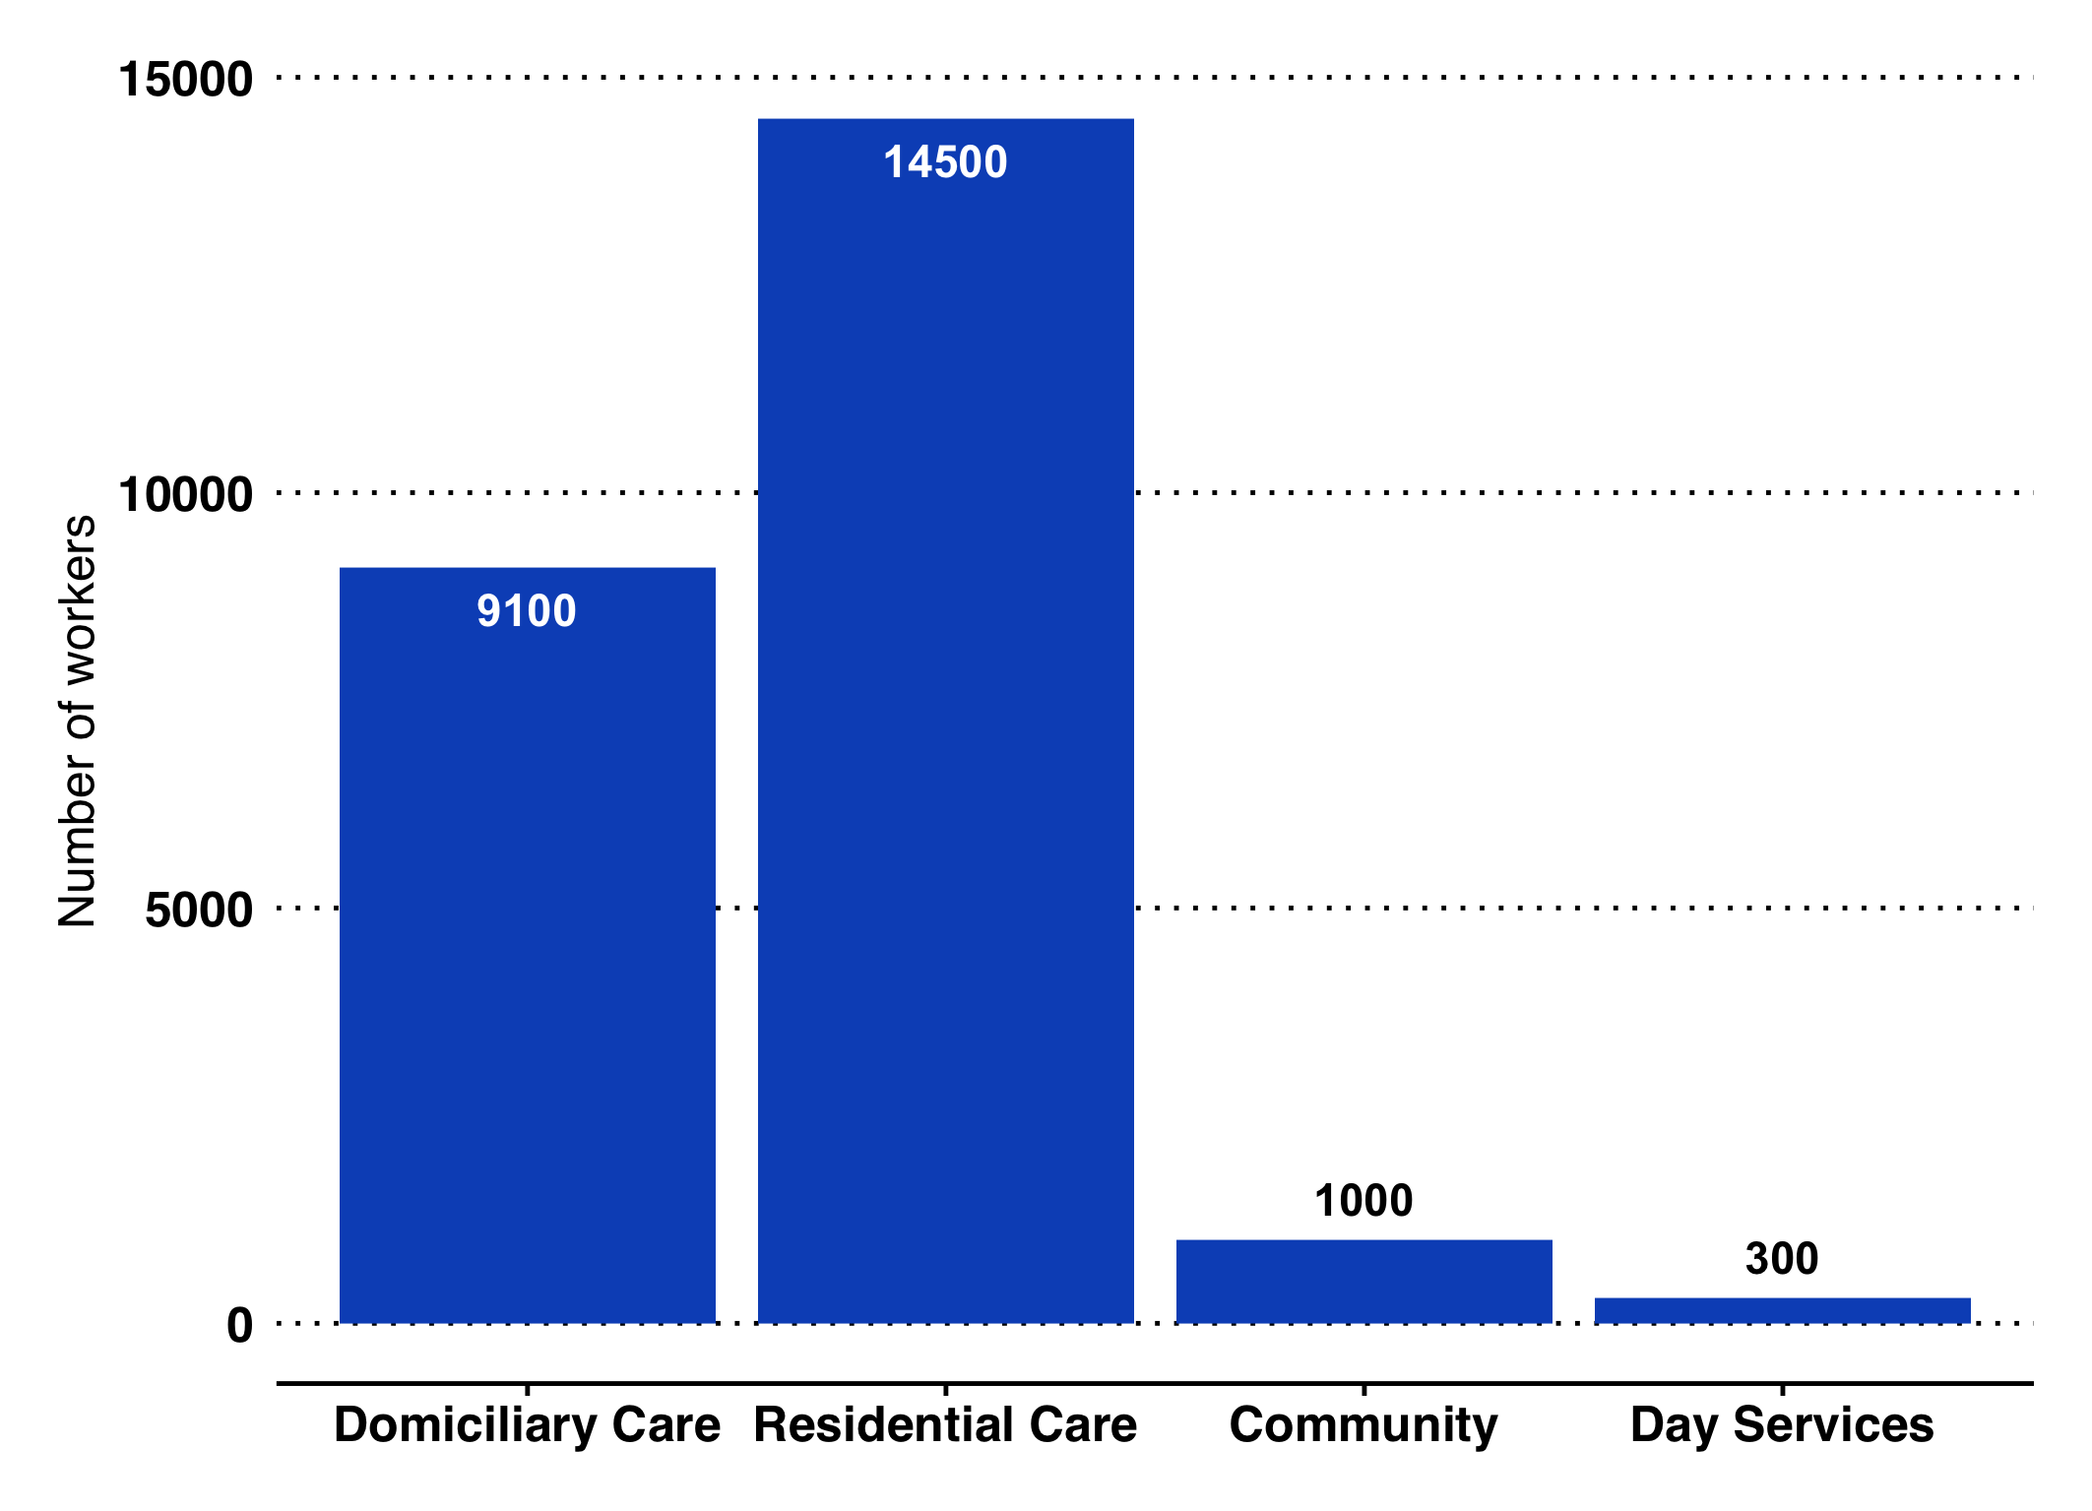

Estimated Number of Social Care Staff (all sectors)

* 27% of workers are over 55
* Average Age = 44
* 82% female
* 23% of workers on zero hours contracts
* On average 8.8 days of sickness per year

#### Attendance Allowance - November 2021 (Rounded to nearest 10)

Attendance Allowance (AA) is non-means tested contribution towards additional costs incurred by people who have a disability and are aged 65 years or over. To qualify, people need to require help with personal care for at least 6 months. Payments are made at two rates: the lower rate (for people who need frequent help or constant supervision during the day, or supervision at night) and the higher rate (for people who need help or supervision throughout both day and night, or who are terminally ill).

Attendance Allowance - November 2021

|  | Total (People) | On Lower Rate | On Higher Rate |
| --- | --- | --- | --- |
| Adur | 1,790 | 740 | 1,050 |
| Arun | 5,370 | 2,090 | 3,290 |
| Chichester | 3,310 | 1,220 | 2,100 |
| Crawley | 1,840 | 800 | 1,040 |
| Horsham | 3,200 | 1,310 | 1,890 |
| Mid Sussex | 2,920 | 1,250 | 1,680 |
| Worthing | 2,930 | 1,190 | 1,740 |
| West Sussex | 21,360 | 8,590 | 12,780 |

#### Carers Allowance - November 2021 (Rounded to nearest 10)

This is paid to people (aged 16 or over) who look after a severely disabled person for at least 35 hours a week and who are not employed (i.e. not earning more than £95 per week after certain deductions) and not in full-time education. The disabled person must be receiving specific benefits relating to their disability. The mean amount paid is £65.90 per week.

Carers Allowance - November 2021.

|  | Total |
| --- | --- |
| Adur | 1,120 |
| Arun | 2,720 |
| Chichester | 1,580 |
| Crawley | 1,820 |
| Horsham | 1,530 |
| Mid Sussex | 1,480 |
| Worthing | 1,710 |
| Total | 11,950 |

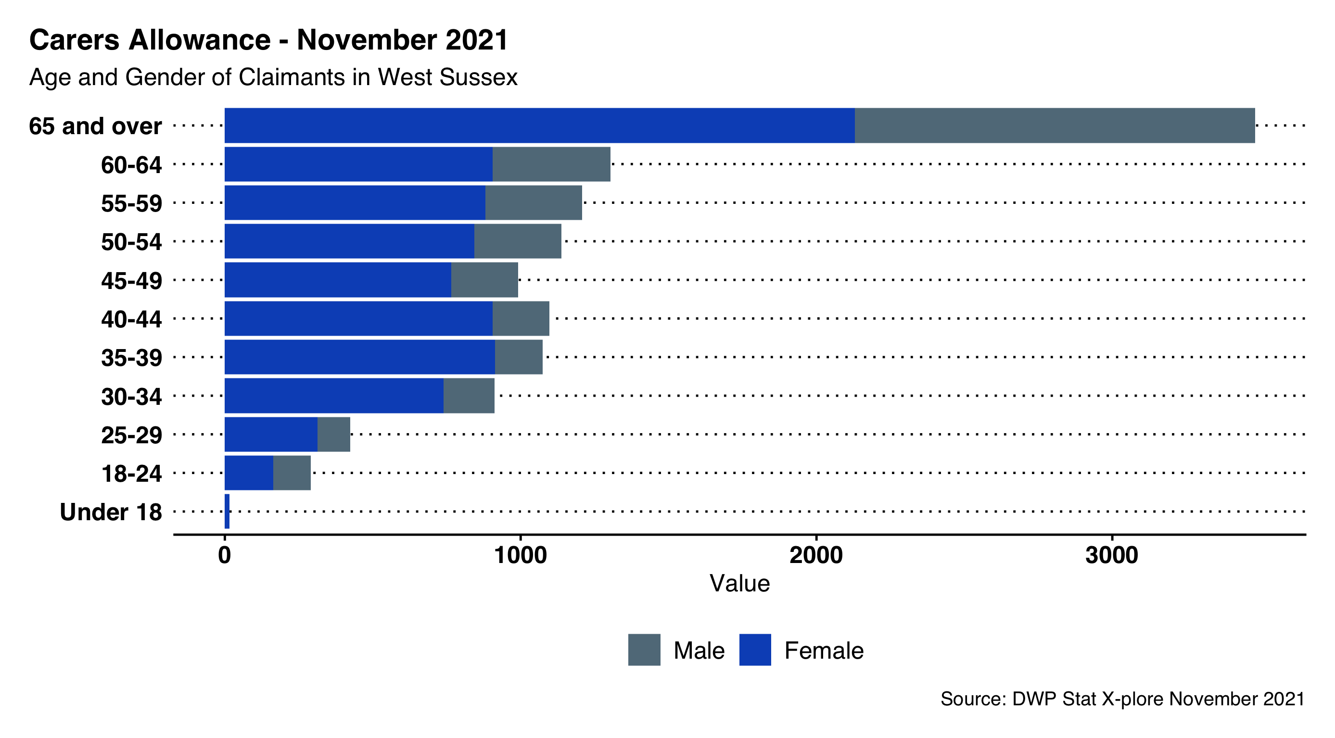

Carers Allowance - November 2021 Age and Gender of Claimants

## Unpaid Care

#### Unpaid Care

There are an estimated 90,405 unpaid carers of all ages in West Sussex, representing 10.4% of the total population (similar to the England proportion).

Women tend to take on more caring responsibilities than men, with an estimated 52,652 female carers compared to 37,704 male carers.

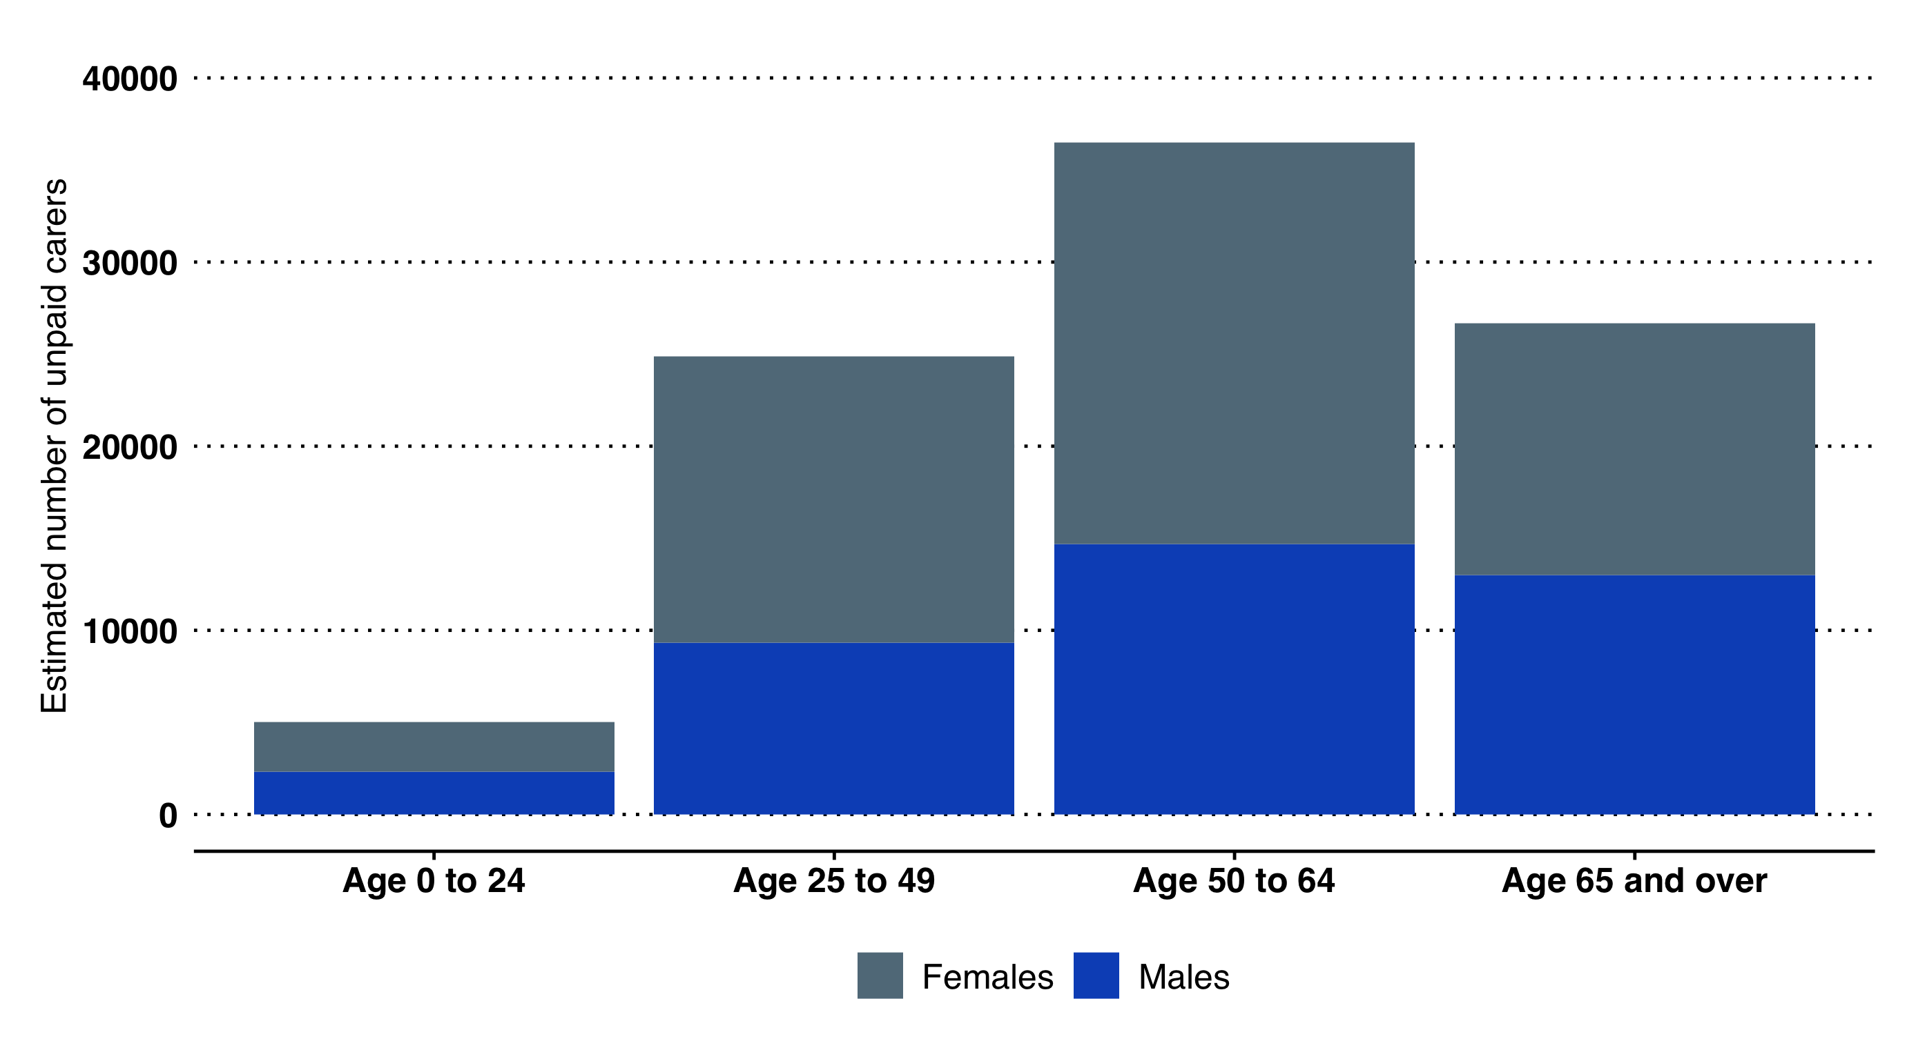

Estimated number of unpaid carers in West Sussex, by age and sex. 2011 Census estimates applied to 2020 mid-year population estimates.

Those of working age (ages 25-64) account for 68% of unpaid care, whilst over- 65s account for 29%.

Arun has the greatest number of unpaid carers of all ages, at 17,753, followed by Mid Sussex (15,144) and Mid-Sussex (15,042). Adur has the fewest number of unpaid carers, at 7,277.

#### 50 or more unpaid care hours per week

Of the total number of carers in West Sussex, approximately a fifth are estimated to do 50 or more hours of unpaid care a week (slightly below the England proportion). This burden of care again falls more heavily on female carers (over 11,000 female carers, compared to nearly 7,500 male carers, do >50 hours per week).

Over 65s make up the majority of carers doing >50 hours per week; 37.5% of female carers and 51.6% of male carers doing >50 hours are in this age-group.

Adur has the greatest proportion of unpaid carers doing >50 hours per week, followed by Arun.

#### How do we estimate the numbers of unpaid carers?

The Carers Trust defines a carer as anyone who cares, unpaid, for a friend or family member who due to illness, disability, mental health problems or an addiction cannot cope without their support. The current number of unpaid carers in West Sussex can be estimated by applying the percentage of unpaid carers in the population, as recorded in the most recent census (2011), to the latest population estimates (2020).

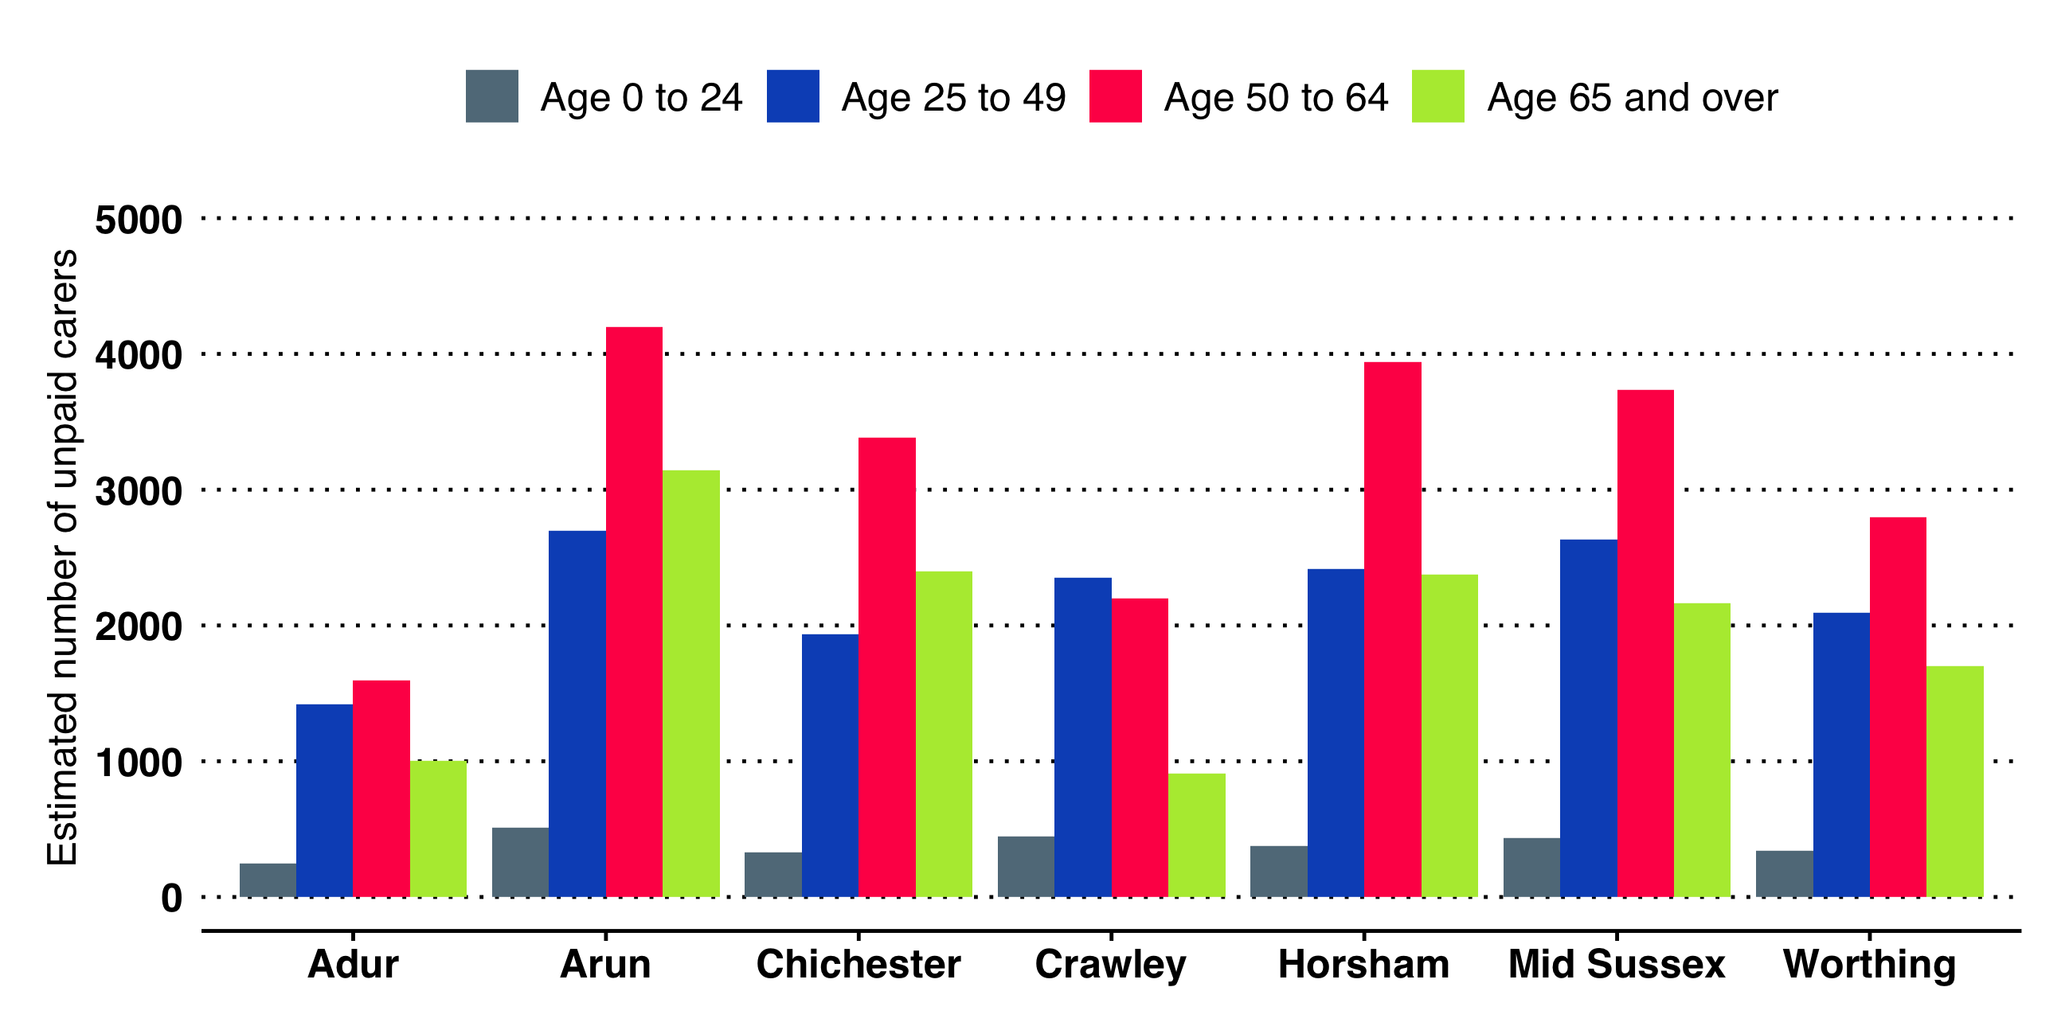

Female carers by West Sussex Local Authorities.

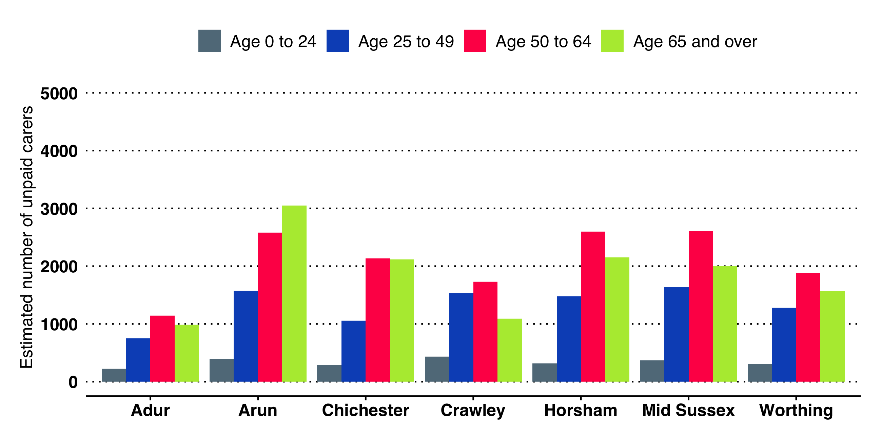

Male carers by West Sussex Local Authorities.

## Health Related Behaviours

#### Lifestyle risk factors: smoking; diet; physical activity; and alcohol and other substance misuse.

West Sussex is relatively healthy with lower levels of "riskier behaviour". However this masks considerable differences between areas, and between groups within the county.

We know that there is a clustering of behaviours; people who smoke are more likely to drink above recommended levels and have lower physical activity rates and so on. This means that there is polarisation taking place, with people who take on key health messages and take steps to lead healthier lives and those who do not. This acts to reinforce and increase existing inequalities.

#### Smoking

The following data have been taken from the PHE Local Tobacco Control Profiles. These profiles bring together the range of measures which examine the effects and wider impact of smoking, including prevalence rates, smoking quits and attributable mortality. <https://fingertips.phe.org.uk/profile/tobacco-control>

Smoking the remains biggest cause of premature deaths in West Sussex and smoking attributable mortality. There were 3,049 deaths attributed to smoking over the 3 year period between 2017 and 2019.

The overall adult smoking rate in the county has continued to fall. In 2020 the rate was estimated at 11.2% (CI 8.5% to 13.9%)[59] - meaning almost 80,000 people in the county still smoke.

**Declines in the smoking rates of people from routine and manual occupations have been smaller.** The most recent survey (2020) estimated the odds of current smoking in West Sussex among routine and manual workers aged 18-64 at 2.0 (CI: 1.2 to 3.4), meaning that prevalence among routine and manual workers could be between 13.4% and 38.1%.

In 2020, around a third of people in West Sussex aged 18+ reported being ex-smokers, while 56.4% reported never having smoked.

#### Physical Activity and Obesity

* An estimated 70.2% of adults were classed as physically active[60]. This is higher than England and the average of statistical neighbours. (2020/21 survey data).
* 20% of adults were physically inactive[61].
* The proportion of the adult population meeting the recommended ’5-a-day’ portions of fruit and vegetables on a ’usual day’[62] in West Sussex was 60.6%. This is higher than the England rate. Within West Sussex, the majority of districts and boroughs had a rate significantly higher than England, though Arun, Adur, and Crawley are similar to England.
* 63.8% of adults were overweight or obese[63] in West Sussex, similar to comparable authorities and England. In Adur, rates were higher than England whilst the other districts and boroughs were similar to England.

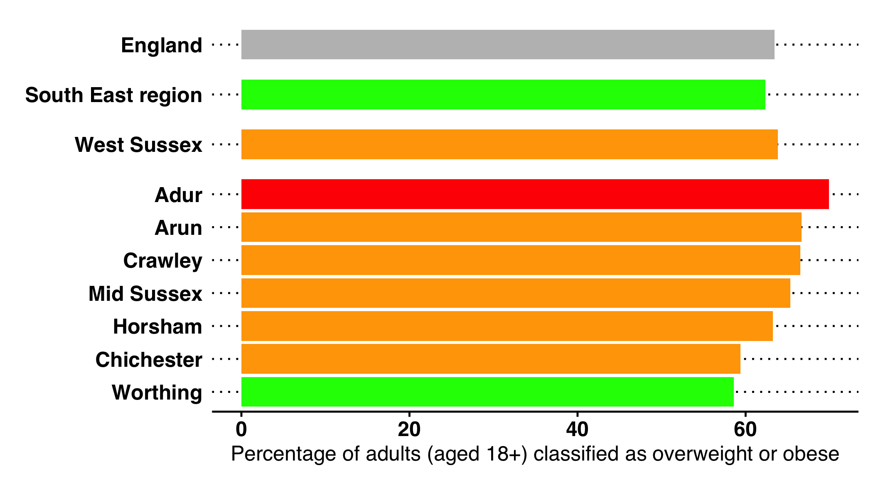

Percentage of overweight or obese adults - West Sussex Local Authorities, 2020/21

## Substance Misuse

### Tobacco

#### West Sussex Tobacco Control Strategy 2019-2022

Smoking remains the single biggest preventable cause of death and ill health in England. Any differences in smoking prevalence across the population inevitably translate into health inequalities.

The Smokefree West Sussex Partnership is a group of organisations across West Sussex working in partnership to provide strategic direction and leadership on the tobacco control agenda in West Sussex. The West Sussex Tobacco Control Strategy 2019-2022 contributes to realising the Public Health vision for West Sussex and meeting the national objectives through the co-ordinated effort of a wide range of partners. The strategy builds on national plans which establish tobacco control as a comprehensive and coordinated effort to reduce demand, prevent uptake, and support cessation rather than a sole focus on the delivery of smoking cessation services.

The details of the full strategy document and action plan can be found on the JSNA website. An additional website (<https://sfws-action-plan.netlify.com/>) provides an interactive version of the strategy to support partners in understanding what actions can be taken, and by who in the short-, medium- and longer- term.

### Substance Misuse - Alcohol and Drugs

Prevalence Estimates Alcohol-related harm is affected by the amount of alcohol that is consumed and how it is consumed (frequency and intensity of use). Describing patterns of use is therefore complicated. This diagram[64] sets out the various terms and estimates (at a national level).

* **Abstainers**
* **Lower Risk Drinking** - drinking less than 14 units per week
* **Increasing Risk Drinking** - drinking 14 to 50 units a week
* **Higher Risk Drinking** 50+ units for men a week / 35+ units for women a week
* **Binge drinking** - drinking of 8+ units (men) / 6+ units (women) on heaviest drinking day in previous week
* **Dependent Drinkers** - this is derived from data collected as part of the Adult Psychiatric Morbidity Survey (APMS), a national survey of 16+ year-olds. Alcohol dependency is assessed by the Alcohol Use Disorders Identification Test (AUDIT) and the Severity of Alcohol Dependence Questionnaire (SADQ).

At **West Sussex level** using data from the Health Survey for England (2011 to 2014):

* 9.6% of the 18+ population are estimated to be **abstainers** - equivalent to 66,600 people in West Sussex (2020 population estimates).
* 14.5% of the 18+ population are estimated to be **binge drinkers** - equivalent to 100,700 people in West Sussex.
* 23.7% of the 18+ population are estimated to be **drinking 14+ units a week** - equivalent to 168,900 people in West Sussex.

Using the APMS, it is estimated that there are 5,500 to 9,300 people in West Sussex with a dependency on alcohol and potentially in need of specialist treatment.

### Treatment Outcomes / Impact

Some of the following data have been taken from the PHE Local Alcohol Profiles for England. These profiles bring together the range of measures which examine the effects and wider impact of alcohol, including alcohol related admissions to hospital, attributable mortality and road accidents.[65]

PHE also publish annual estimates of the prevalence of opiate use and/or crack cocaine use. However, data at county level and for specific age groups have not been updated since March 2019. The values presented here are taken from OHID Fingertips.

#### Alcohol-Related Hospital Admissions

Each rate is for all ages, directly age standardised and measured per 100,000 population. West Sussex compares favourably with England for each rate and is lower than most statistical neighbours. Note that only the specific definition has been updated since 2019.

* There were 583 admissions for alcohol-related conditions (Narrow)[66] per 100,000 (England 664 per 100,000). The number of such admissions in West Sussex was 5,116.
* There were 1,887 admissions for alcohol-related conditions (Broad) per 100,000 (England 2,367 per 100,000). The number of such admissions in West Sussex was 17,301.
* There were **480 admissions for alcohol-related conditions (Specific) per 100,000** (England 587 per 100,000). The number of such admissions in West Sussex was 4,230.

#### Other alcohol-related impacts

Between 2014 and 2016 there were 206 alcohol-related road traffic accidents in which at least one driver failed a breath test. This represents a rate of 33.8 per 1,000 accidents and is higher than the England rate (26.4) but in line with other comparable local authorities.

#### Mortality from chronic liver disease

Mortality from chronic liver disease[67], which is strongly associated with alcohol consumption and obesity, has risen in West Sussex. Recent mortality rates for men and women were significantly lower than the England rate, but this is no longer the case. Using a three year range, the rate is now similar to that of England. Nationally there is evidence that deaths from liver disease are occurring at younger ages.

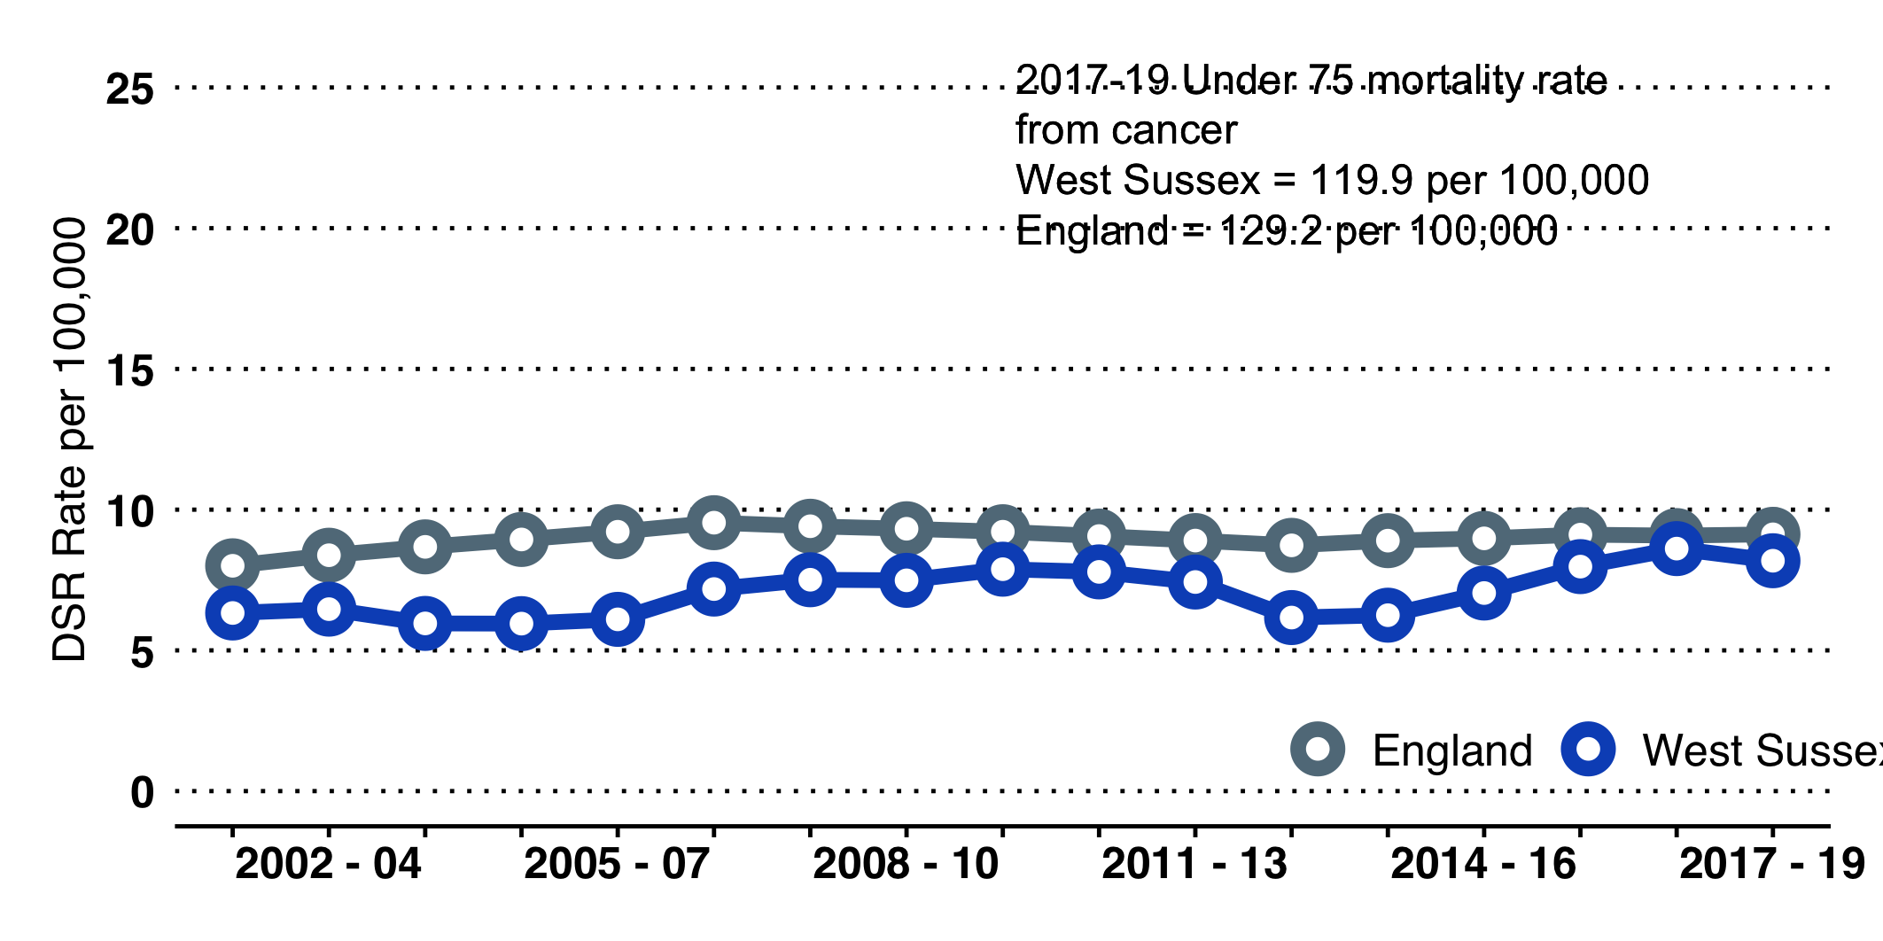

#### Drug misuse

It is estimated that between 1,400 and 4,100 people (aged 16-64 years) use opiates and/or crack in West Sussex, 70% of which are 35 years or older. In 2018-2020, there were 78 deaths in West Sussex classified as drug misuse deaths[68]. Although the rate of drug related deaths in West Sussex remains lower than the England rate (3.2 per 100,000 compared to 5.0 nationally) a recent upward trend has begun to stabilise.

#### Treatment Outcomes

There have been improvements in recent years in the successful completion rates of treatment in West Sussex. Note there is a time lag on these measures and numbers are low - notably for opiate drug users.

* 32.9% of **alcohol users** that left treatment successfully[69] in 2020 did not re-present to treatment within 6 months (England rate 35.3%). This is similar to other comparable local authorities (33.7%).
* 31.4% of **non-opiate drug users** who left treatment successfully[70] did not re-present to treatment within 6 months (England rate 33.0%). This has improved in recent years, with the rate similar to England and comparable local authorities (34.5%).
* 5% of opiate drug users who left treatment successfully[71] did not re-present to treatment within 6 months (England rate 4.6%). This is similar to the England rate but less than the average of comparable local authorities (5.7%, CI: 5.4%-6.1%).

#### People NOT in Receipt of Treatment (2018/19)

Using prevalence estimates and data from treatment services (from the National Drug Treatment Management System (NDTMS)), we can estimate the percentage of people with an alcohol dependency and users of opiates and/or crack cocaine (OCU) who are not in receipt of treatment.

* The estimated proportion of the West Sussex OCU users in 2018/19 who were **not in contact with drug treatment services for an OCU problem was 51%** (approximately 1,350 people).
* The estimated proportion of the West Sussex dependent drinkers in need of specialist alcohol treatment who were **not in contact with treatment services for alcohol only or alcohol and non-opiate use was 78.3%** (approximately 5,600 people).

#### Drug Use

The Royal Society for Public Health report ’Taking a New Line on Drugs’ (2016)[72] sets out the challenge of reducing drug-related harm.

It notes that:

* Many substances that cause harm are legal and socially embedded, including alcohol, tobacco and prescription drugs.
* Harm is multi-faceted, including harm to individuals, others and the wider society.
* The relationship between drugs and mental health is complex. People may use drugs for a psychological effect and use can result in feelings of anxiousness, depression etc.
* Some people are at a higher risk of drug use and harm than others. People with pre-existing mental health conditions, including anxiety and depression, are particularly at risk.
* Drug harm can affect all ages and communities, but it is known that harm disproportionately affects people from more deprived communities.

## Sexual Health

#### Key Points

In 2020, there were a total of 2,984 new STI diagnoses (all STIs), a rate of 344 per 100,000 population. This is a large decrease compared to 2019, which had the highest rate of new diagnoses in West Sussex in the previous 5 years, and below the national rate (562 per 100,000) along with comparable local authorities. While local services did provide an online service supplying self-testing kits, it is likely that the number of diagnoses is a result of Covid-19.

Number and rate of specific STI diagnoses in West Sussex, 2020.

| STI | Number of diagnoses | Rate (West Sussex) | Rate (England) |
| --- | --- | --- | --- |
| Chlamydia | 1336 | 154 | 286 |
| Genital warts | 455 | 52.4 | 48.6 |
| Genital herpes | 330 | 38 | 36 |
| Gonorrhoea | 351 | 40 | 101 |
| Syphilis | 84 | 9.7 | 12.2 |

Rates of new STI diagnoses for Chlamydia, Gonorrhea, Syphilis, Genital Herpes and Genital Warts are consistently below the England rate. However, the rates of the former three have been increasing over the past ten years, at a similar rate of increase to England. Compared to similar authorities, diagnosis rates for Gonorrhea, Herpes and Syphilis in West Sussex are amongst the highest.

The overall testing rate (excluding for Chlamydia in under 25s), a metric strongly associated with the level of diagnoses, was 3583.7 per 100,000 in 2020, remaining significantly lower than the England rate (4549.3 per 100,000) and 9th highest amongst CIPFA neighbours.

The proportion of late HIV diagnoses (i.e. where the CD4 cell count is less than 350 per )[73] has increased in recent years, to approximately 52% in 2018 - 2020. This is higher than England (42.4%) and equates to 50 late HIV diagnoses in West Sussex between 2018 - 2020.

In 2020, there were 148 conceptions in under-18 year-olds[74], a slight decrease on 2019. The rate of 11.1 per 1,000 15-17 year-olds is similar to England. 63% of teenage conceptions ended in abortion in West Sussex (England, 53%).

In 2020, the rate of abortions per 1,000 females aged 15-44 in West Sussex was 17.1, in line with comparable authorities and below the England rate (18.9/1,000), although higher than the previous 8 years. The percentage of abortions undertaken under 10 weeks in West Sussex is, at 88.7%, similar to England (88.1%) and 7th lowest amongst comparable authorities. Of the abortions to women aged under 25 years, 25.3% (212 abortions) were repeat abortions i.e. to women who had had previous abortions.

The use of long acting reversible contraception[75] in West Sussex is relatively high (51.6 per 1,000 female population aged 15-44 years in 2020) compared with similar authorities and England (34.6/1,000). All rates are considerably lower than 2019, highlighting the difficulty of accessing these services during the Covid-19 pandemic.

The hospital admission rate for Pelvic Inflammatory Disease (PID) in West Sussex has been high in recent years. Between 2016/17 and 2019/20, admissions rates were significantly higher than the England rate. In 2019/20 the rate in West Sussex the rate was 329.9 per 100,000 compared to 254.7 per 100,000 in England. Rates fell significantly in both West Sussex and England during 2020/21, with the rate for West Sussex 191.6 per 100,000 higher than that for England (186.2 per 100,000).

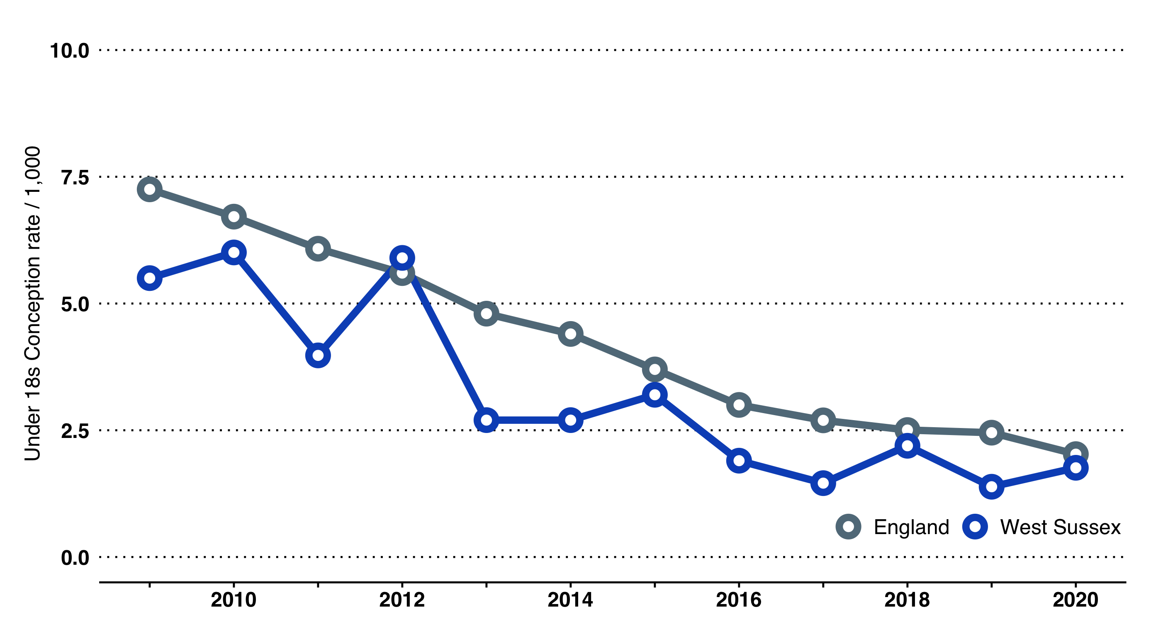

Teenage conceptions have steadily declined in the last 20 years, although two of the past three years have seen small increases.

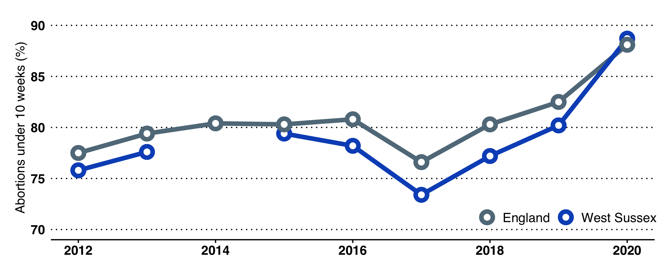

The percentage of abortions undertaken in under 10 weeks has declined in recent years; after a steep fall in 2017, the percentage has risen again, and is now similar to England.

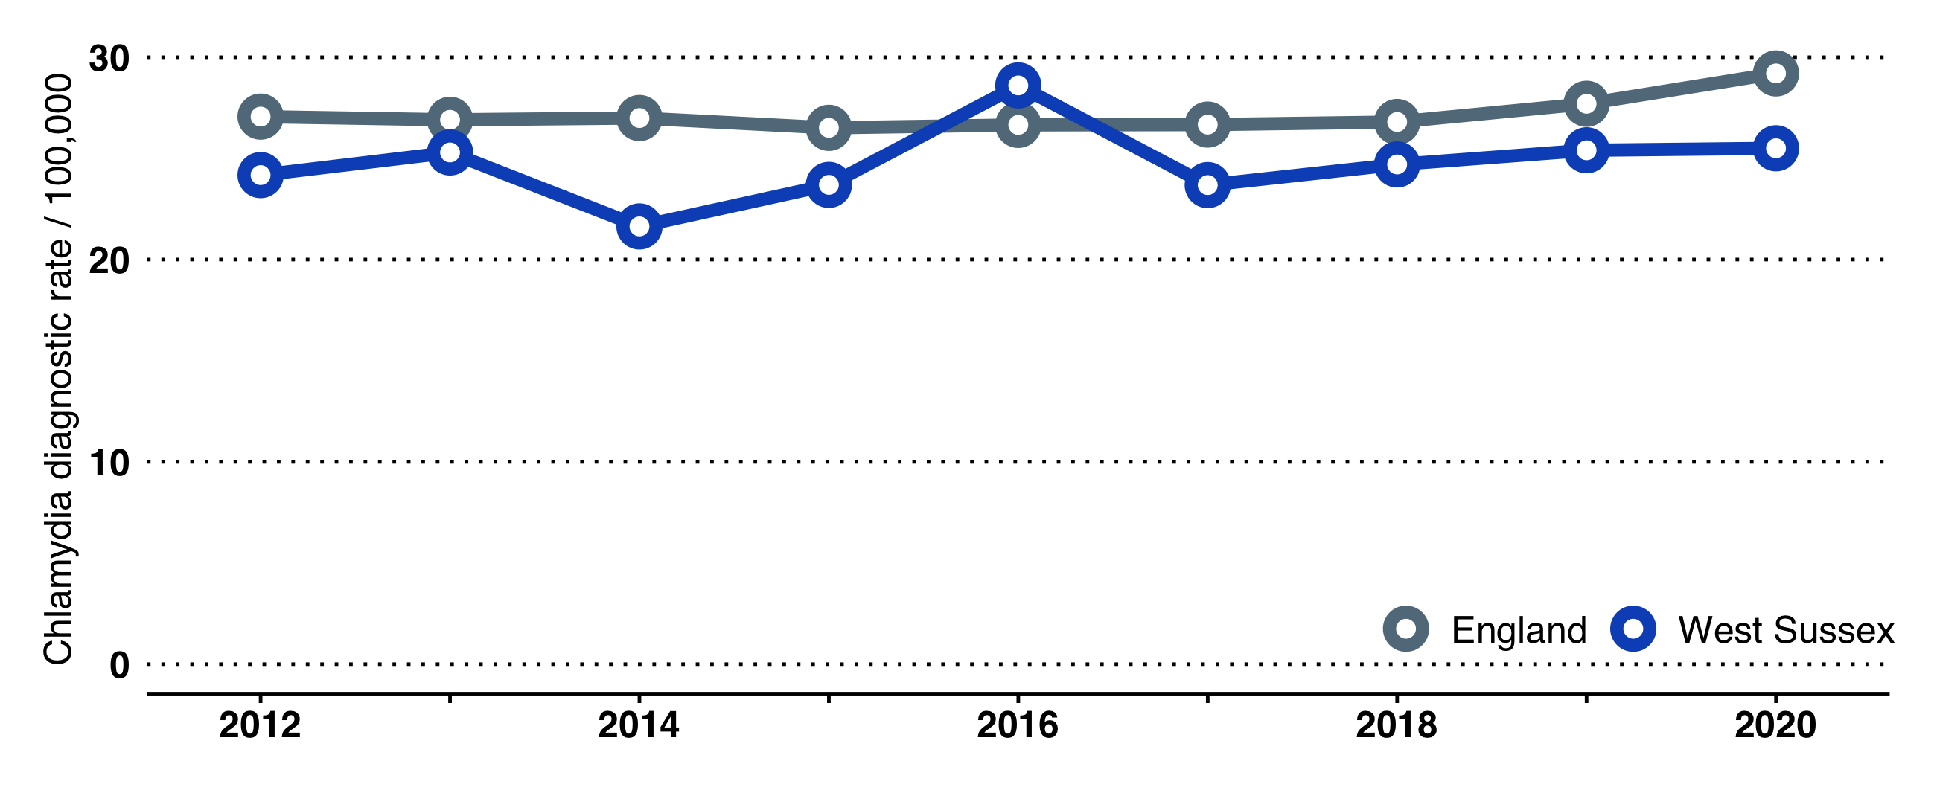

After peaking in 2016, the percentage of repeat abortions in under-25s has fallen to the average level of previous years (around 24%).

#### A focus on chlamydia

Chlamydia is the most common bacterial sexually transmitted infection in England and causes avoidable sexual and reproductive ill-health. Chlamydia rates are substantially higher in young adults (<25 years) than any other age group, although >25s are also at risk.

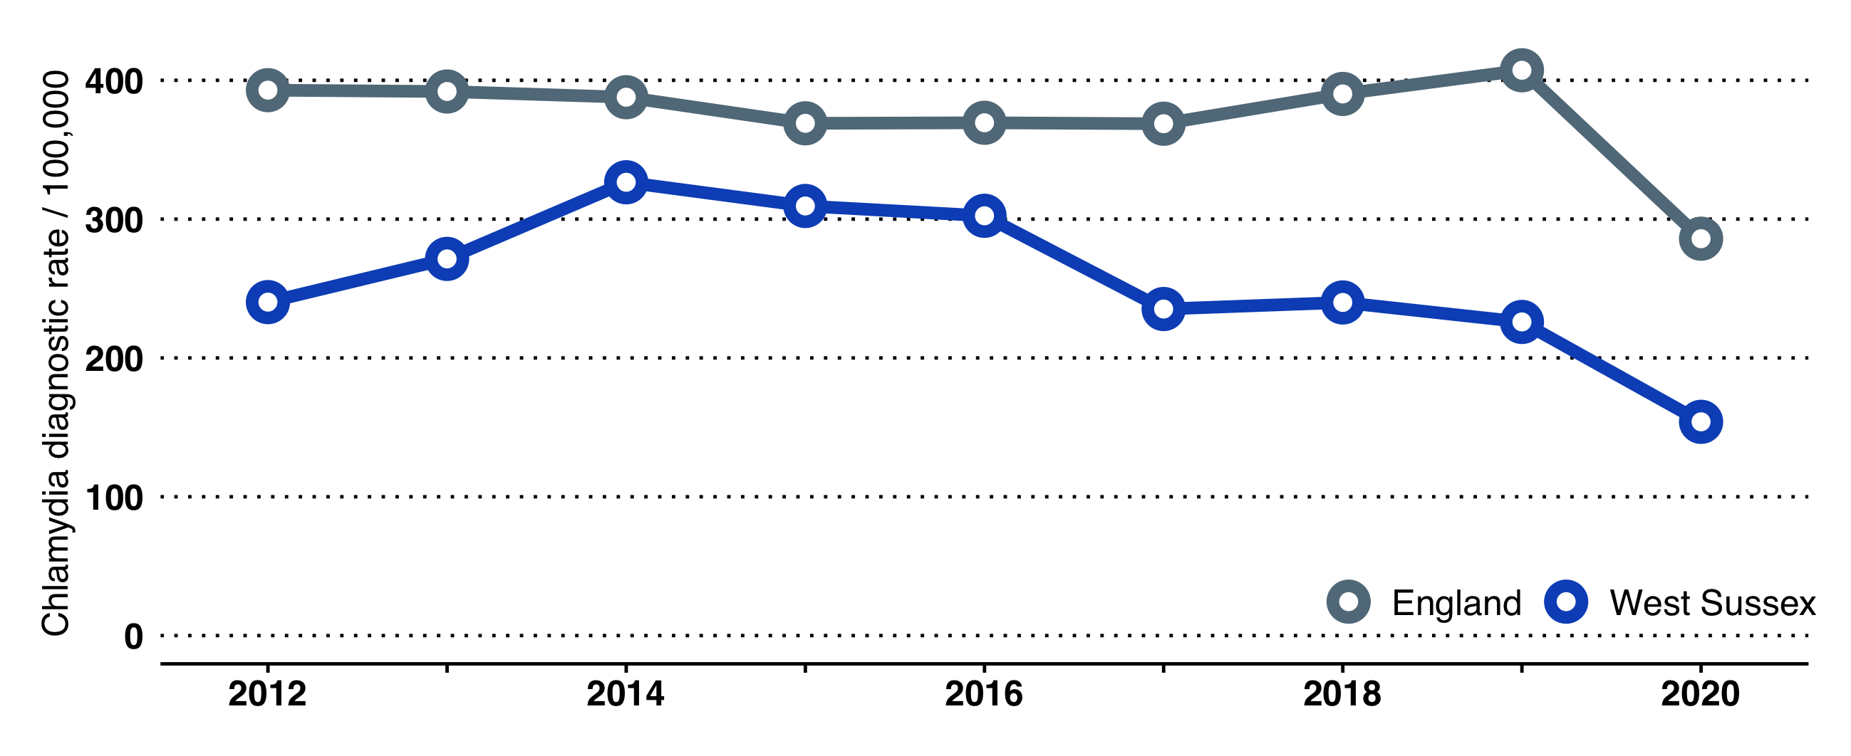

West Sussex Chlamydia diagnosis rate. Diagnosis rates have been been falling in West Sussex, even as rates rose in England prior to 2020.

#### Screening in 15-24 year-olds

Chlamydia screening in 15-24 year-olds allows diagnosis and prompt treatment of symptomatic chlamydia infections. In addition to reducing the time in which the infection can be passed on and thus the spread of chlamydia, screening reduces the chances of an infected individual developing complications.

Screening has declined in West Sussex since 2014 and remains significantly below England in most districts and boroughs, save for Crawley which at 33.3% of the 15-24 year-old population is signifcantly above the England average (14.3%) and the highest proportion screened in the South East.

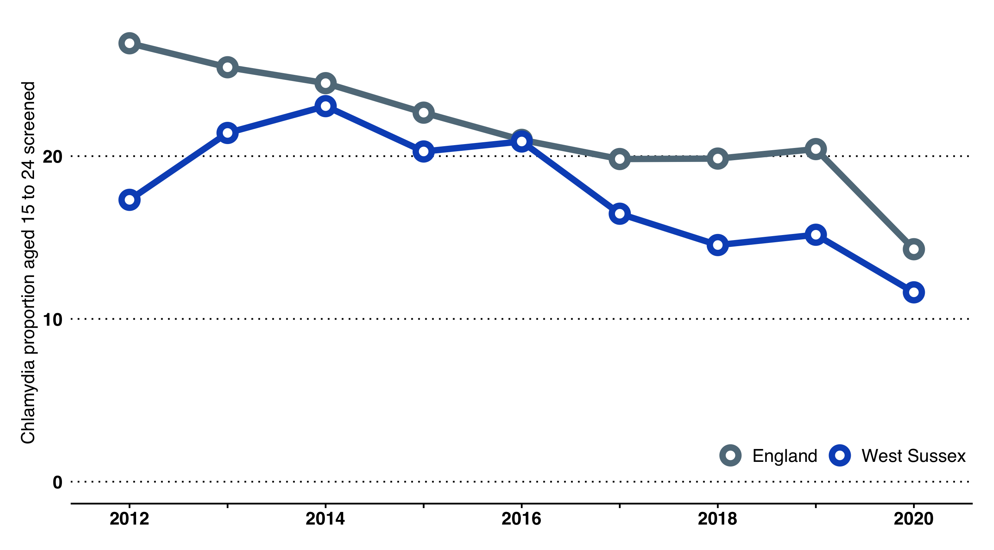

Annual percentage of 15-24 year olds screened for Chlamydia, West Sussex 2012 to 2020.

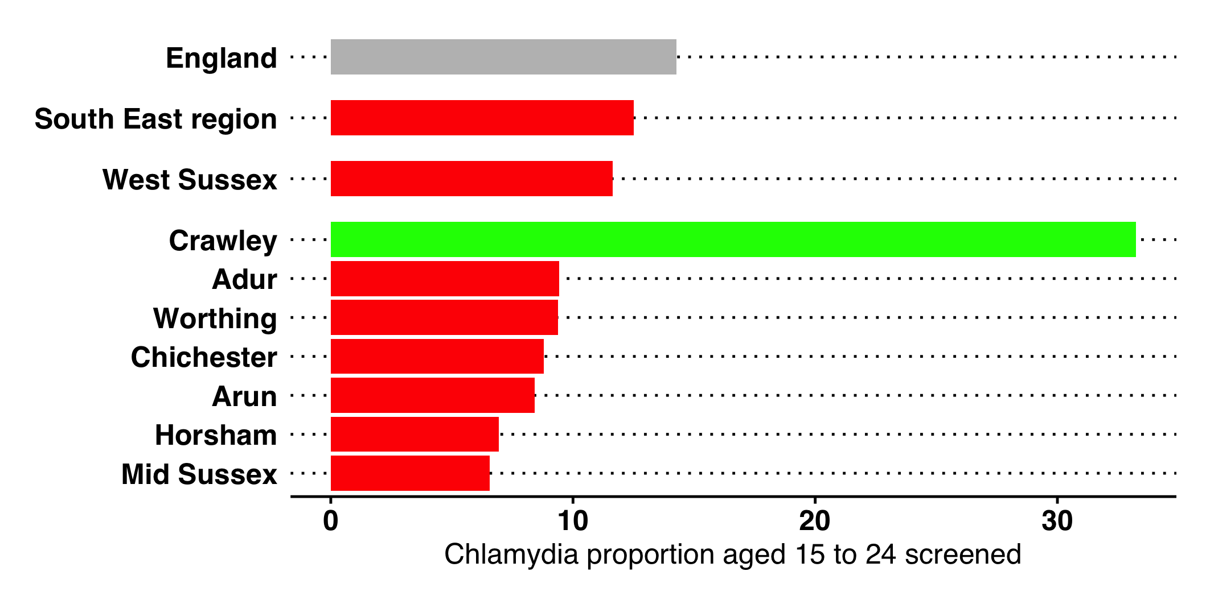

Percentage of 15-24 year olds screened for Chlamydia, West Sussex Local Authorities 2020.

## Screening

### Flu jabs - for at risk groups

Coverage of flu vaccinations for at-risk groups[76] was 56.7% in 2020/21. Coverage has been increasing year on year since 2015/16, remains above the England rate and is now above the $≥$ 55% benchmark.

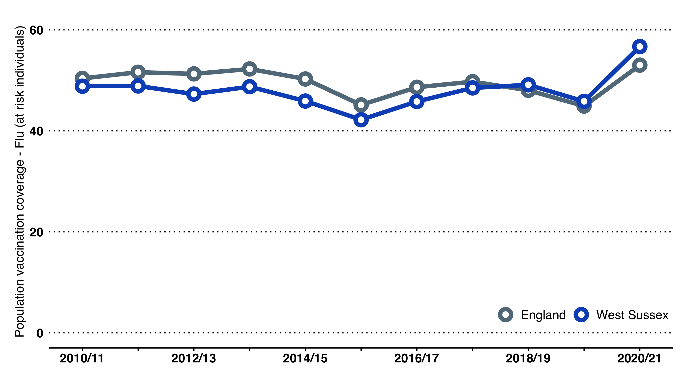

Flu vaccinations for frontline healthcare workers involved in direct patient care increased nationally from 2017/18 to 2018/19, although there is variation above and below the 75% target between the NHS Foundation Trusts serving the population of West Sussex.[77]

### NHS Health Checks

For NHS Health Checks, West Sussex continues to perform poorly compared with England on all outcome measures[78]:

* The cumulative percentage of the eligible population aged 40-74 offered an NHS Health Check in the five year period 2016/17 - 2020/21 was 60.4%.
* The cumulative percentage of the eligible population aged 40-74 offered an NHS Health Check who received an NHS Health Check in the five year period 2016/17 - 2020/21 was 35.2%, a decrease on the previous five year period.
* The cumulative percentage of the eligible population aged 40-74 who received an NHS Health Check in the five year period 2014/15 - 2018/19 was 21.3%.

### Non-Cancer Screening

#### Abdominal Aortic Aneurysm screening coverage

The screening coverage rate at county-level for abdominal aortic aneurysm (PHOF reference C25a) was 76.7% in 2020/21, compared to 55.0% in England overall. Coverage in all West Sussex local authorities is higher than the South East and England.

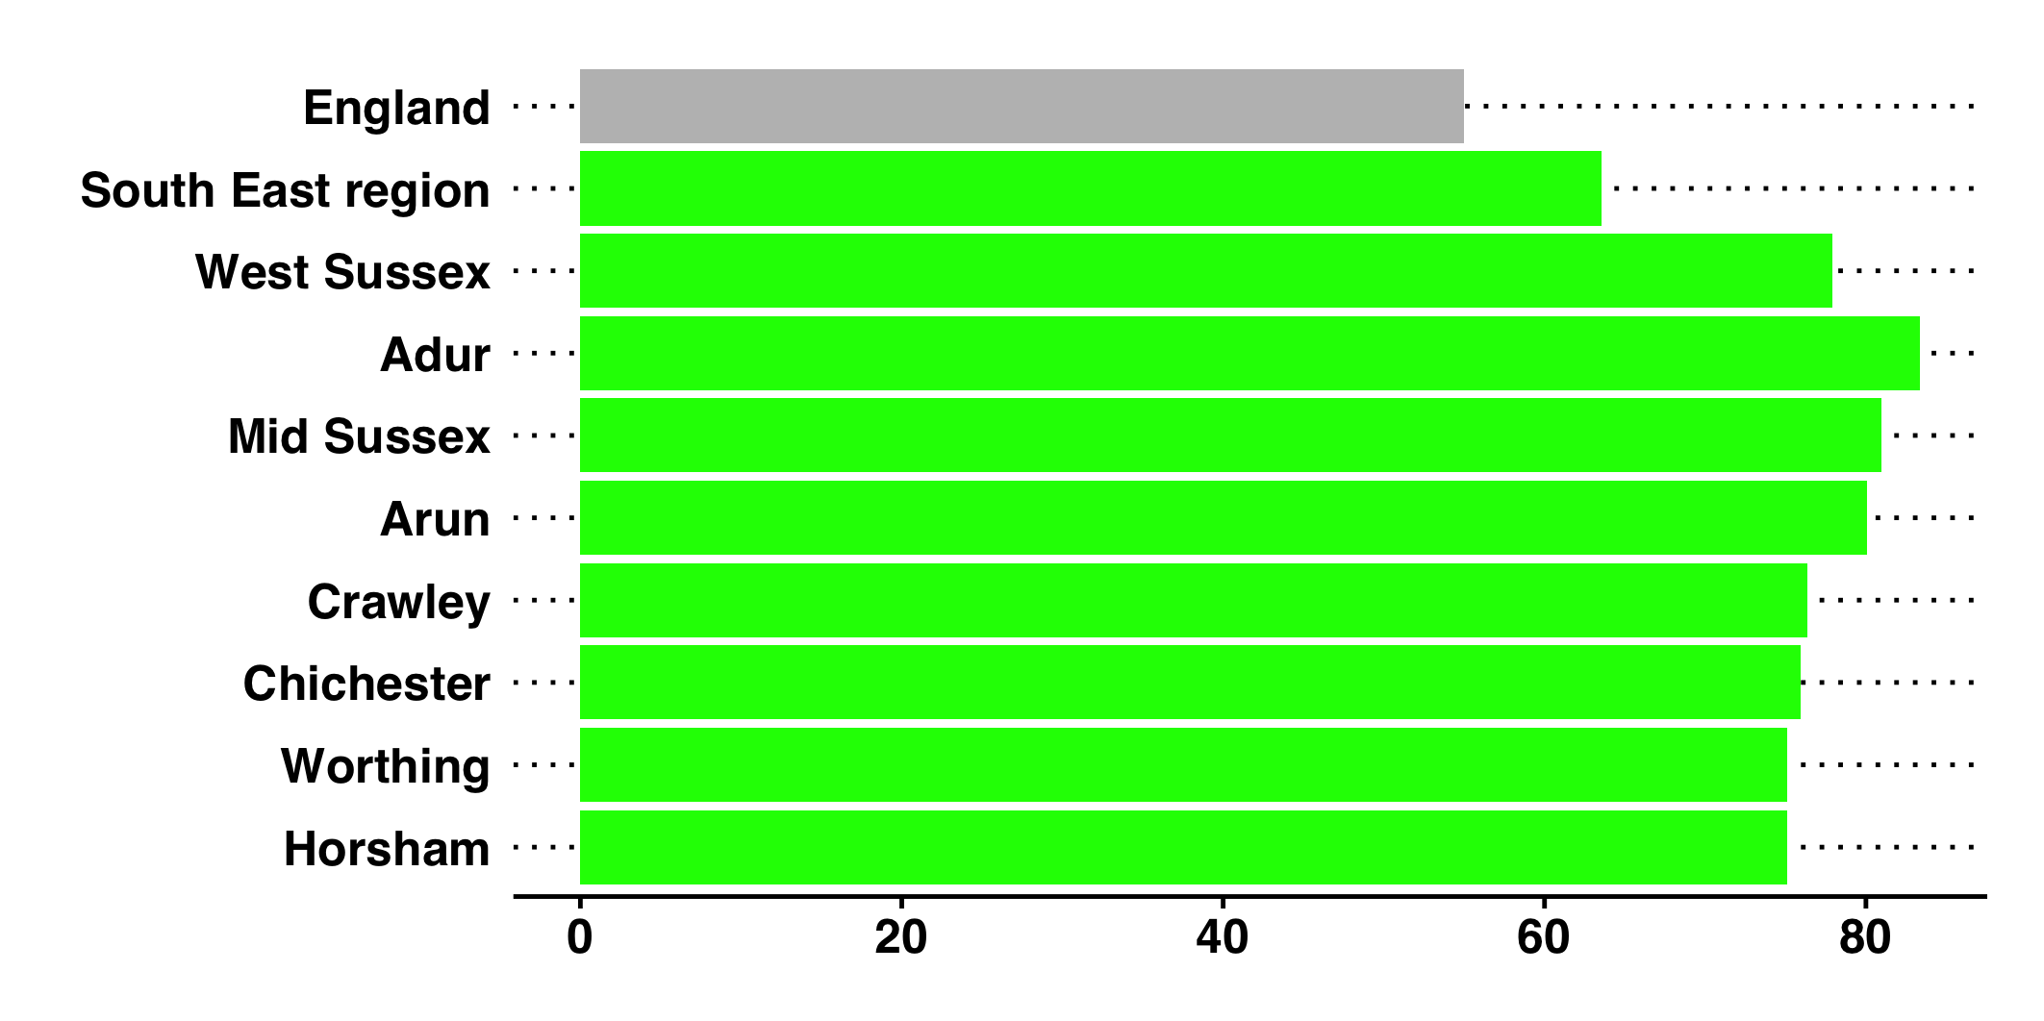

Abdominal Aortic Aneurysm screening coverage, West Sussex local authorities, 2020/21.

#### Diabetic Eye screening uptake

At the time of writing, only regional figures were available for the uptake of routine digital screening events for diabetic eye[79]. In the south east uptake was 79.2% in 2020/21, comparing favourably to the England rate.

However this figure is lower than past coverage in West Sussex (e.g. 87.5% uptake rate in 2018/19), indicating the disruptive effect of the pandemic on preventative screening efforts.

### Cancer Screening Programmes

At county-level, overall take-up rates of screening programmes are good, comparing favourably with England and in line with rates in statistical neighbours (Figure [fig:cancer-screening]). However, there is variation between the West Sussex local authorities, with notably low rates in Crawley. All relate to 2020/21[80].

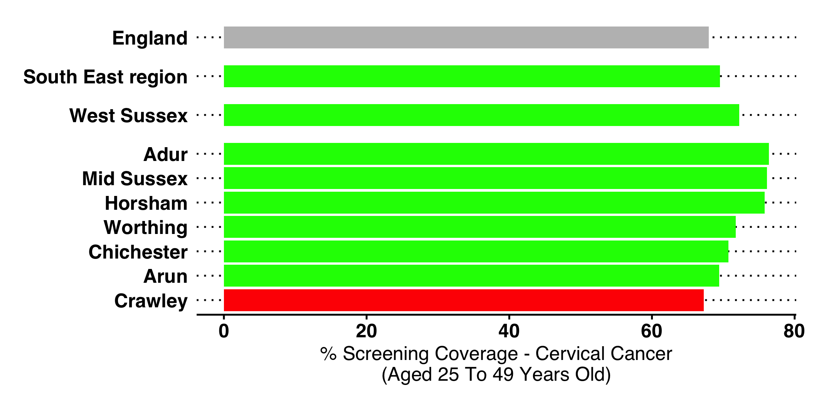

Cervical cancer screening coverage 2020/21 West Sussex Local Authorities

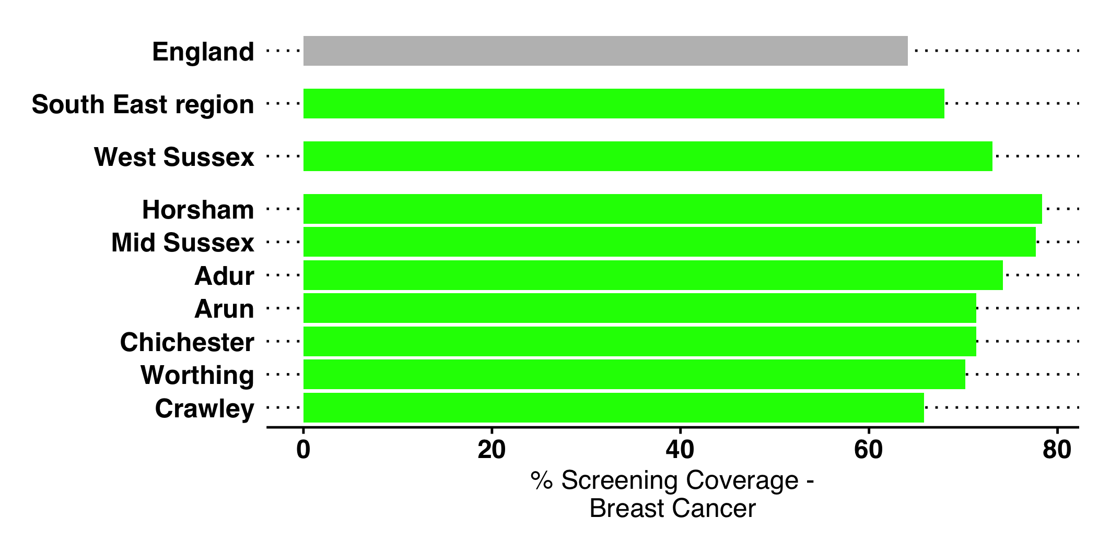

Breast cancer screening coverage 2020/21 West Sussex Local Authorities

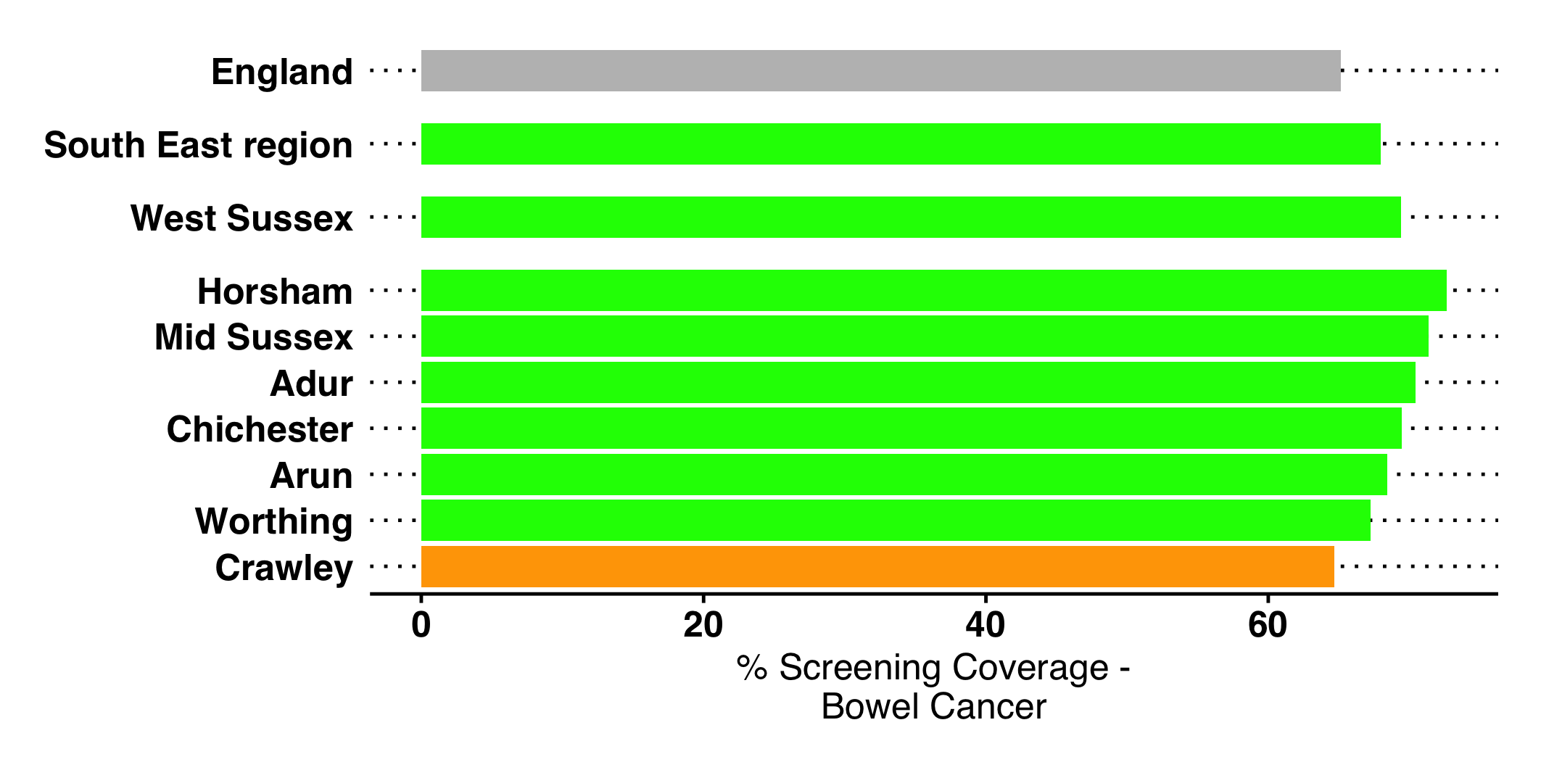

Bowel cancer screening coverage 2020/21 West Sussex Local Authorities

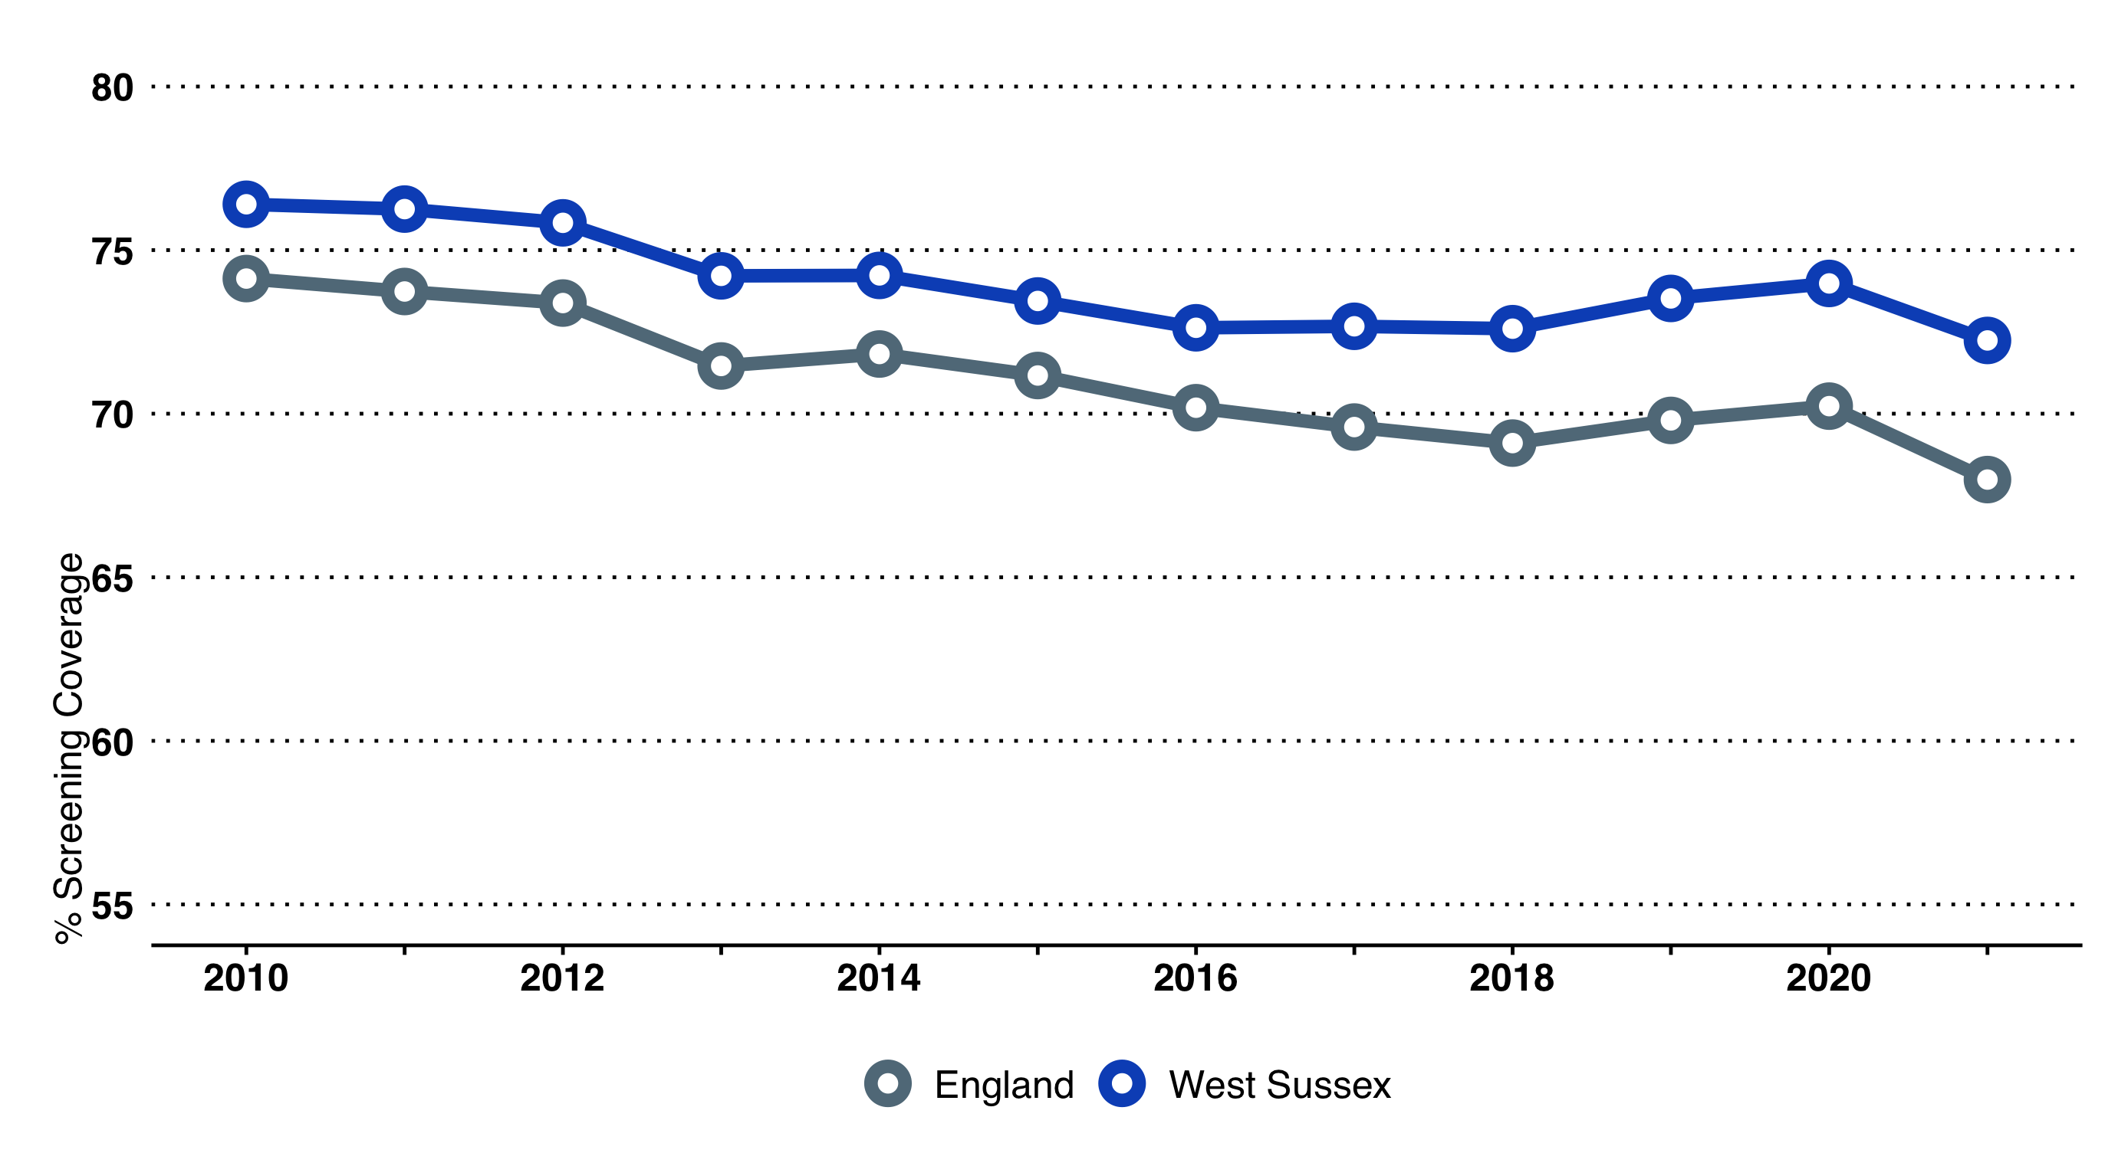

Cervical Cancer screening coverage - West Sussex and England over time

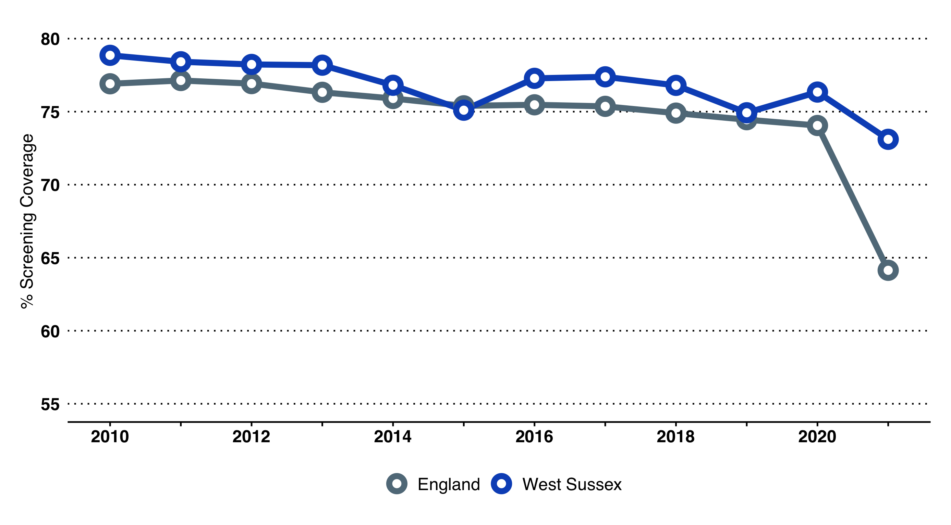

Breast Cancer screening coverage - West Sussex and England over time

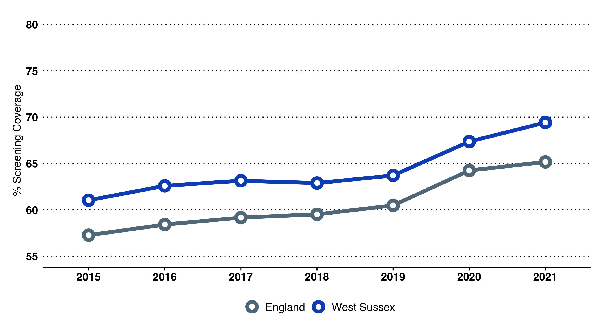

Bowel Cancer screening coverage - West Sussex and England over time

## Mental Health

Many of the prevalence assumptions for adult mental health conditions are derived from national surveys and research. Of particular note is the Adult Psychiatric Morbidity Survey (APMS). The APMS provides data on the prevalence of treated and untreated psychiatric disorders among adults (aged 16+) in households in England. The most recent survey was conducted in 2014 (McManus, Bebbington, Jenkins, & Brugha, 2016) and is the fourth in the series (previous survey years include: 1993, 2000 and 2007).

### APMS Key Findings

* Nationally, 1 in 6 adults (17.0%) were identified with a common mental health disorder (CMD) in the week prior to being interviewed APMS. Applying this prevalence estimate to West Sussex, it is estimated that 121,200 adults (aged 16+) are likely to have a common mental health problem[81].
* Women were more likely to have a common mental health disorder than men.
* 64.4% of adults who were identified as having a common mental health disorder in the survey had been diagnosed by a professional.
* Around a third (35.6%) of adults identified as currently with CMD by the survey have never been diagnosed. This may reflect unmet need, or demonstrate how perceptions of mental health vary.

|  | 16-24 | 25-34 | 35-44 | 45-54 | 55-64 | 65-74 | 75+ | All |
| --- | --- | --- | --- | --- | --- | --- | --- | --- |
| Generalised anxiety disorder | 4,530 | 5,670 | 7,370 | 8,870 | 7,510 | 4,140 | 2,470 | 42,050 |
| Depressive episode | 1,660 | 3,250 | 4,380 | 5,470 | 5,040 | 2,170 | 1,280 | 23,520 |
| Phobias | 2,380 | 3,070 | 3,210 | 3,280 | 2,700 | 620 | 490 | 17,100 |
| Obsessive compulsive disorder | 1,300 | 1,300 | 1,710 | 1,940 | 1,760 | 310 | 300 | 9,260 |
| Panic disorder | 860 | 460 | 320 | 610 | 590 | 720 | 590 | 4,280 |
| CMD-NOS (not otherwise specified) | 6,050 | 8,460 | 8,760 | 10,570 | 9,500 | 5,380 | 4,830 | 55,590 |
| Any CMD | 13,600 | 17,660 | 20,620 | 23,200 | 21,110 | 11,900 | 8,680 | 121,160 |

### Severe Mental Illness

The mental health register is a count of the total number of people with schizophrenia, bipolar disorder and other psychoses. In 2020/21, the recorded disease prevalence for mental health was 0.91% in West Sussex CCG, which is lower than that of England as a whole (0.95%).

Recorded disease prevalence for mental health conditions (schizophrenia, bipolar disorder and psychoses) (2016/17)

|  | List Size | Register | Prevalence (%) |
| --- | --- | --- | --- |
| West Sussex CCG | 913,467 | 8,314 | 0.91 (CI: 0.88-0.94) |
| England | 60,444,947 | 574,227 | 0.95 (CI: 0.94-0.95) |

### Learning Disability

There are an estimated 17,200 people aged 15+ years living with a learning disability in West Sussex

* 4,100 people with a moderate to severe learning disability
* 5,100 people on GP practice Learning disability registers
* 300 people with Down’s syndrome

#### Autism

In relation to adults (18+ years) it is estimated that there are 1,100 adults in West Sussex living with autism.

### Wellbeing

People with higher wellbeing have lower rates of illness, recover more quickly and for longer, and generally have better physical and mental health. As a key health issue, ONS has developed new measures to estimate national wellbeing. Four questions included in the Integrated Household Survey are used to measure individual (and therefore subjective) wellbeing. These ask, on a scale of 0-10, overall:

* how satisfied are you with your life nowadays?
* how happy did you feel yesterday?
* how anxious did you feel yesterday?
* to what extent do you feel the things you do in your life are worthwhile?

**Note**: these measures are estimates, based on a sample of the population from each area. Some years may lack data due to too small sample sizes or have wide confidence intervals (i.e. the range in which the true estimate could lie).

#### People with a low satisfaction score

4.2% of people gave a low life satisfaction score[82] (those scoring 0-4/10; confidence intervals 2.8-5.6%) in 2017/18, similar to the England score in this period (4.4%).

#### People with a low worthwhile score

3.5% of people gave a low worthwhile score[83] (those scoring 0-6/10; confidence intervals 2.1-4.8%) in 2017/18, similar to the England score (3.6%) in this period. Trend data is not available for this measure, as the sample size of the most recent and previous years is too small.

#### People with a high anxiety score

17.6% of people gave a high anxiety score[84] (those scoring 6-10/10; confidence intervals 14.7-20.5%) in 2018/19. This is lower than the England score (19.7%) and the fourth lowest score amongst CIPFA neighbours.

#### People with a low happiness score

6.8% of people gave a low life happiness score[85] (those scoring 0-4/10) in 2018/19. This is slightly lower than the England score (7.8%), although not significantly different (confidence intervals 4.8-8.8%) and of middling position compared to CIPFA neighbours.

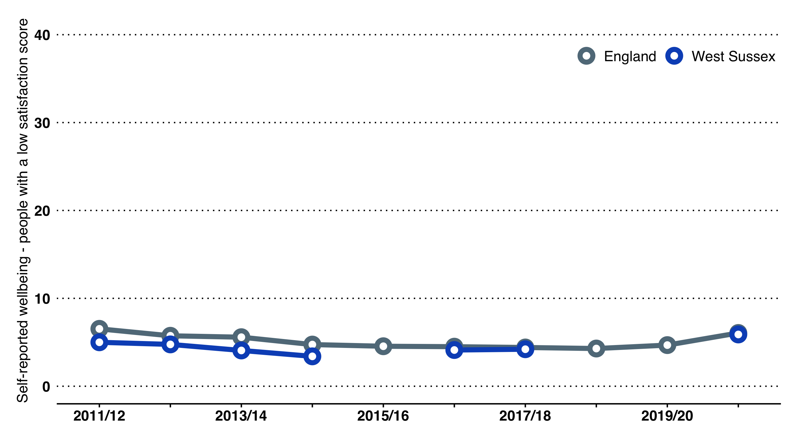

People with a low satisfaction score

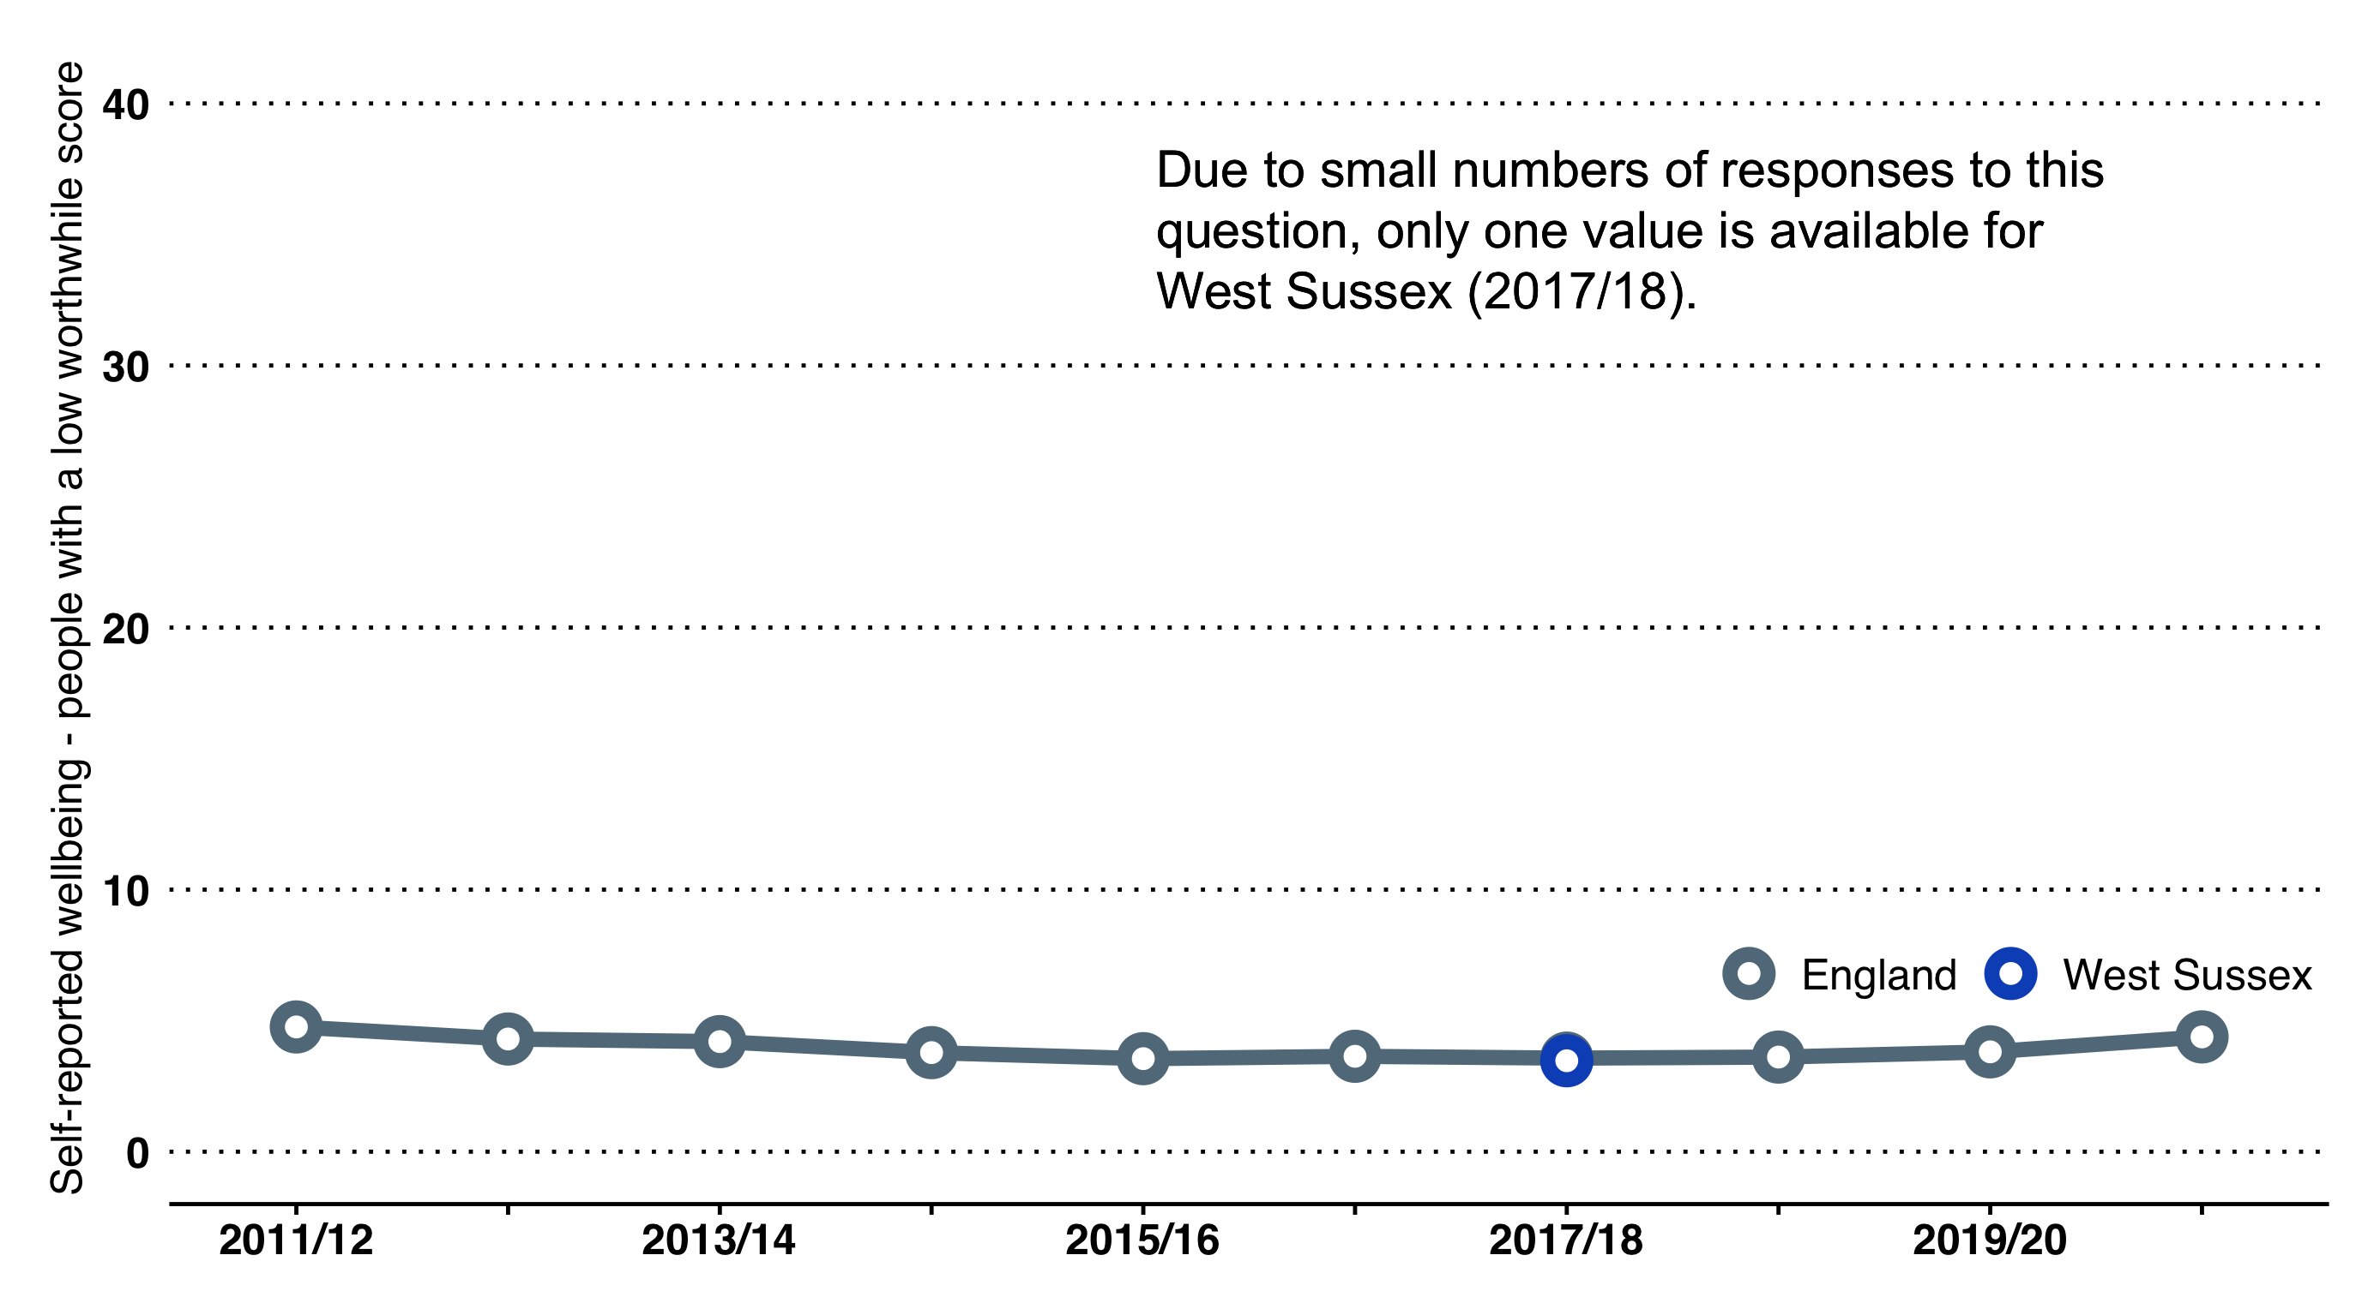

People with a low worthwhile score

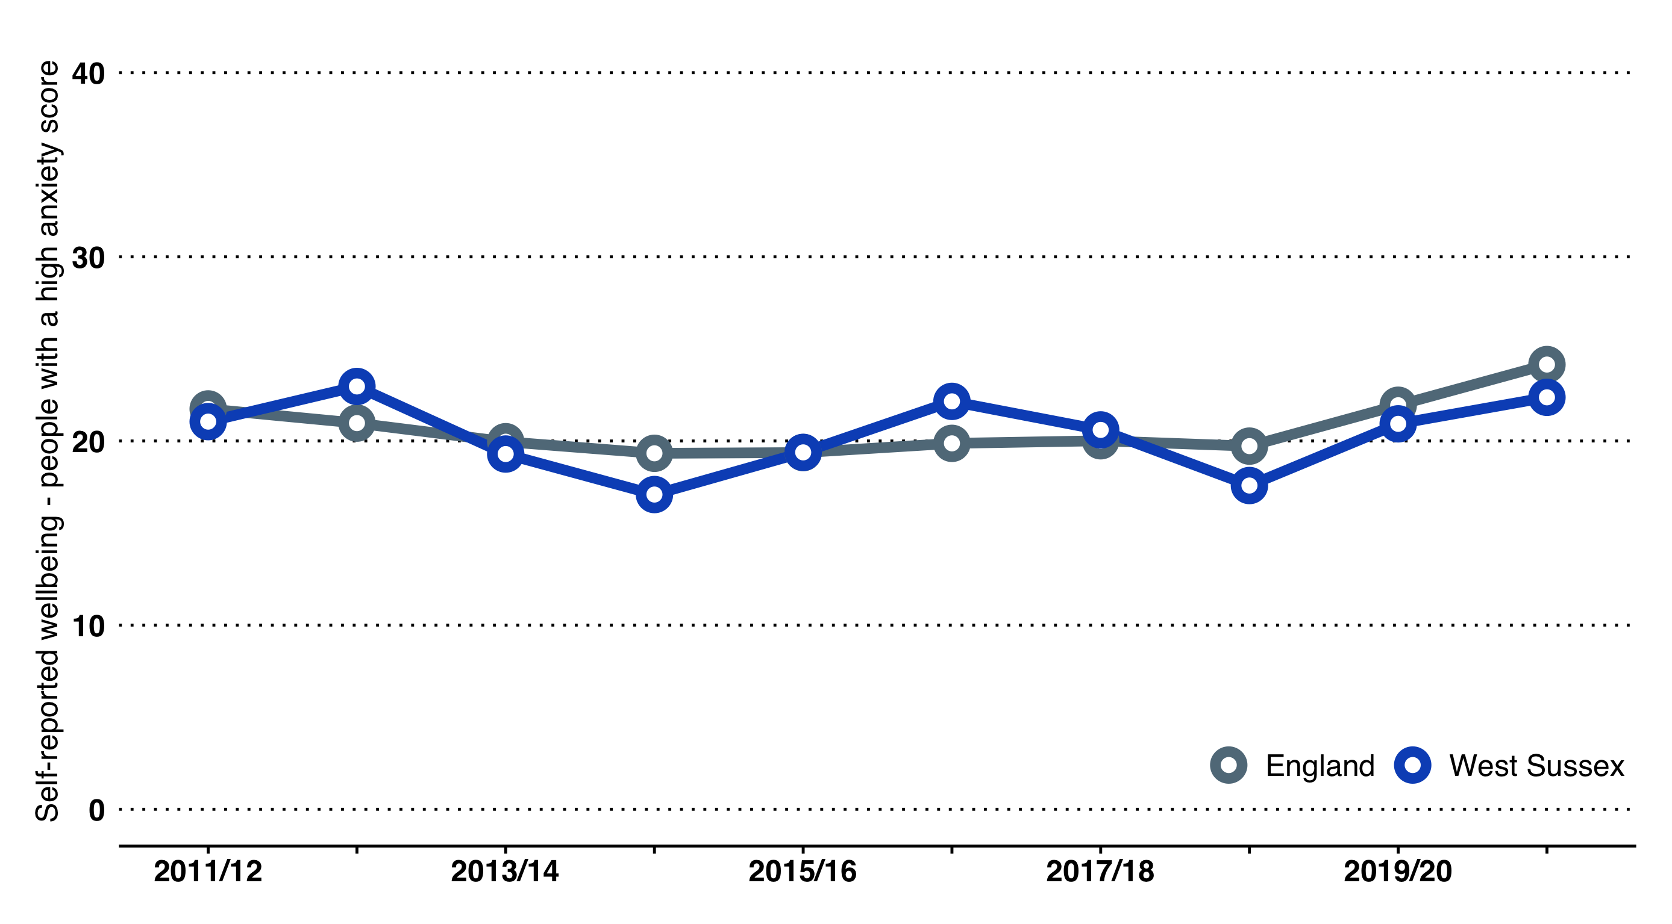

People with a high anxiety score

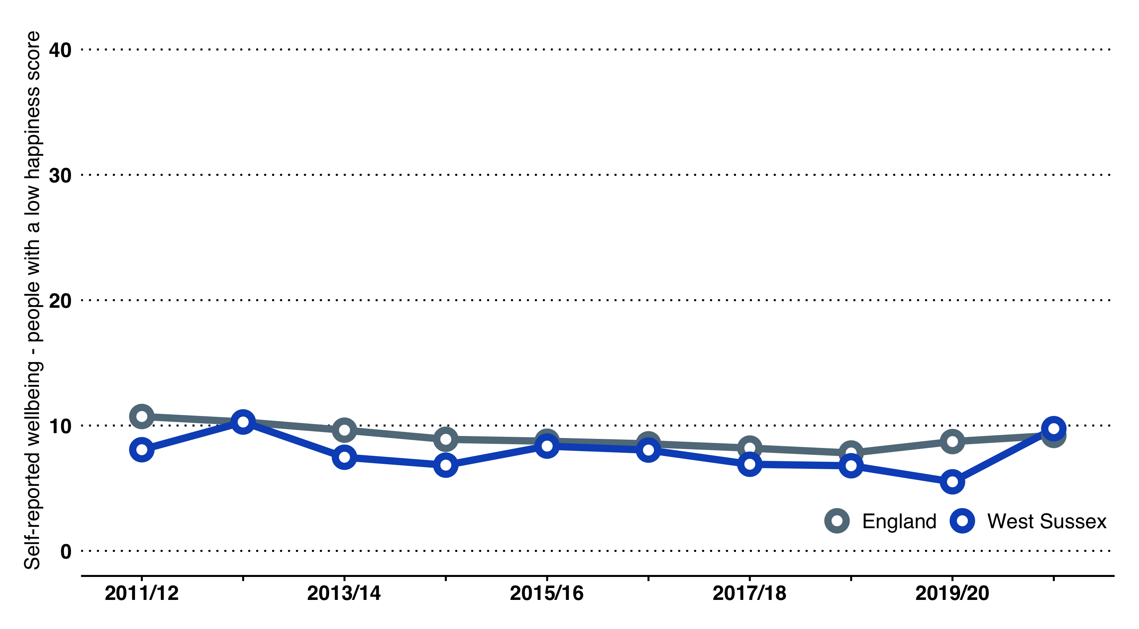

People with a low happiness score

### Measuring Wellbeing

There is not a single measure of health, wellbeing or happiness: different tools focus on different things. Six commonly used tools/instruments are summarised on this page.

* Some tools concentrate on one domain/theme, such as health-related quality of life (HRQ0L) e.g. the EQ-5D tool.
* Some look at subjective wellbeing (SWB), such as the ONS Wellbeing survey.
* Others consider what outcomes different policy-makers are seeking answers to, such as the ability of people to undertake personal care tasks or the ability to manage a condition (e.g. self-efficacy in the Patient Activation Measure, or undertaking daily activities in adult social care surveys).
* Some questions focus on the frequency a feeling/experience occurs, whilst others ask about intensity (e.g. WEMWBS asks about frequency whilst ONS Wellbeing asks about intensity).

Subjective wellbeing, designed as an adjunct to GDP measurement at a national level. Questions include evaluation, eudemonic and experience approaches.

**Pros:** Short, used widely. Nationally developed measure can be applied across programmes.

**Cons:** Not specifically centred on health, but broader subjective wellbeing. May not be sensitive to short term change

Warwick Edinburgh Mental Wellbeing Measure, focuses on mental health and wellbeing and has a long and short version.

**Pros:** Widely used, long and short versions. Sums to provide a composite score, which can be useful in dissemination.

**Cons:** Centred on individual, using only positive statements. Scale relatively short, may not pick up small movement. In a recent local evaluation there were some problems reported in using with the very elderly (85+ years).

Concentrates on using a specific format (spider diagram) and a wide range of measures for different groups and contexts within the population (e.g. young people, family, carers, homelessness)

**Pros:** Wide range of tools may be more suitable for specific conditions and circumstances, although less suitable for overall strategic reporting. Good visual format, easy to undertake

**Cons:** To use this tool an annual fee is paid (not prohibitive approx. £350)

Self-efficacy, willingness and ability to take on role of managing own health and health conditions. Describes activation in 4 levels (low activation to having the skills to self-manage)

**Pros:** Measures the ability of self-efficacy; the value is in understanding a patient’s ability and starting point. Can be used across programmes.

**Cons:** Does not focus on issues of wider wellbeing. Fluctuates with deterioration, not necessarily linear assumption and not designed to be a high level performance measure. Costs (but not prohibitive)

Developed by the EuroQol Group as a measure of health-related quality of life. Widely used, has some overlap with ASCOF. Measure of intensity. Has a 3 level range version and a 5 level version

**Pros:** Widely used in health, wide application possible Easy, simple questions. Used for economic evaluation

**Cons:** Narrow view of health-related quality of life does not cover more subjective aspects of wellbeing. Requires registration but cost minimal.

Measures social-care related quality of life - developed to assess whether a person’s social care needs and wants are being met.

**Pros:** Validated and used annually by council (only with people in receipt of services). Would be expected to decline with increased age and frailty, if population frame altered (i.e. fewer, frailer people accessing care). Useful range of tools for format (self- complete/proxy), easy read

**Cons:** Narrow focus. Designed for a specific function/policy area.

## Premature Mortality

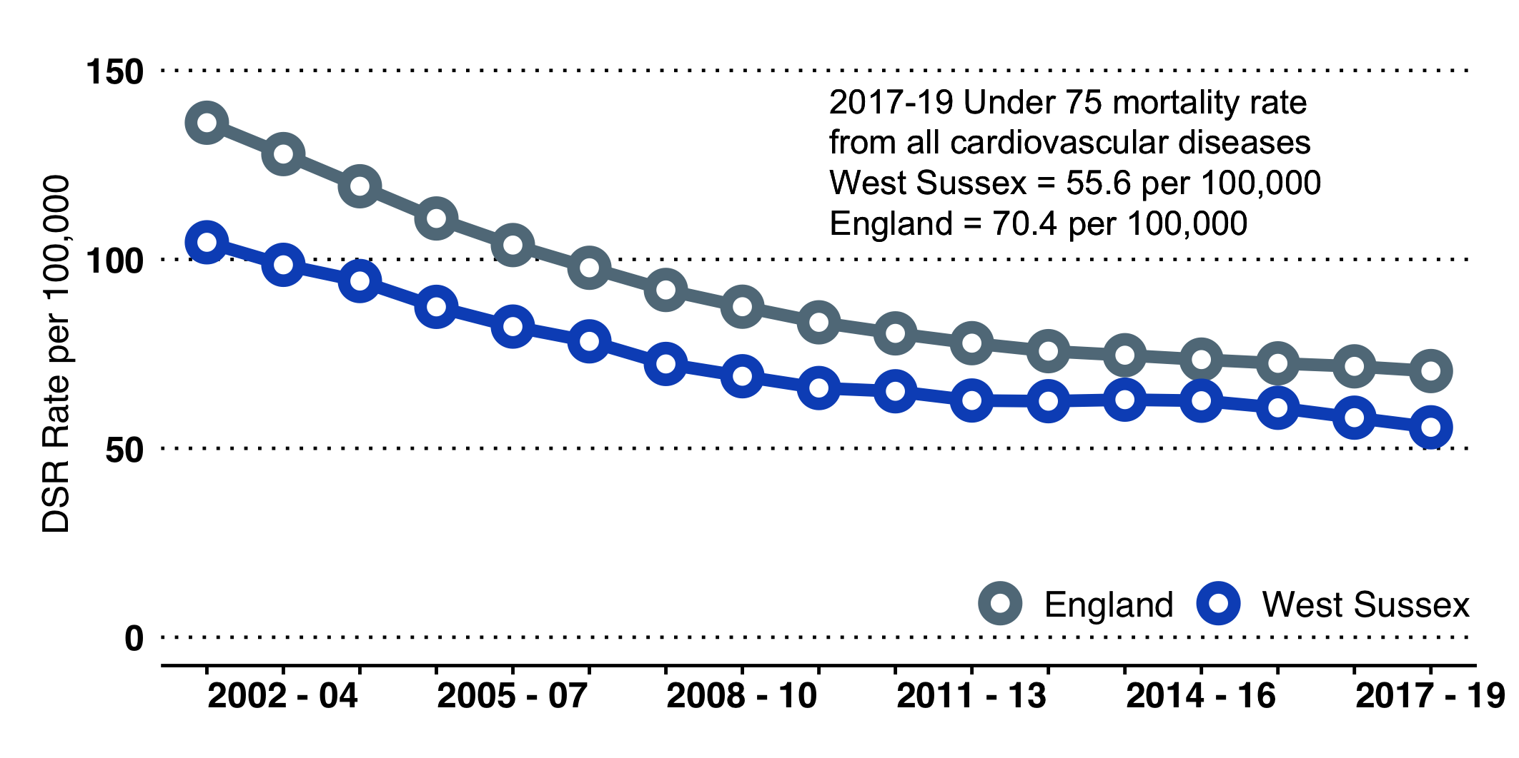

Cardiovascular disease (CVD) remains a major cause of premature mortality. The rate has reduced greatly over the last 20 years, due to lifestyle improvement and treatment. The mortality rate in West Sussex is significantly better than the England rate[86].

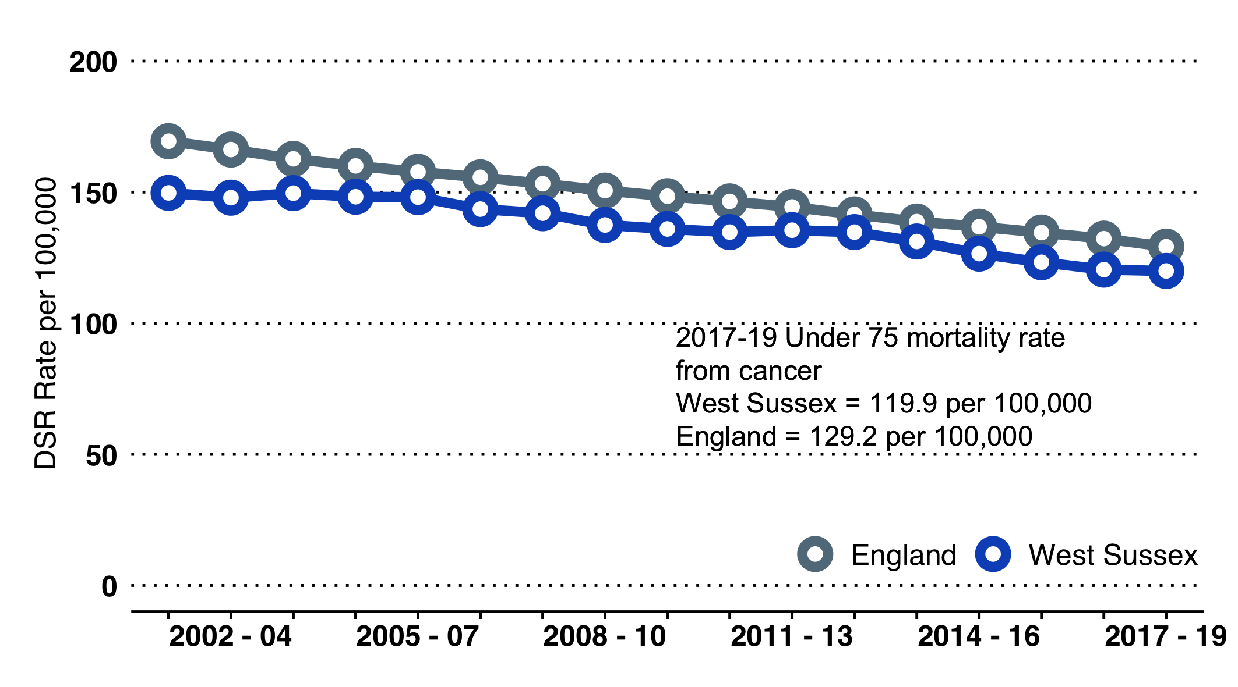

Cancer remains the biggest cause of death for people under 75. A continued reduction will require sustained effort on prevention, early diagnosis and treatment. The rate in West Sussex is significantly better than the England rate[87].

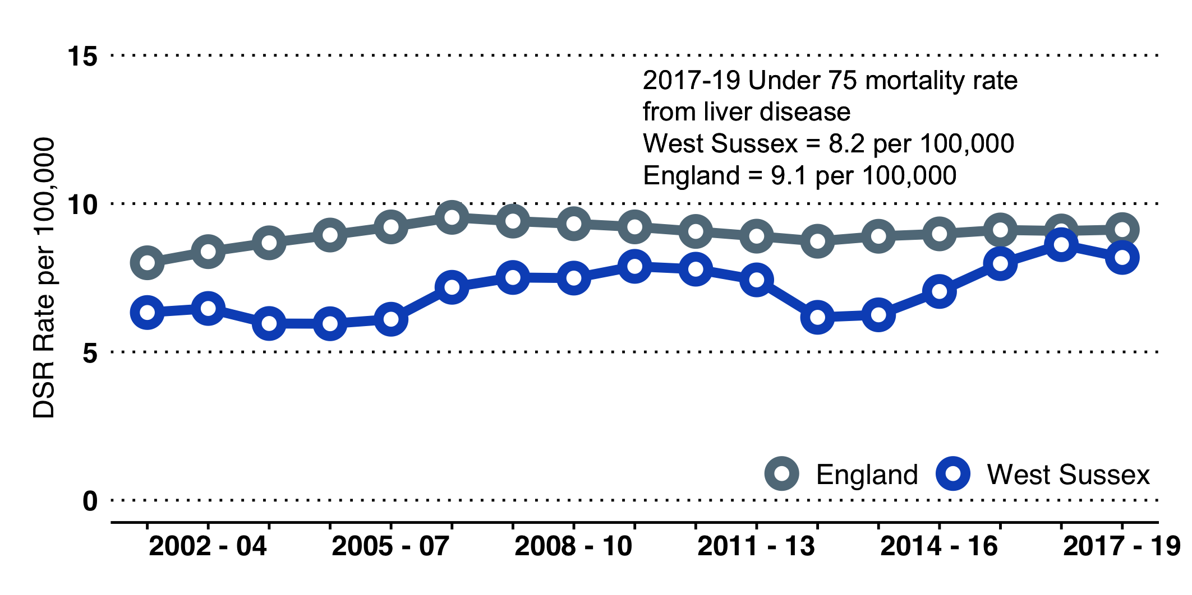

Liver disease is a major cause of premature death. Most liver disease is preventable; both alcohol consumption and obesity are underlying factors, amenable to public health interventions. Of the major causes, the rate of mortality is not reducing. Locally the rate is below England[88].

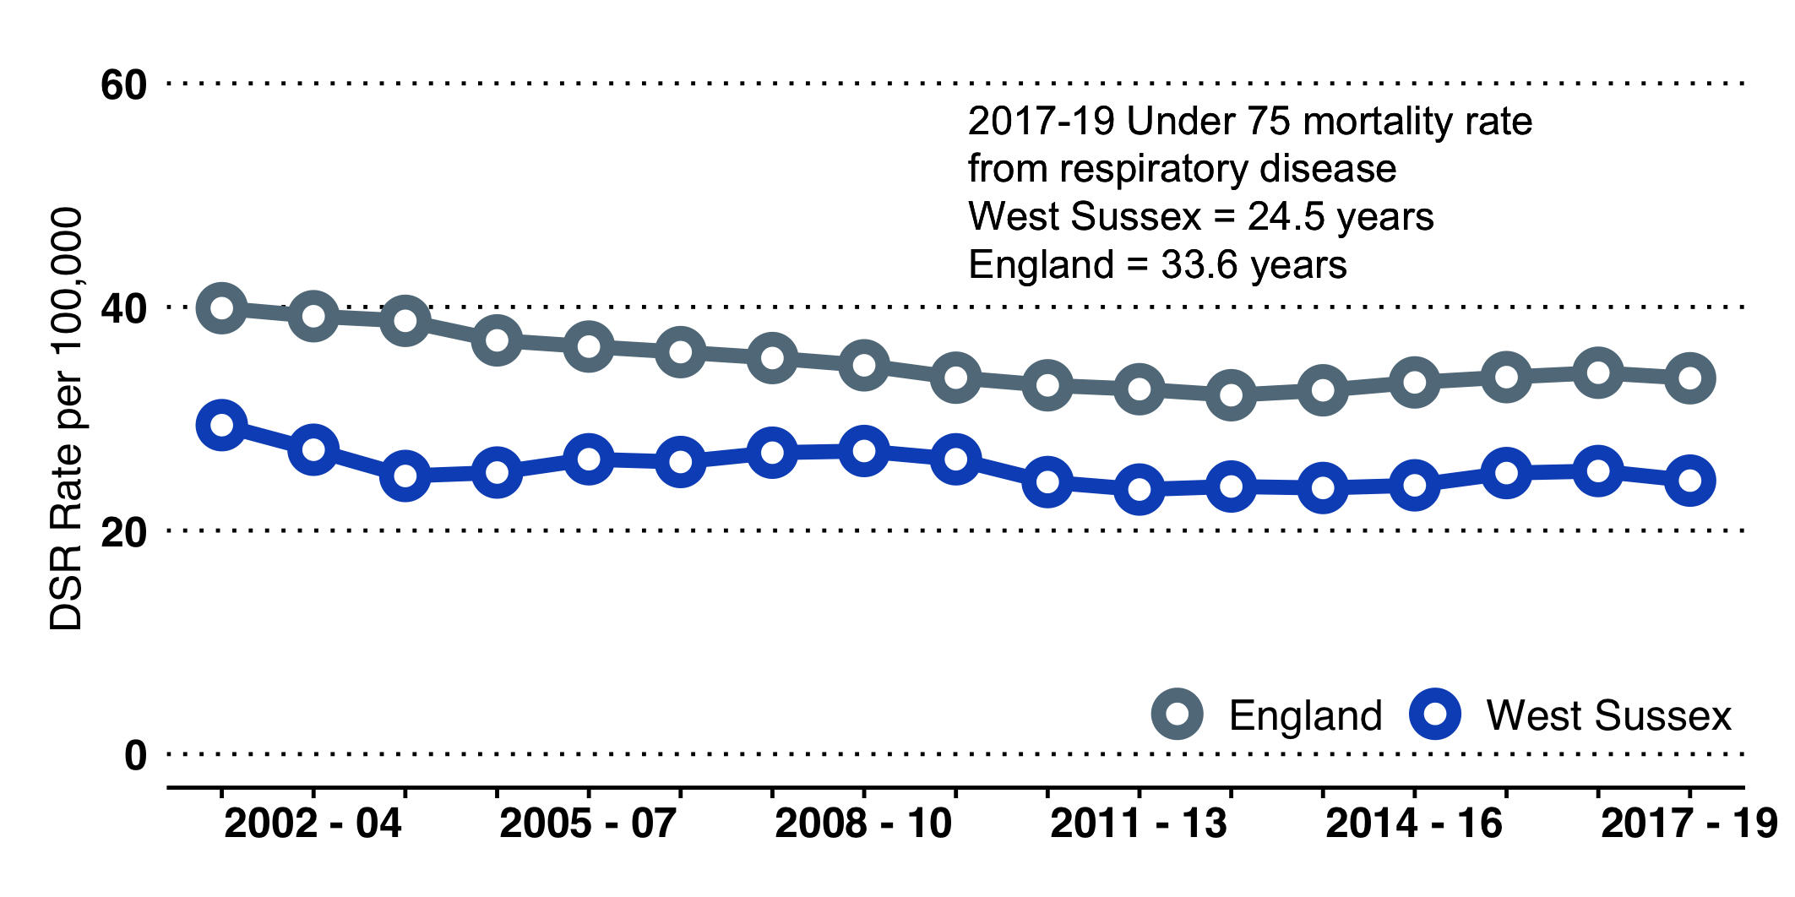

Respiratory disease is a major cause of premature mortality. For chronic obstructive pulmonary disease (COPD), one of the main respiratory diseases, smoking is a major cause. The West Sussex rate is below that of England[89].

## Suicide

The West Sussex Public Health and Social Research Unit carried out a Suicide Audit in 2017, covering suicides in the years 2013 to 2015. The audit provided detailed background context and circumstances and was undertaken to inform the local Suicide Prevention Strategy.

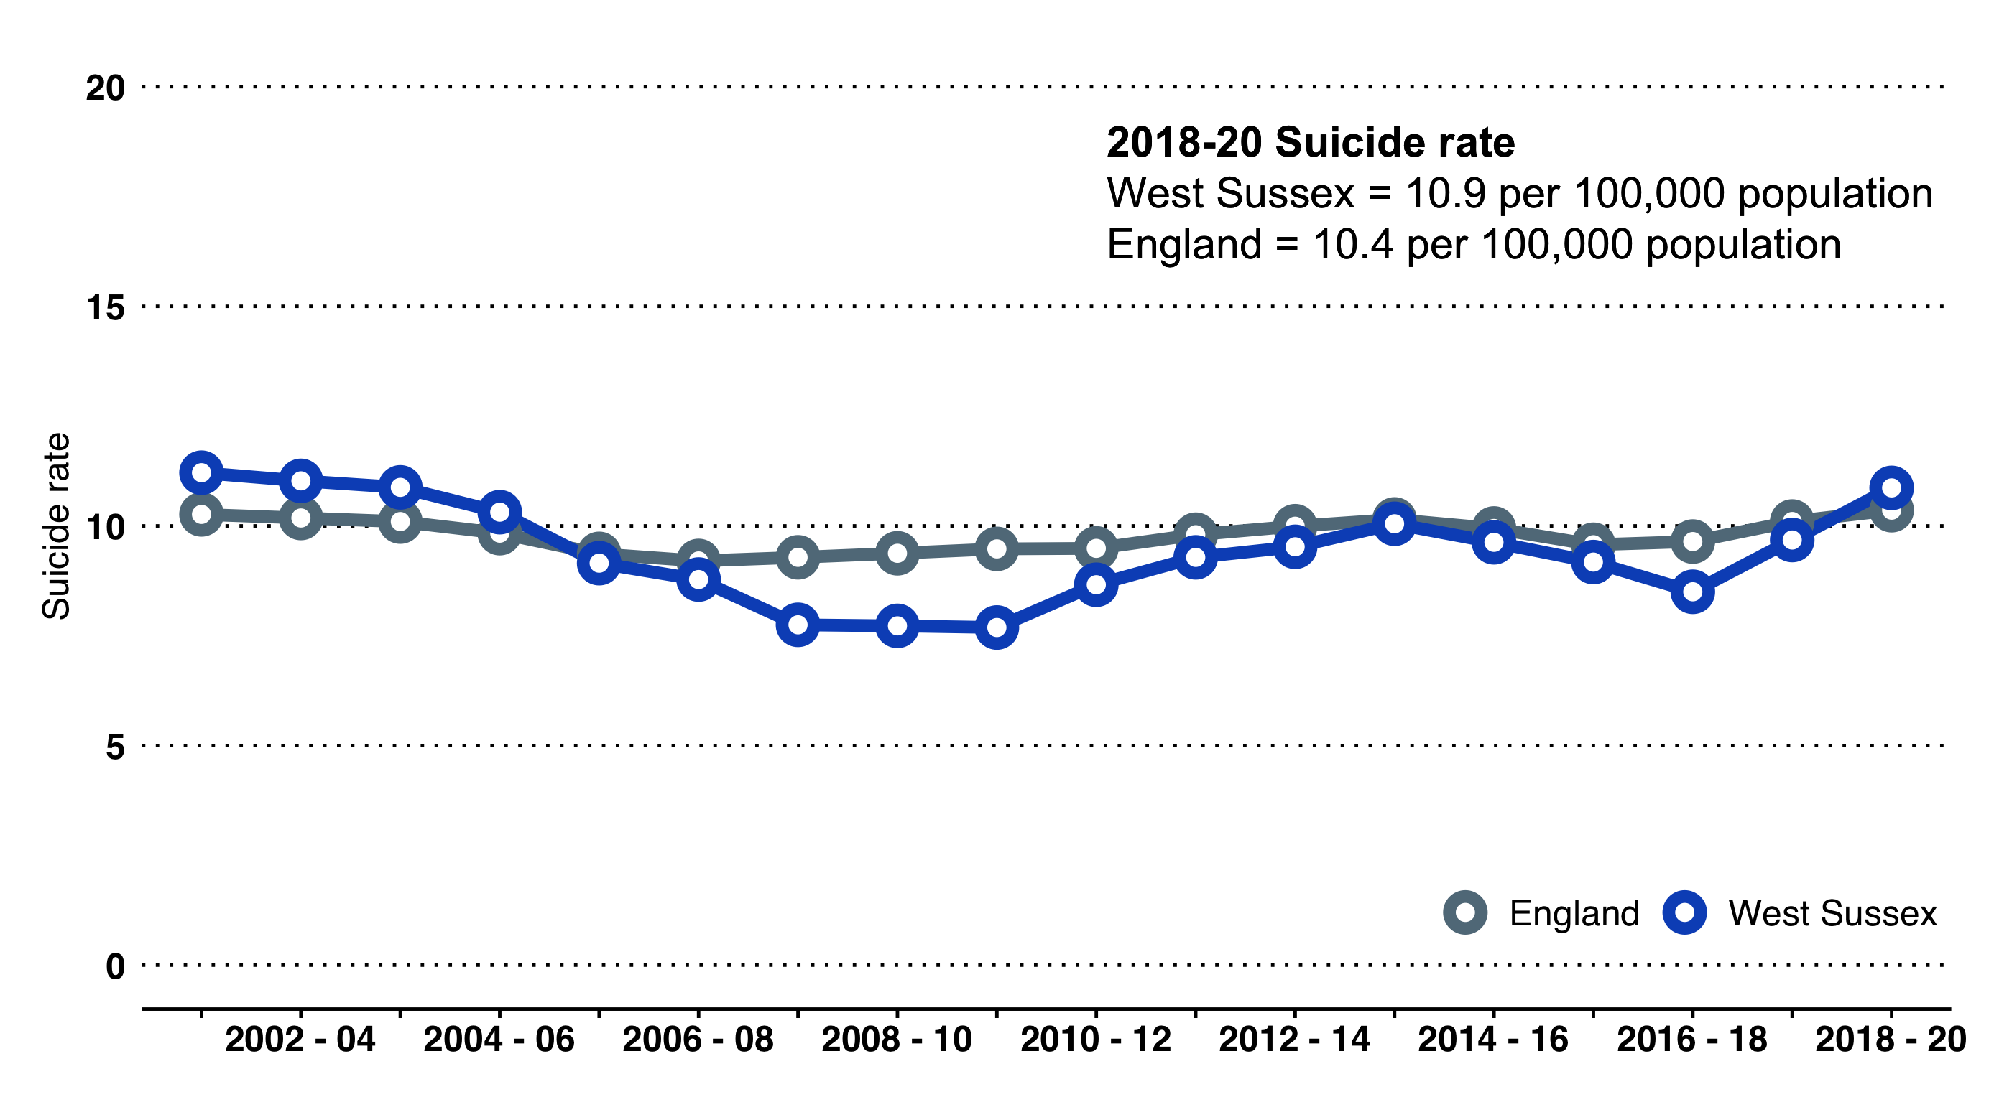

### Demographic Information from the West Sussex Suicide Audit 2013-15

For the years 2013-15 inclusive, there were 190 confirmed suicides and 23 open verdicts likely to be suicides.

* Combined, there were 52 females and 161 males included in the audit.
* Seasonal variations show a higher prevalence in summer months, though it is possible that this is random error found in low sample numbers.
* Nearly a third of male deaths and female deaths occurred between the ages of 45 and 54. Roughly half of female deaths and a fifth of male deaths occurred in those aged 65 and over.
* One in three individuals lived alone at the time of death and one in four lived with their spouse or partner.
* The most common means of suicide was by hanging or strangulation (43%). Following this was self-poisoning (20%), more frequent in older females, then impacts with a train (10%), more frequent with younger males.
* Rail crossings are as common for suicide as rail stations (together accounting for 10% of deaths).
* Over half of suicides occur in the home or elsewhere on the premises.
* Nearly one in three deaths occurred after consuming some level of alcohol. One in seven had taken illicit or non-prescribed drugs.

## Community Safety

### Violent offences

Violent offences (measured per 1,000 population)[90] more than doubled in West Sussex the last six years to 2018/19, in line with national rises. While no longer increasing as quickly, numbers and rates of violent offences in West Sussex remain high. In 2020/21, there were 18,454 recorded offences, compared with 7,448 in 2013/14.

The rate in West Sussex (21.8 per 1,000 population) remains lower than England (29.5 per 1,000) and most comparable authorities. However, the Crawley rate (35.1 per 1,000) exceeds both West Sussex and England, though this has fallen since 2019/20.

### Sexual offences

Sexual offences (measured per 1,000 population)[91] have also more than doubled in West Sussex over the last eight years, in line with national rises. In 2020/21, there were 1,602 recorded sexual offences, compared with 697 in 2013/14 (though a decrease on 2019/20).

The rate in West Sussex (1.9 per 1,000 population) remains lower than England (2.3 per 1,000) and is the seventh lowest amongst CIPFA neighbours. Crawley exceeds the national and West Sussex rates, at 2.8 per 1,000.

### Domestic abuse

In 2020/21, the rate of domestic abuse-related incidents and crime[92] was 22.1 per 1,000 in West Sussex, significantly below the national rate of 30.3 per 1,000 and one of the lowest amongst CIPFA neighbours.

### Road accidents

Whilst the national number of people killed or seriously injured (KSI) on roads[93] has remained stable in recent years, there has been an upward trend in West Sussex. At 131.0 per billion vehice miles (equal to 576 people in 2019 and 505 people in 2020), West Sussex has one of the highest KSI rates in the country (England 86.1 per billion vehicle miles). Note that Figure 26 refers to historic data, as no information are available for districts and boroughs post-2020.

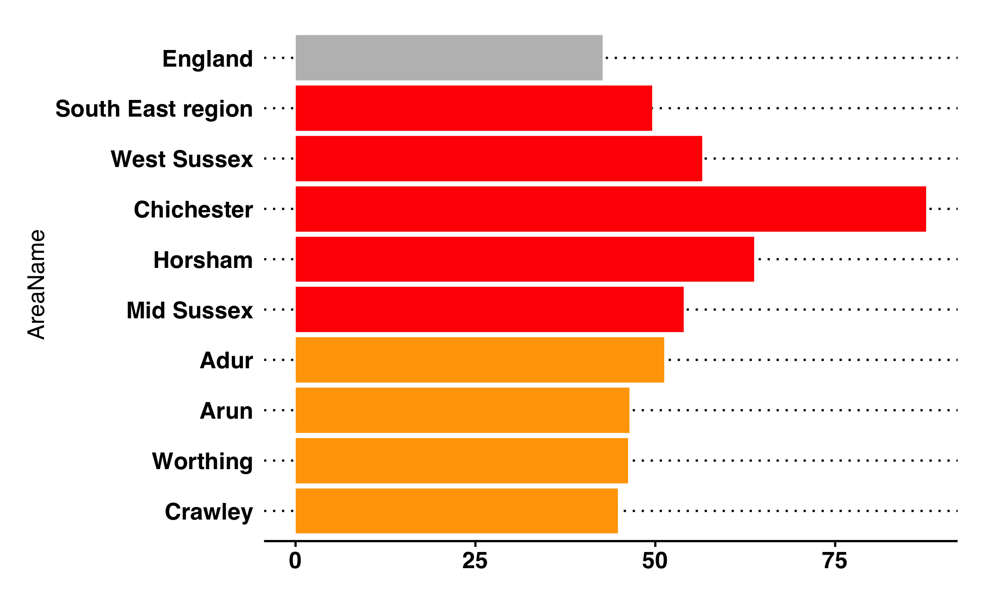

Number of people killed or seriously injured (KSI) on roads in West Sussex districts and boroughs, compared to England (PHOF reference B10).

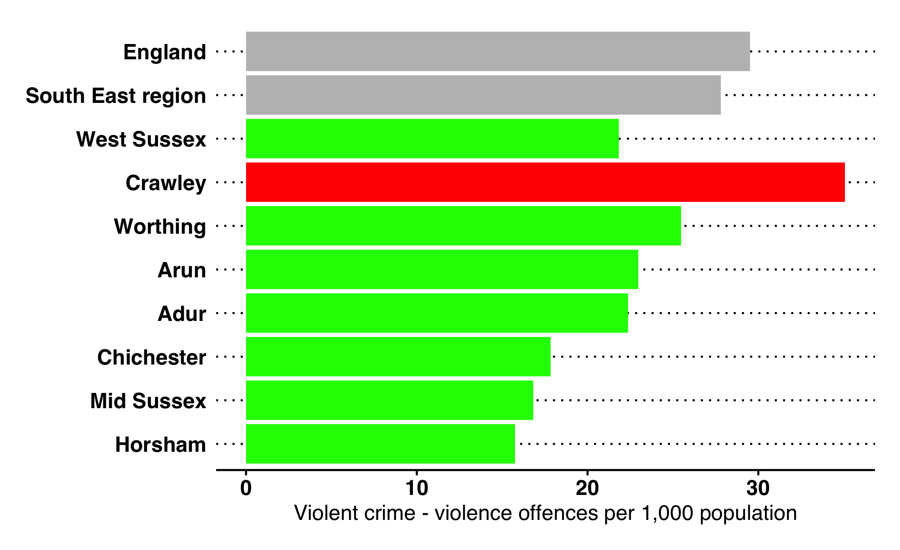

Violent offences per 1,000 population (all ages) in West Sussex districts and boroughs (PHOF reference B12b).

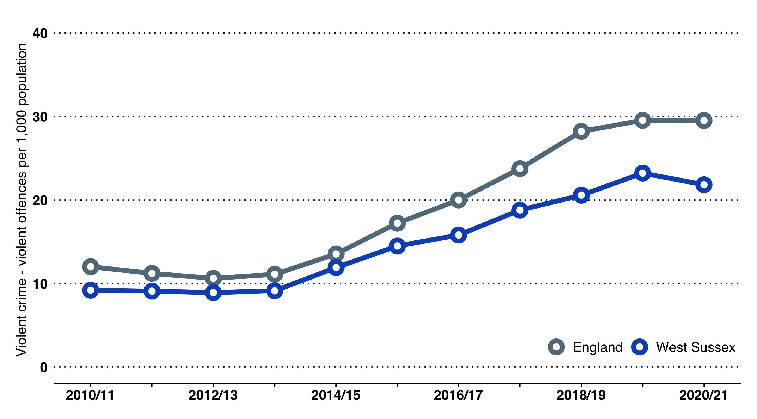

Violent offences per 1,000 population (all ages) over time compared to England (PHOF reference B12b).

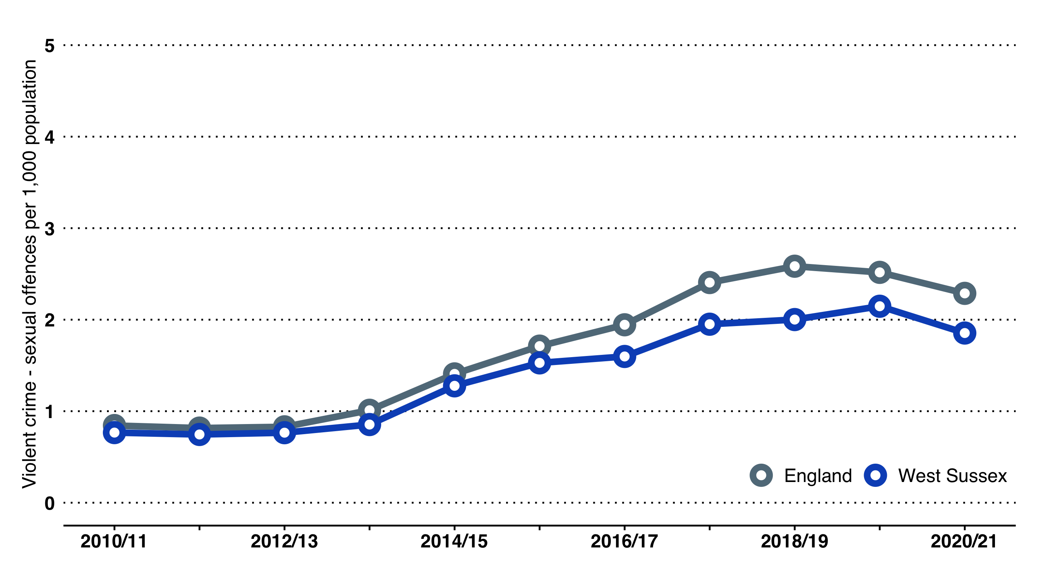

Sexual offences per 1,000 population (all ages) over time compared to England (PHOF reference B12c).

# Ageing Well

## Summary

West Sussex is home to 201,000 people aged 65 years or over. Overall, older people in the county are relatively healthy and the county is a good place to live. More people are continuing in paid employment well past the "traditional" retirement age, and older people provide considerable caring support to their families and friends, and the wider community.

The number of older people is projected to increase and to do so at a greater rate than the overall population increase. It will be increasingly important that services, communities and families work together to support older people and their families to remain healthy, happy and at home in the community. To have a healthy older population it is important that the wider determinants of health (housing, planning, income, education etc) are conducive to better ageing, and that organisations and communities work together to promote good health in mid-life, prevent the onset of long- term conditions, and support self-care of health and self-management of conditions.

Overall, health and wellbeing outcomes are good for all life stages in West Sussex, including later life. However, as with the earlier lifestages, the average hides the considerable inequalities in the county.

Life expectancy overall has continued to increase but with healthy life expectancy stalling, this means that more of life is being spent in poor health or with a disability. Male life expectancy still lags behind female life expectancy (80.3 years compared with 83.9 years) and is far lower amongst people from the most deprived and disadvantaged groups, including older people living in poverty and people with a learning disability and/or mental health condition.

The importance of the quality of life lived, not just the length of life, is central to the priorities identified in the West Sussex Health and Wellbeing Strategy 2019-24. Loneliness and social isolation in later life have been identified, through national and local surveys, as impacting the quality of life and are linked to physical health outcomes. Although it should be stressed that the impact of loneliness is not restricted to this age group, it is a life stage when mobility and the opportunity for social contact can decline.

Locally, outcomes relating to falls have fluctuated and often have been poorer compared with comparable authorities; in 2020/21 there were over 4,900 emergency hospital admissions due to falls. At 2,280 per 100,000, this rate is significantly higher than England and the third highest amongst comparable authorities. Of specific concern were the 835 hip fractures in residents aged 80+ years, as, for many older people, such an injury may result in moving into residential care.

Most care is self-care. To self-care and self-manage long-term conditions, people of all ages need access to good advice and may need additional support. Data from the GP Patient Survey found that, across West Sussex, 83% of people said that they were ’fairly’ or ’very’ confident in managing their conditions but there is variation across the county and confidence tends to decline with age. In terms of support from local organisations and services, compared to working age adults with a health condition, older people were more likely to say they had enough support.

Just as the quality of birth is valued at the start of life, support for the end of life was identified as a priority by the West Sussex Health and Wellbeing Board. There is again considerable variation across the county; notably, the percentage of people dying at home remains low in Crawley, when compared with the rest of the county and England overall.

## Over 65 Population Background

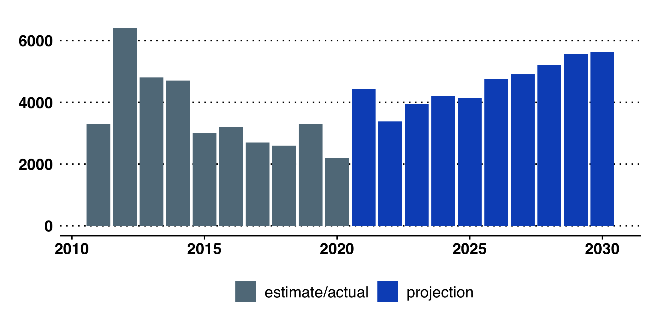

Year-on-year change in the number of 65+ year olds in West Sussex

**In 2020, there were an estimated 201,000 people aged 65 years or over in West Sussex,** compared with 164,800 in 2010. In 2030, ONS project that there will be 247,200 people in this age group in West Sussex, with the average year-on-year change increasing from 3,600 in the last 10 years to over 4,500 in the next 10 years.

* Over 30% of people aged 65 years or over **live alone**, representing over 60,000 people and 15 of all households in West Sussex.
* Over 9,100 people aged 65 years or over **live in residential or nursing care.**
* Over 27,500 people aged 65 years or over are **providing unpaid care** for a family member, friend and/or neighbour, with over 9,000 providing unpaid care for 50+ hours a week (and of these, 1,300 are estimated to be aged 85 years or over).
* West Sussex has a **high rate of home ownership**, with over 80% of older people being home owners.
* **It is estimated that over 40,000 older people (approximately 20%) in the county have mobility problems** (such as going out of doors and walking down the road; getting up and down stairs; getting around the house on the level; getting to the toilet; getting in and out of bed).

**Loneliness** is the subjective feeling of a gap between someone’s desired and actual social contact. Linked to quality of contacts. Loneliness is not desired by the person experiencing it.

**Social isolation** is an objective measure of contact with others, usually measured in quantitative terms. Some people may choose to have few contacts.

Age UK have produced maps of areas where people may be at greater risk of loneliness. The maps reflect four underlying indicators taken from the 2011 Census:

* marital status
* self-reported health status
* age
* household size

Age UK state that the four factors predicted around 20% of the loneliness observed amongst people aged 65+. This was established by work undertaken as part of the English Longitudinal Study of Ageing (ELSA). Age UK state that their map should be used alongside local knowledge and understanding of the local population.[94]

## Long Term Health Conditions

#### Older people with long term conditions

Estimates of the number of older people living with a long term condition are based on prevalence assumptions from national research[95]. Note: these are broad rounded estimates

* People aged 65+ predicted to have **diabetes - 25,000**
* People aged 65+ estimated to have **dementia - 15,100**[96]
* People aged 65+ predicted to have **depression - 17,400**
* People aged 65+ predicted to have **severe depression - 5,500**
* People aged 65+ predicted to have **a longstanding health condition caused by bronchitis and emphysema - 3,400**
* People aged 65+ predicted to have **a bladder problem at least once a week - 33,500**
* People aged 65+ predicted to have **a fall - 54,700**
* People aged 65+ predicted to be **admitted to hospital as a result of a fall - 6,700**
* People aged 65+ predicted to have **severe hearing loss - 16,700**

In relation to recorded prevalence, approximately 6,368 people in West Sussex are on GP dementia registers.

#### Musculoskeletal problems (MSK)

In 2021, **16.4% of people aged 18+ reported a long-term Musculoskeletal (MSK) problem**[97], such as a long-term back pain or joint pain, representing over 116,900 people in West Sussex. This is similar to England (17%).

#### Sensory impairment

Independence in later life can be severely impacted by hearing and sight loss. Sensory impairment can act to increase loneliness and social isolation and hearing loss is a risk factor for dementia at older ages.

* Around 18,000 people aged 65 years or over are estimated to have a moderate to severe visual impairment[98]. Of those over 75 years, approximately half are estimated to have "correctable sight loss", with conditions such as cataracts.
* 6,200 people aged 75 years or over are estimated to have a registrable eye condition.
* 17,000 people aged 65 years or over are estimated to have severe hearing loss[99].
* **Sight loss due to age-related macular degeneration (AMD) in 65+ year-olds has decreased in West Sussex in the last three years**. In 2020/21, the rate in West Sussex was 70.1 per 100,000 and, having previously been higher than England, is now below the national rate and is ranked eleventh amongst comparable local authorities. In 2020/21, there were 141 new Certifications of Visual Impairment (CVI), 37 fewer than 2020/21.

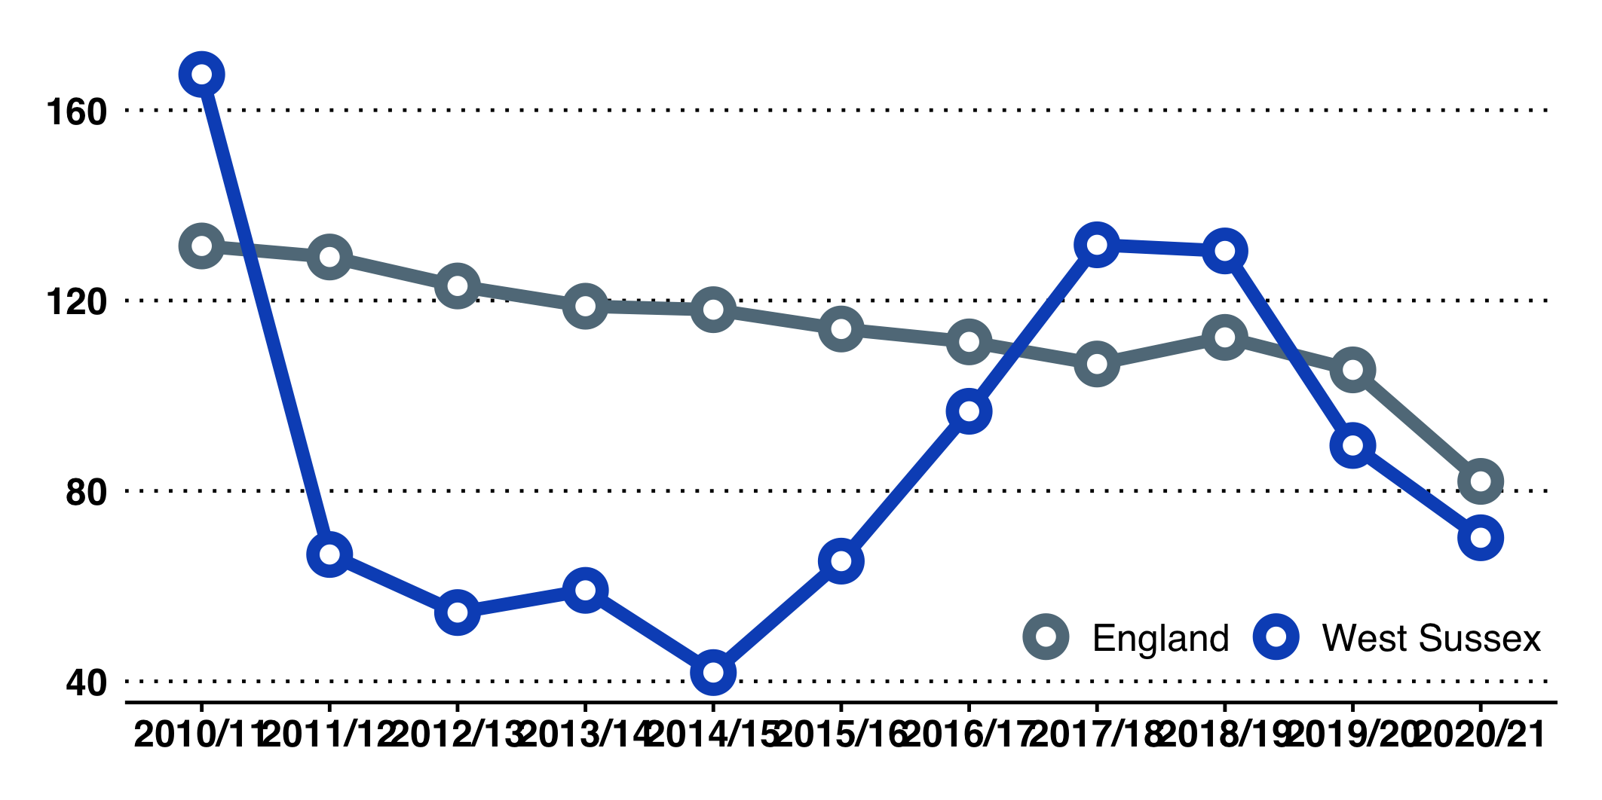

Rate of new Certifications of Visual Impairment per 100,000 over-65s in West Sussex

## Multi-morbidity estimates

#### Multi-morbidity - Public Health England Estimates

As we age we are likely to have or develop one or more long term health condition. This is called co-morbidity.

In 2018, Public Health England (as was) published estimates of the number of people with multi-morbidities in each lower tier authority in England. In doing this, PHE noted some challenges in how multi-morbidity is described, including how many and which conditions are included (physical and/or mental health conditions).

The physical conditions included in the PHE estimates are listed in Table [tab:op:phys_conditions] on page . The mental health conditions are listed in Table [tab:op:mh_conditions] on page .

|  |  |  |
| --- | --- | --- |
| Hypertension | Heart failure | Treated constipation |
| Painful condition | Prostate disorders | Stroke & transient Ischaemic attack |
| Asthma (currently treated) | Glaucoma | Chronic kidney disease |
| Coronary heart disease | Epilepsy (currently treated) | Diverticular disease of intestine |
| Treated dyspepsia | Psoriasis or eczema | Viral Hepatitis |
| Diabetes | Inflammatory bowel disease | Chronic liver disease |
| Thyroid disorders | Migraine | Atrial fibrillation |
| Rheumatoid athritis | Blindness & low vision | Peripheral vascular disease |
| Hearing loss | Chronic sinusitis | Parkinson’s disease |
| Chronic obstructive pulmonary disease | Irritable bowel syndrome | Multiple sclerosis |
| Bronchiectasis | New diagnosis of cancer in last 5 years |  |

|  |  |  |
| --- | --- | --- |
| Anorexia or bulimia | Anxiety & other neurotic, stress | Schizophrenia (and related non-organic psychosis) |
|  | related & somatoform disorders | or bipolar disorder |
| Depression | Learning disability | Dementia |
| Alcohol problems |  |  |

### Multi-morbidity estimates by age - West Sussex

Tables 13 through 15 show the multimorbidity estimates from PHE applied to 2020 population estimates.

Multi-morbidity estimates by age - West Sussex. Prevalence of 2 or more chronic conditions applied to 2020 population estimates.

|  | Number | Prevalence |
| --- | --- | --- |
| 0-24 years | 4,090 | 1.7% |
| 25-44 years | 21,940 | 11.1% |
| 45-64 years | 70,210 | 29.5% |
| 65-84 years | 109,720 | 64.2% |
| 85+ years | 24,500 | 81.4% |

Multi-morbidity estimates by age - West Sussex. Prevalence of 3 or more chronic conditions applied to 2020 population estimates.

|  | Number | Prevalence |
| --- | --- | --- |
| 0-24 years | 720 | 0.3% |
| 25-44 years | 8,300 | 4.2% |
| 45-64 years | 36,410 | 15.3% |
| 65-84 years | 75,370 | 44.1% |
| 85+ years | 19,440 | 64.6% |

Multi-morbidity estimates by age - West Sussex. Physical & Mental health co-morbidity prevalence applied to 2020 population estimates.

|  | Number | Prevalence |
| --- | --- | --- |
| 0-24 years | 1,200 | 0.5% |
| 25-44 years | 10,870 | 5.5% |
| 45-64 years | 27,610 | 11.6% |
| 65-84 years | 28,540 | 16.7% |
| 85+ years | 9,090 | 30.2% |

## Segmenting the 65+ Population

### Using GP Patient Register Data

Registered patient data provide details of age, sex, long-term conditions (nature of condition and number), and may include some data on health care activity and cost. Public Health has some, but limited, access to the data. We have been able to analyse anonymised data to provide a population level view of a health and to segment the 65+ population. The intelligence provided by the sample of records (approximately 30% of the West Sussex 65+ population).

The data show that **54% of patients at age 65 had no long term health condition**, but that **this falls to 21% by the age of 85 years**. Using sample data[100], it was found that of the population aged 65 years and over:

* 62.7% had no or 1 long term condition (hypertension was the most common, see Figure 32 on page .)
* 26.6% had 2 or 3 conditions
* 8.5% had 4 or more conditions

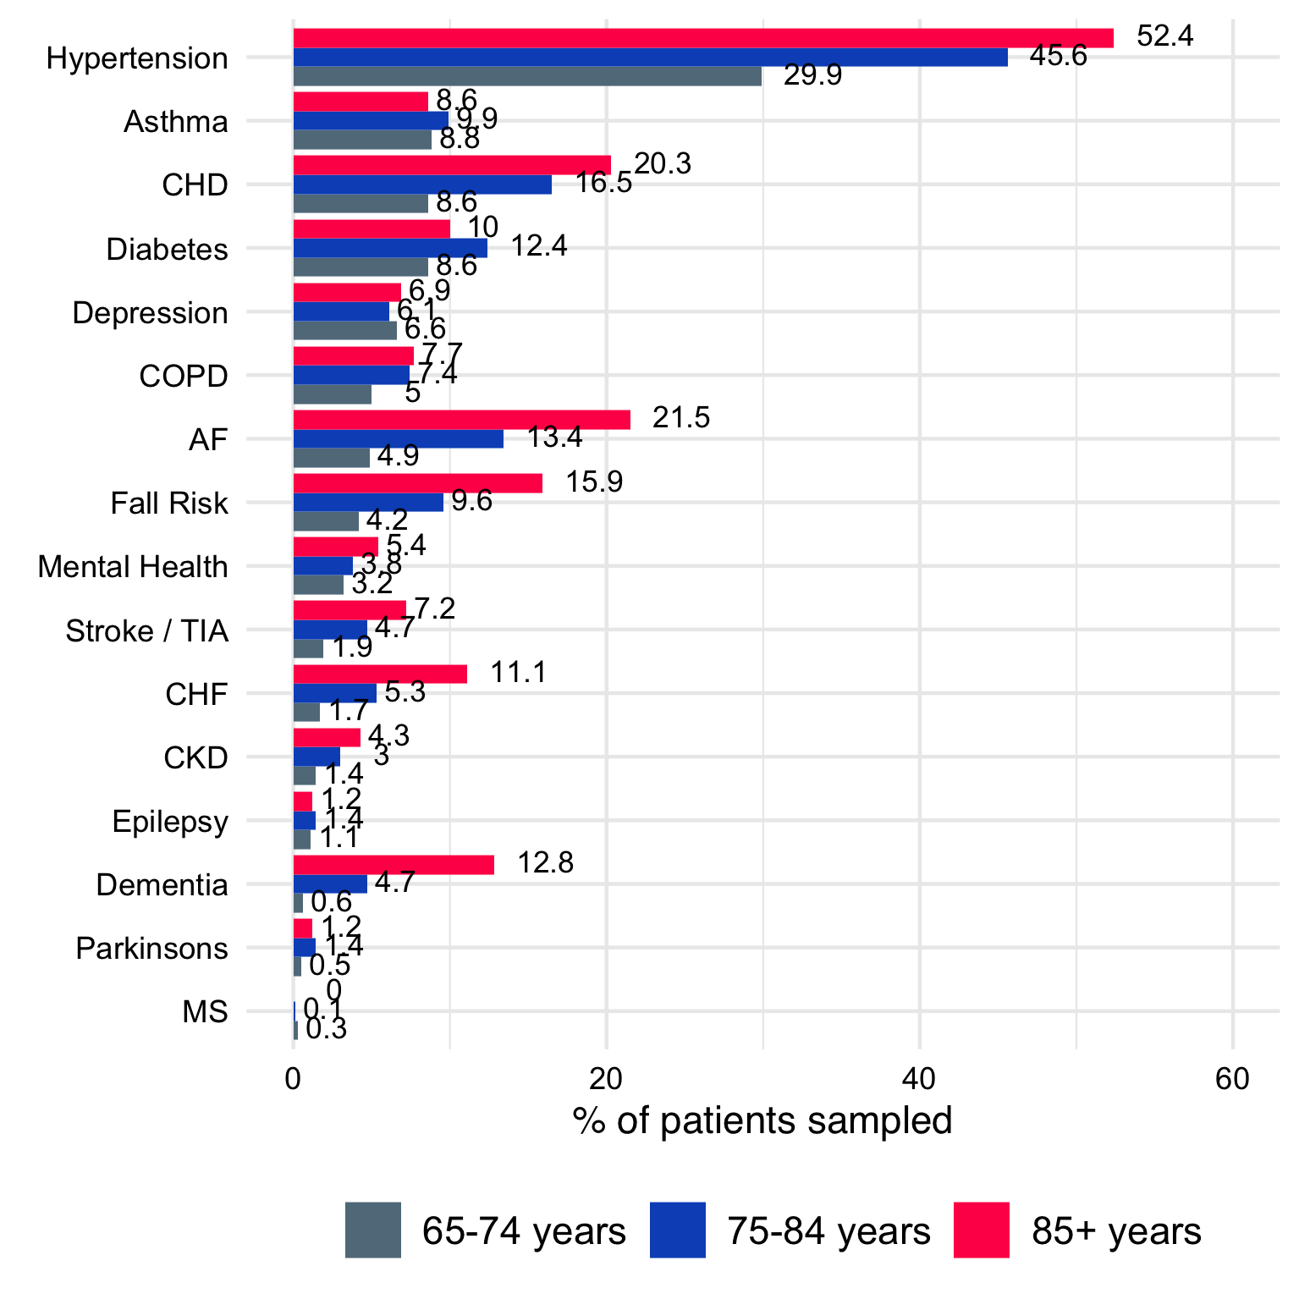

Specific Conditions and percentage of Age Group Identified with Long Term Conditions

### Estimating Care Needs in a Population

In 2020, there were an estimated 201,000 residents in West Sussex aged 65 years or over. To help plan services for older people, different approaches can be used to estimate how many older people (in any year) may need help to maintain or regain independence, and how many may need on-going support from others. To do this, we segment residents into distinct groups. There are various ways to estimate these groups. Using different datasets, three methods are set out in our briefing document available on the JSNA website and summarised below.

In any one year, residents may fall into one of four scenarios/segments:

* **Independent** - Most people aged 65+ are "fully" independent and need no formal (paid) support
* **Short-term/Regain** - Some people need temporary support (for example after a fall or a short term illness)
* **On-going** - Some people need on-going and long term support, in the community or in residential care
* **Die** - Estimated number of people aged 65+ (in total) that die each year

Three methods of segmenting the population were considered:

* using population health data from the census
* using assumptions about the need for support to undertake activities for daily living
* using the prevalence of people with long-term health conditions

Table 16 (on page ) shows the approximate number of older people in each segment based on 2020 population estimates.

Segmentation of West Sussex population aged 65+ according to likely care needs based on 2020 population estimates.

|  | Independent | Short-term / Regain | Ongoing | Death |
| --- | --- | --- | --- | --- |
| Method 1 | 118,100 | 34,100 | 34,100 | 8,300 |
| Method 2 | 135,600 | 34,400 | 22,500 | 8,300 |
| Method 3 | 120,800 | 51,200 | 20,700 | 8,300 |

## Self care

The Self Care Forum[101] provides a range of resources relating to self-care and have conceptualised self-care as a continuum from decisions made everyday to managing long term conditions.

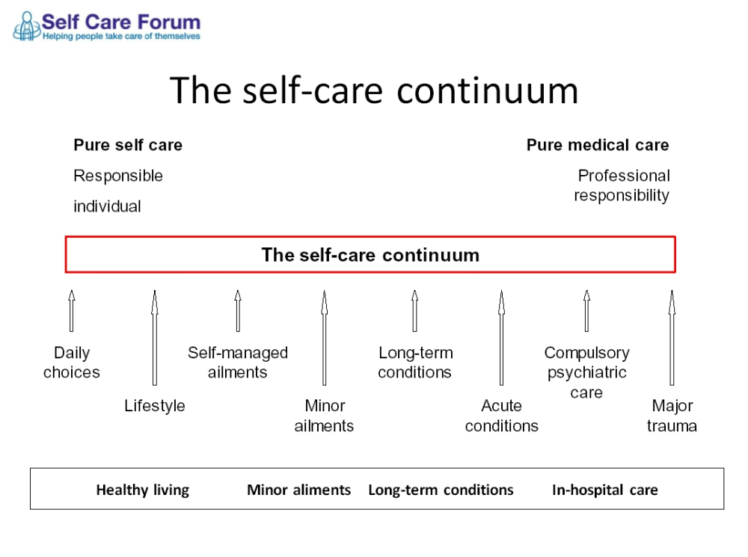

As people age, general health declines and the likelihood of having one or more long-term health condition or disability increases. **It should be recognised that most care in a society is "informal": self-care, or care provided by others in a family or group of friends and neighbours.** One source of self-care data is the GP Patient Survey, which includes the following questions:

* How confident are you that you can manage any issues arising from your condition (or conditions)?
* In the last 12 months, have you had enough support from local services or organisations to help you to manage your condition (or conditions)?

Data for West Sussex overall for 2019 are shown below. GP Patient Survey data are available at CCG and individual practice level, although care should be taken with small sample sizes[102].

#### Confidence in managing condition(s)

86% of people overall said they were fairly or very confident in managing their health condition. This declines with age; within the 85+ years respondent group, 1 in 3 said their were not very or not at all confident.

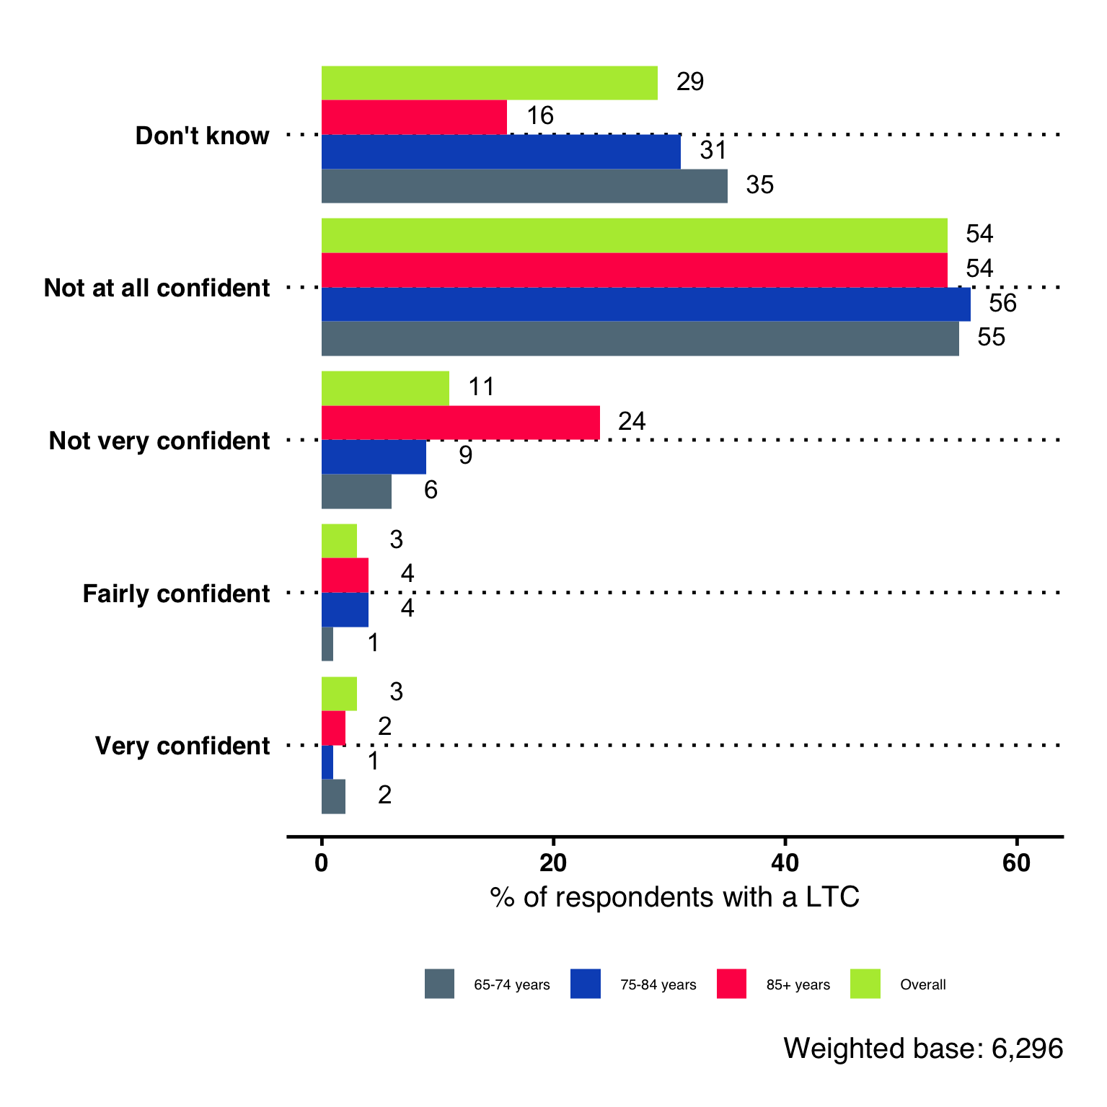

Confidence in managing long term conditions - 2021 GP Patient Survey, West Sussex CCG.

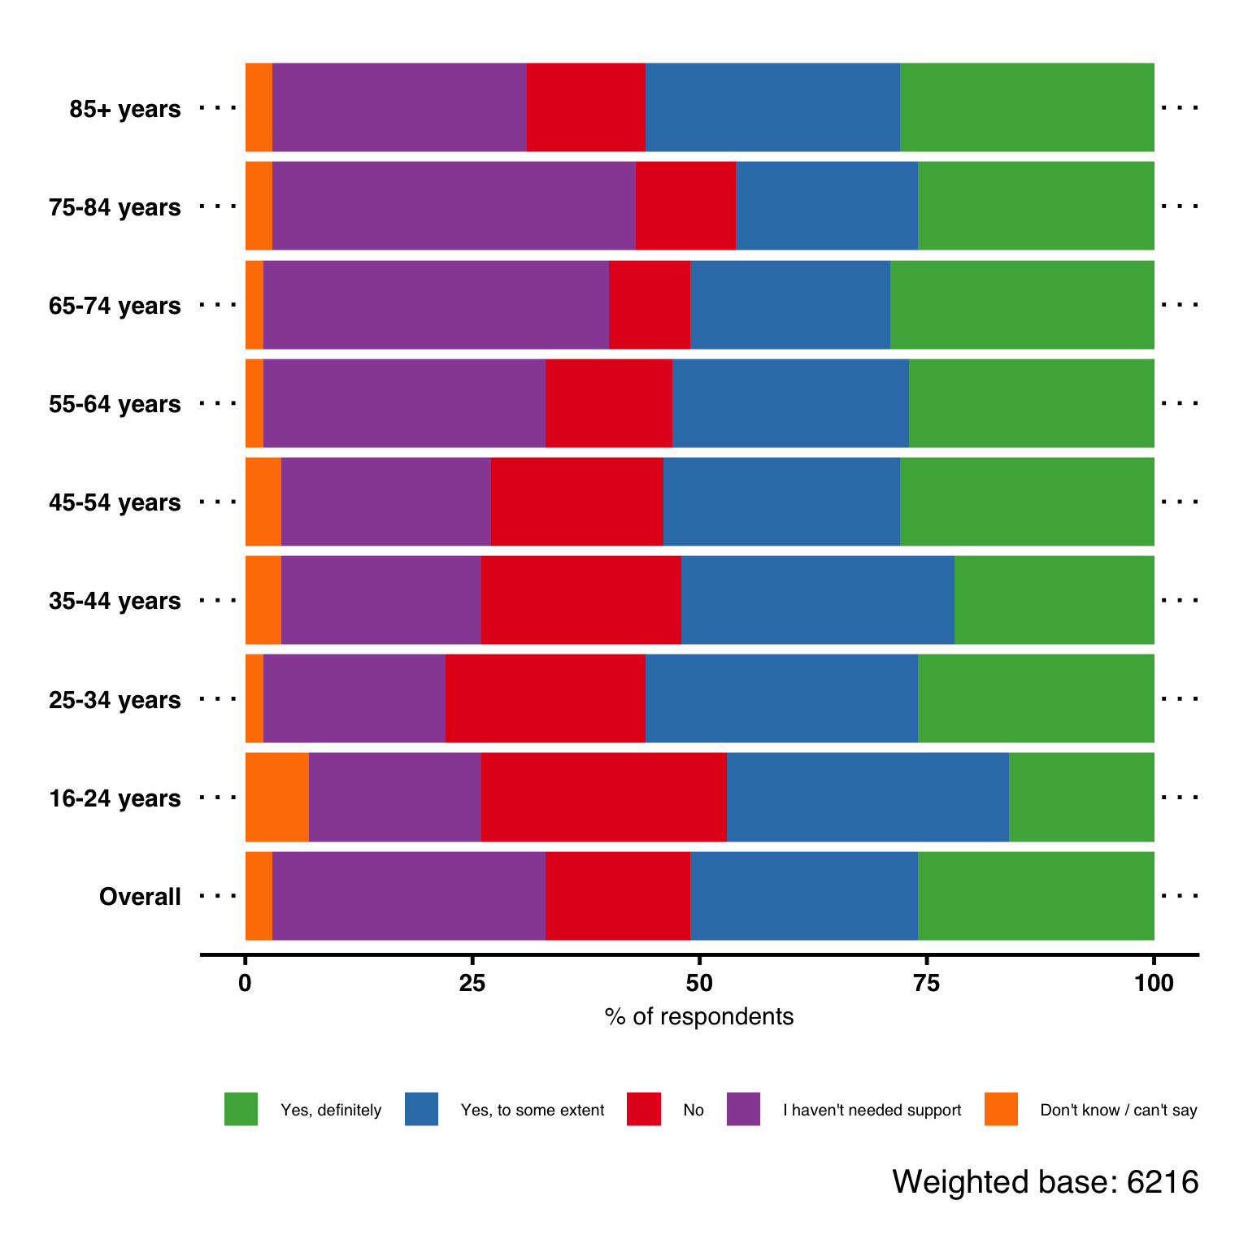

Responses to the question "Do you feel you have enough support from local services and organisations?" 2021 GP Patient Survey, West Sussex CCG.

#### Enough support from local services and organisations to help manage condition(s)

* A higher percentage of people with a long-term condition who said they have not had enough support were of the working age-groups, compared to the older age-groups.
* 1 in 4 respondents aged 16-24 years with a long term health condition said they have not had enough support from local services and organisations.

## Social Care - Expressed Demand

### Need Related to Activities of Daily Living

Most people who have care needs do not seek or obtain support from statutory organisations. On the next few pages, published comparable data are shown in relation to people who request and/or are in receipt of support from West Sussex County Council.

A wide range of data are available, and published by NHS Digital <https://digital.nhs.uk/data-and-information/areas-of-interest/social-care>

In interpreting this information some care should be taken, especially where there are large year-on-year fluctuations. These may reflect changes in definition (or interpretation of definitions) or underlying issues of data collection.

### Route of Access - New Clients (Excluding Repeat Requests)

* 96% of new requests from 18-64 year-olds and 81% of requests from 65+ year-olds came from the community, which is higher than the national percentages.
* For 65+ year-olds, 15% came from hospital discharge in 2020/21.
* For 18 - 64 year-olds, very few requests into adult social care are recorded as planned transitions.
* For both age groups, the ’other’ category in these numbers includes capital depleters, hospital diversions, prison and planned (transition).

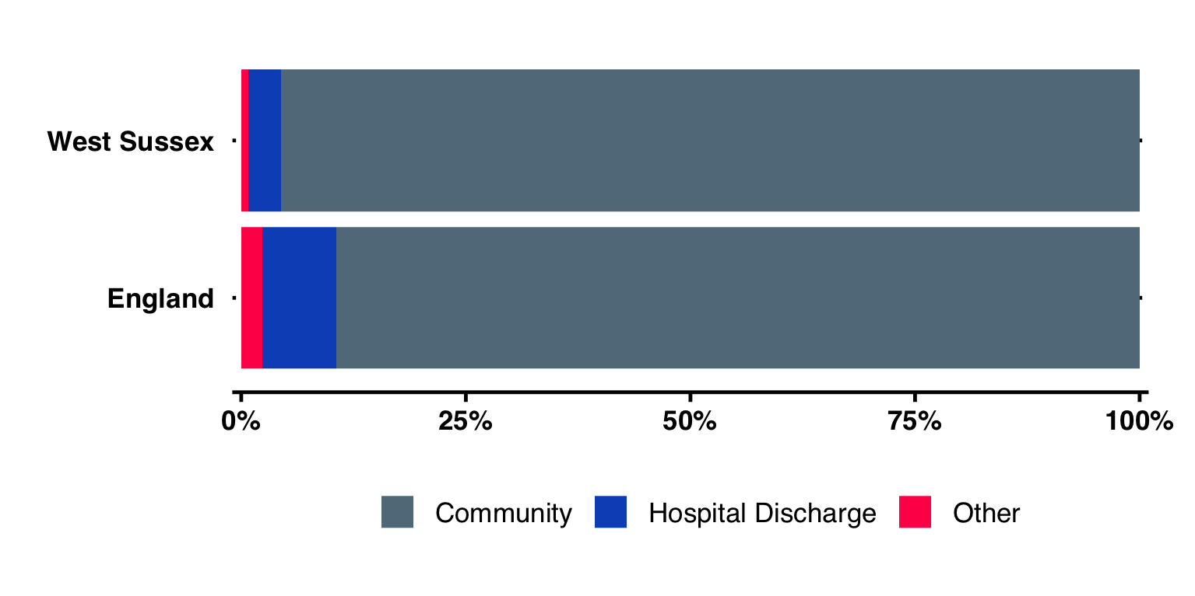

New social care requests from 18-64 year olds, West Sussex and England, 2020/21.

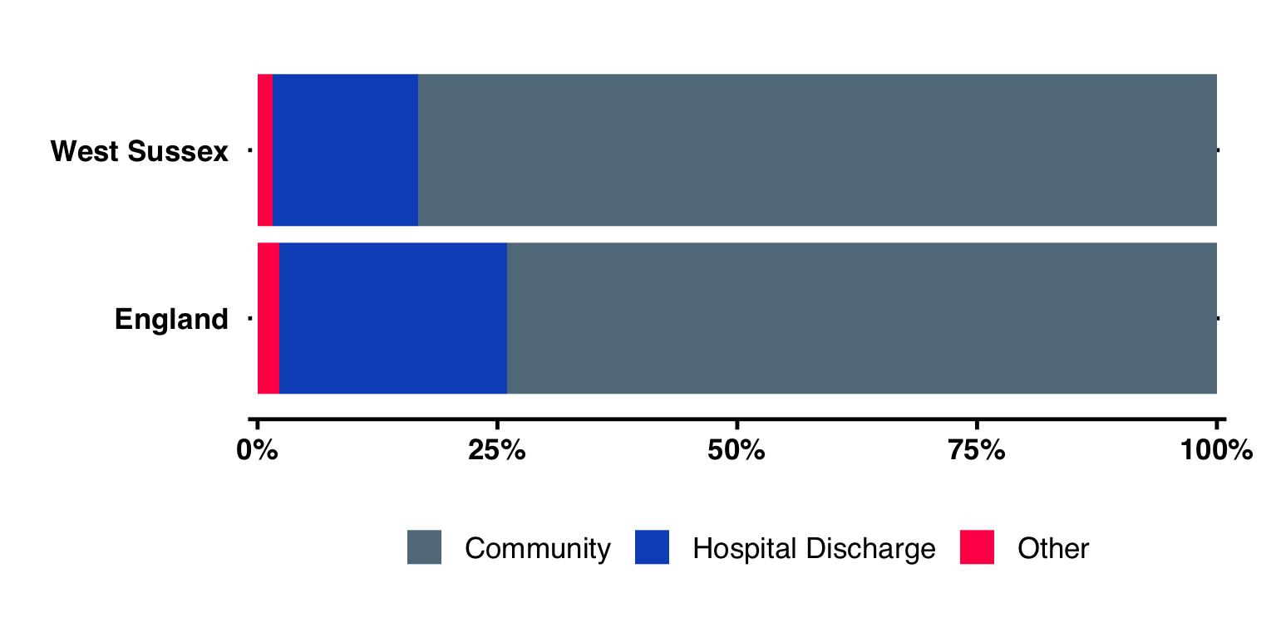

New social care requests from 65+ year olds, West Sussex and England, 2020/21.

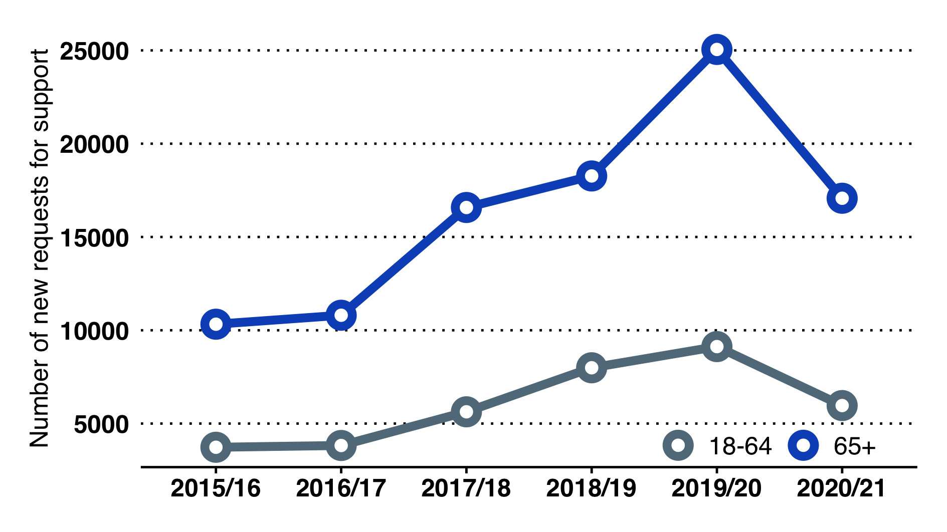

Number of new requests to social care by age, West Sussex and England, 2016/17 to 2020/21.

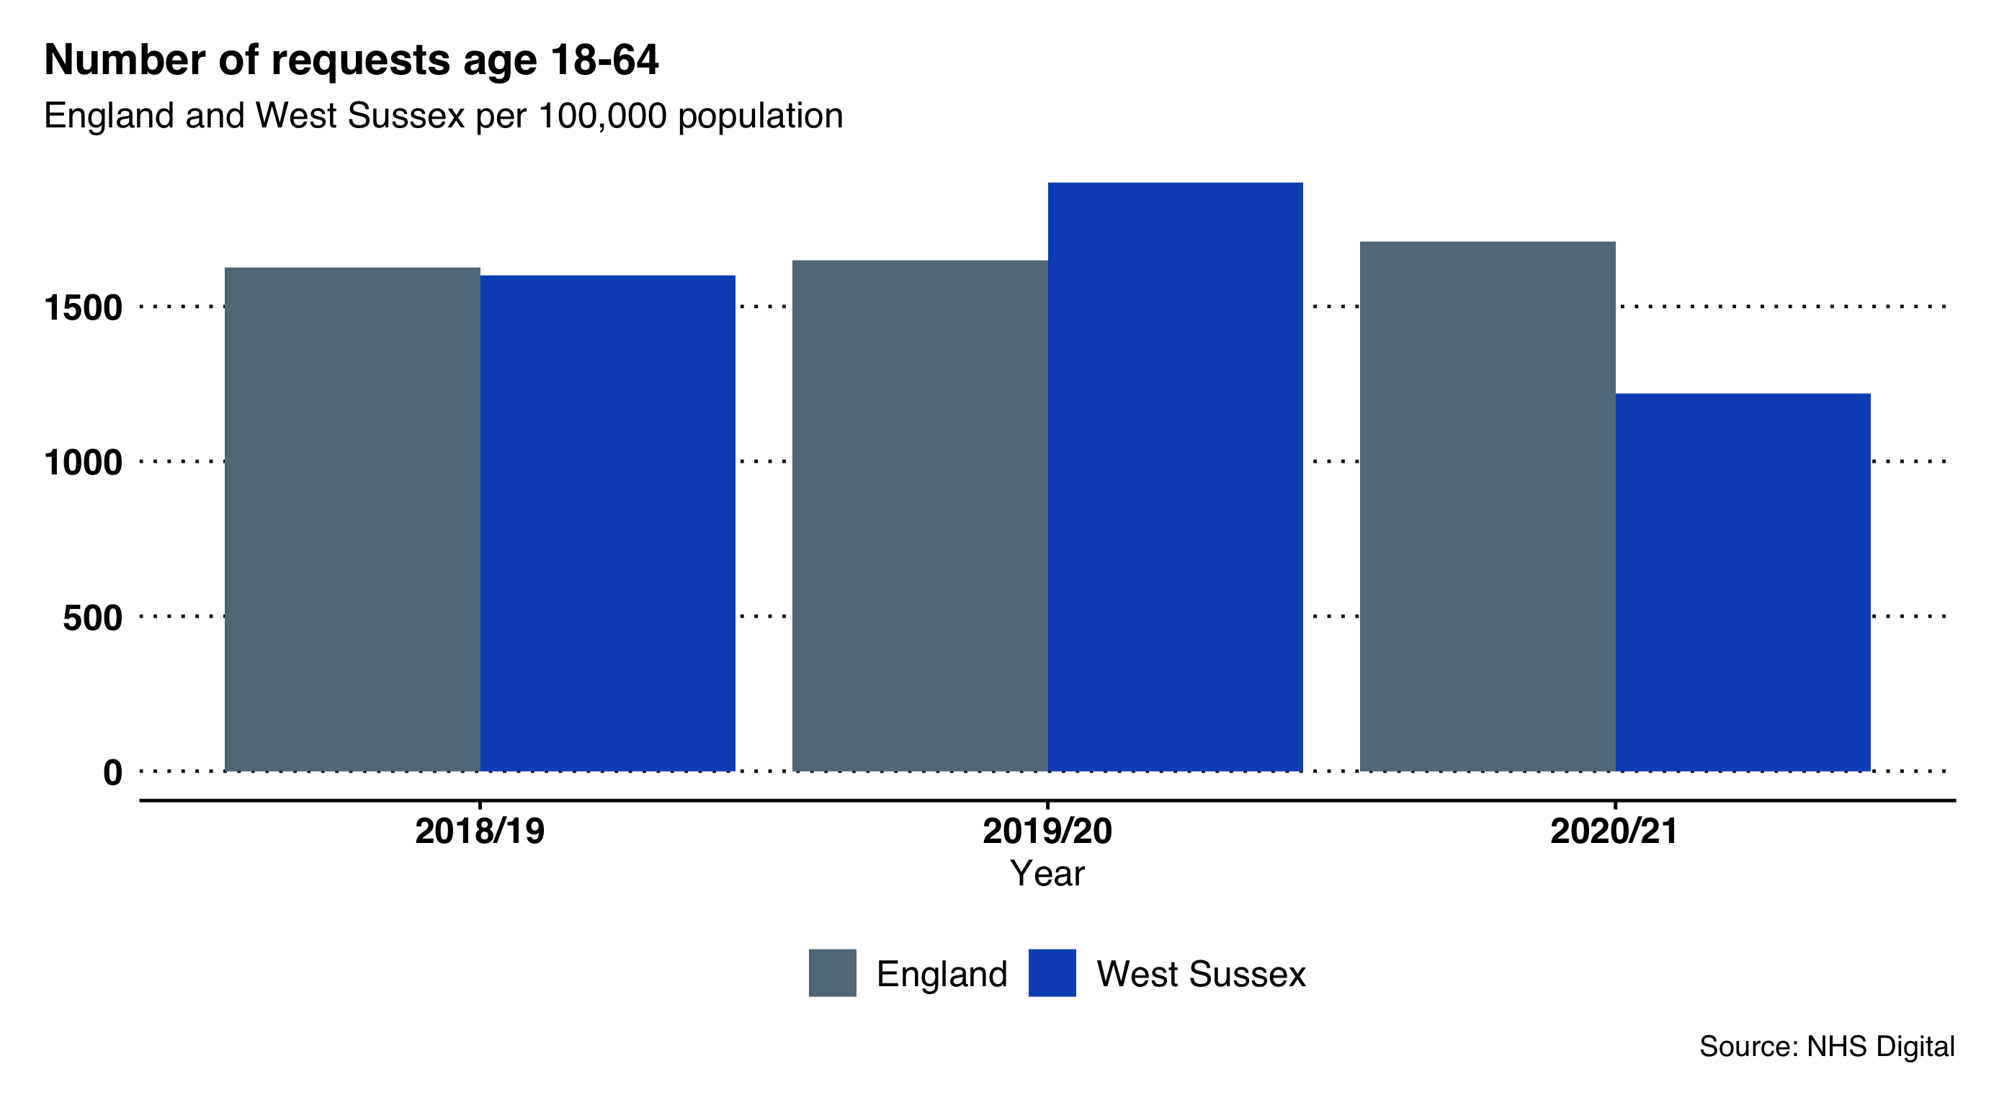

Number of social care requests per 100,000 population, people aged 18-64 year old, 2018/19 to 2020/21.

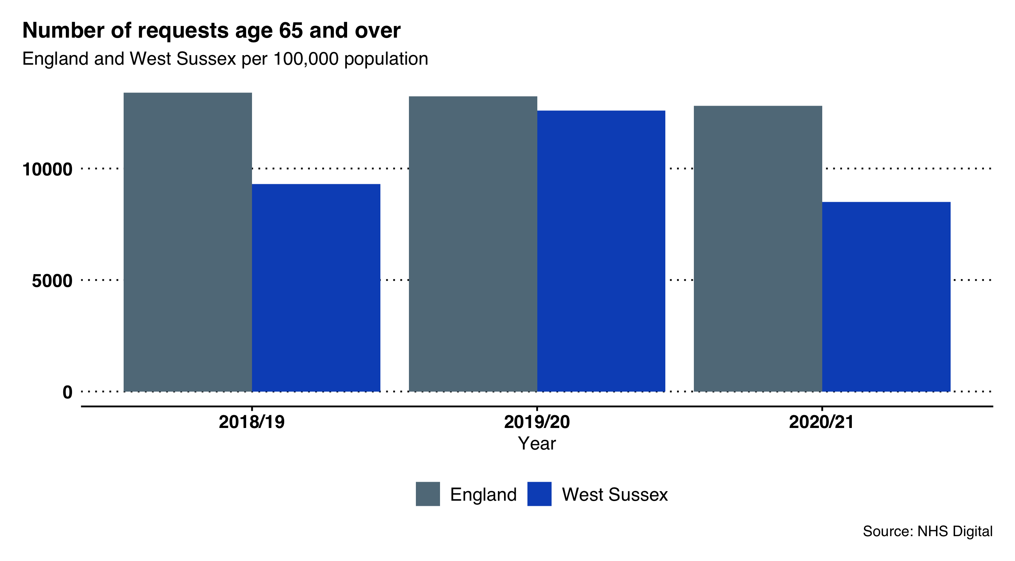

Number of social care requests per 100,000 population, people aged 65 years and over, 2018/19 to 2020/21.

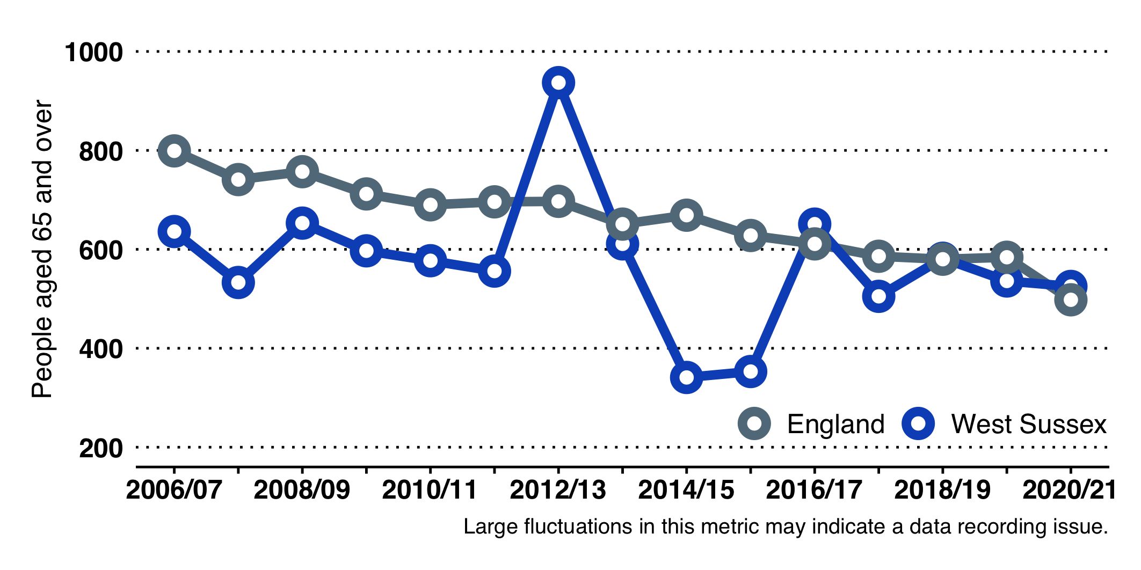

Number of permanent admissions to residential and nursing care homes per 100,000 population, West Sussex and England, 2006/07 to 2020/21.

Data returns from WSCC to NHS Digital show a large recorded increase of requests to social care between 2016/17 and 2018/19:

* There were 5,965 total requests in people aged 18-64 years.
* In the 65+ years group, there were 17075 requests to social care.
* In total, there were approximately 23,000 requests for support in West Sussex in 2020/21, this is equivalent to 63 requests a day.
* The rate of requests, per 100,000 18-64 year-olds, is lower than the national rate.
* The rate per 100,000 65+ remains below that of England and comparable authorities.
* In West Sussex, there were 34% fewer requests for support in working age adults (nationally these increased by 3%) and 32% fewer requests in those aged 65 and over (nationally these fell by 2%).

### Demand over time

#### People aged 18-64 years

The rate of new requests per 100,000 in West Sussex has increased and is now recorded as being higher than comparable authorities and England overall (see Figure 35).

#### People aged 65 years or over

Although the rate of new requests has increased for 65+ age group, it remains below comparable authorities and England (see Figure 36).

#### Permanent admissions to residential and nursing care homes per 100,000 population

Figure 40 (page ) shows the number of permanent admissions (of people aged 65 and over) to residential and nursing care homes per 100,000 population over time. Large fluctuations in this metric around 2012 may indicate a data recording issue.

**In 2020/21, 1,054 people entered residential care.** Rates are similar to England and for the last five years have followed the national downward trend. West Sussex has the third highest rate of residential admissions among comparable authorities.[103]

## West Sussex Social Care

### ASCOF Outcomes and the Adult Social Care Users Survey 2020-21

Each year a sample of people in receipt of support that is funded or managed by social services are surveyed. The survey asks a range of questions, such as how satisfied people are with the support provided and how the support affects their lives. The survey has a variety of questions but here we only show results relating to overall satisfaction, social contact and access to information.

However, the 2020-21 Adult Social Care Users Survey was voluntary. As only 18 CASSRs participated in the 2020-21 survey, aggregated ASCOF outcomes have not been calculated at regional, council type and England level. West Sussex was not one of those CASSRs.

## Falls and Fractures

#### Falls People Aged 65 years or over

Falls in later life are one of the key triggers for entry into residential care. Key risk factors are age and sex. Older people with dementia and sensory impairment are more likely to experience a fall.

The rate of emergency hospital admissions as a result of a fall is relatively high in West Sussex, and of particular concern is the higher rate amongst the 80+ years age group. In 2020/21, the rates were:

* People aged 65+ years[104] - 2,280 per 100,000 (4,965 falls) (England rate, 2,023). Broken down:
  + People aged 65-79 years - 1,016 per 100,000 (1,460 falls) (England rate, 937)
  + People aged 80+ years 5,946 per 100,000 (3,505 falls) (England rate, 5,174)

#### Hip Fractures - People Aged 65 years or over

Hip fractures are of particular concern. Public Health England state that one in three older people who have a hip fracture return to their former levels of independence but one in three ends up moving into long-term residential or nursing care. In 2018/19, the rates were:

* People aged 65+ years[105] - 532 per 100,000 (1,160 hip fractures) (England rate, 529). Broken down:
  + People aged 65-79 years - 225 per 100,000 (325 hip fractures) (England, 219)
  + People aged 80+ years - 1,422 per 100,000 (835 hip fractures) (England, 1,426)

### Vaccination coverage in over-65s

The coverage of the PPV vaccination in over-65s[106] was 71.5% in 2020/21, in line with England and CIPFA neighbours.

The coverage of the flu vaccine for people aged 65 years and over[107] in 2020/21 was 83.7% in 2018/19. This is above the 75% benchmark, and higher than the England coverage (81%) and the average of CIPFA neighbours.

The success of the Covid-19 vaccination programme has likely had a positive effect on the uptake of flu vaccination in over 65s.

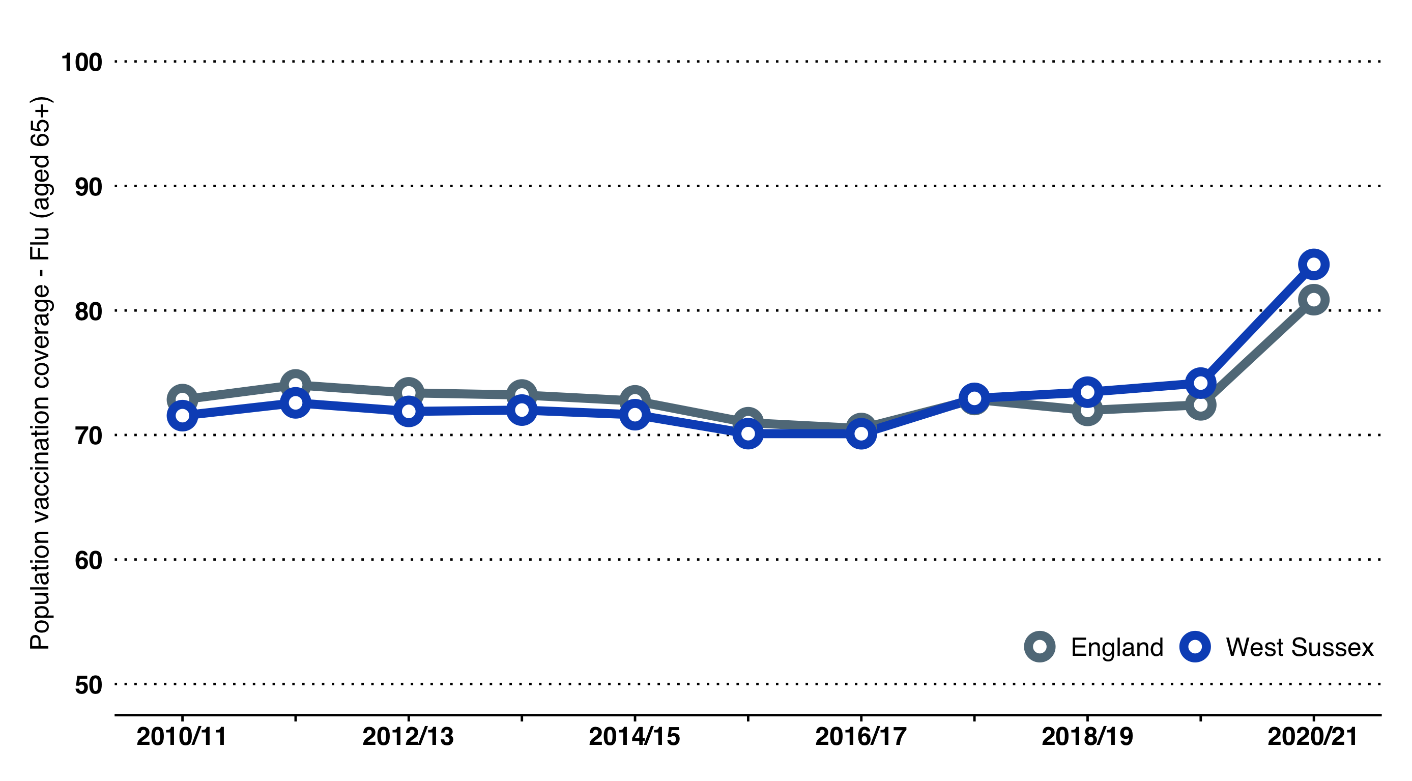

Proportion of population aged 65 or over receiving a flu vaccination, West Sussex and England 2010/11 to 2020/21.

## Mortality

### Underlying Cause of Death

In 2020, there were approximately 10,100 deaths. Cancer and diseases of the circulatory and respiratory systems account for 60% of all deaths.

For underlying cause of Death in Figure 42, we use ICD-10 chapter headings for broad underlying cause of death. Note that deaths from Covid-19 were classified with new codes and these come under the chapter heading "New and Special codes".

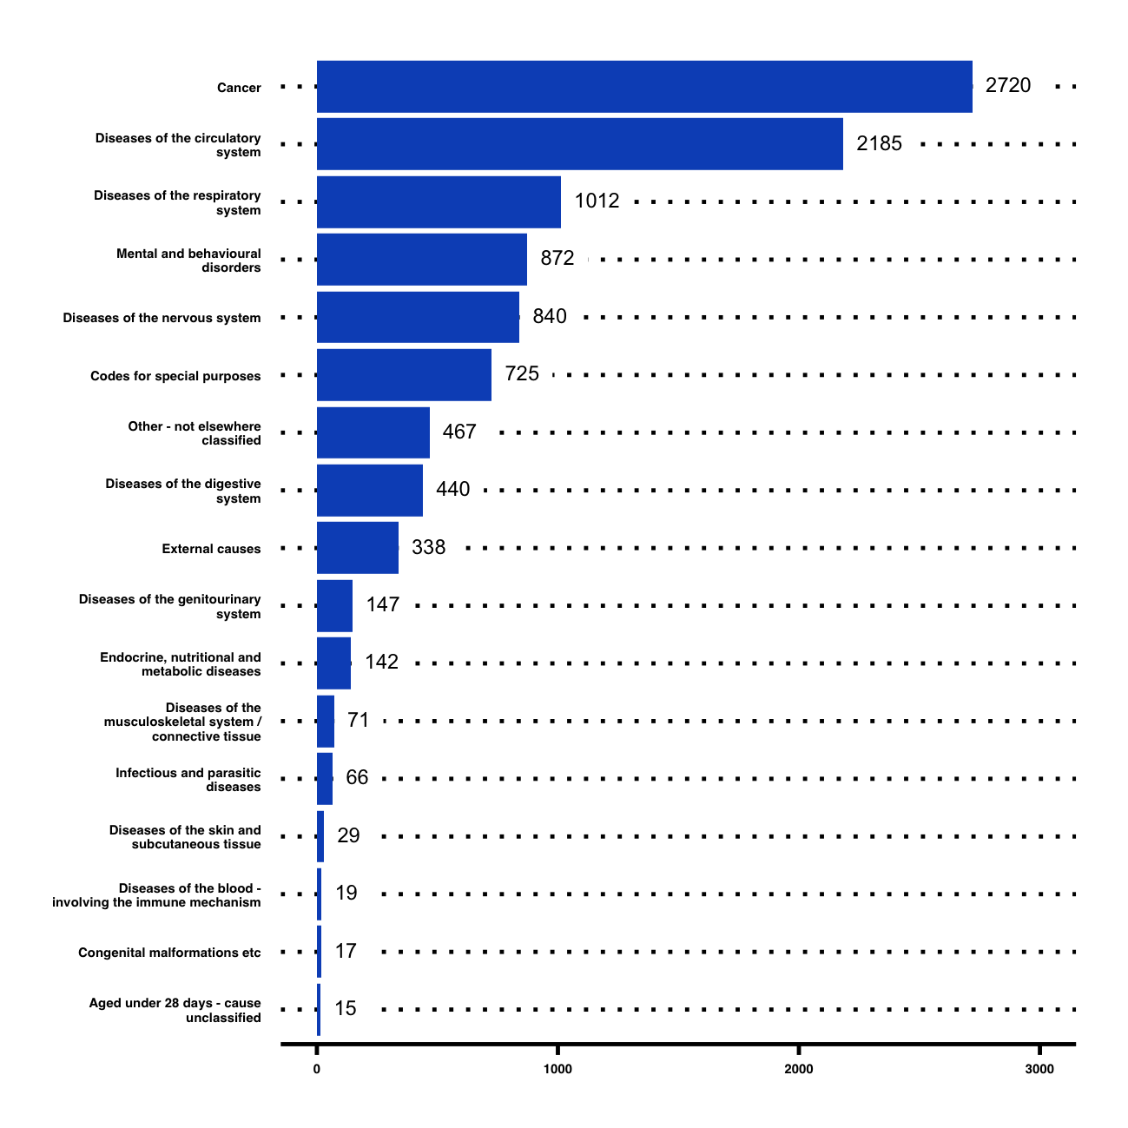

Underlying cause of death, West Sussex 2020

### Place of Death

In the absence of other measures, the place of death is often used as a proxy for the quality of end of life care. This reflects the fact that, when asked, many people express a preference to die in their own home surroundings, or supported in a hospice, rather than a hospital setting.

PHE produce annual Palliative and End of Life Care Profiles, but these have not been updated with local data since 2019. Note that the figures in Figure 43 are from 2017. As noted in the previous JSNA summary: *"*In West Sussex, there is a considerable difference between local authorities. In Crawley, 40.3% of people died at their usual place of residence, which was the lowest percentage in the South East region, whilst Chichester had the highest percentage in the region, at 58.3%."

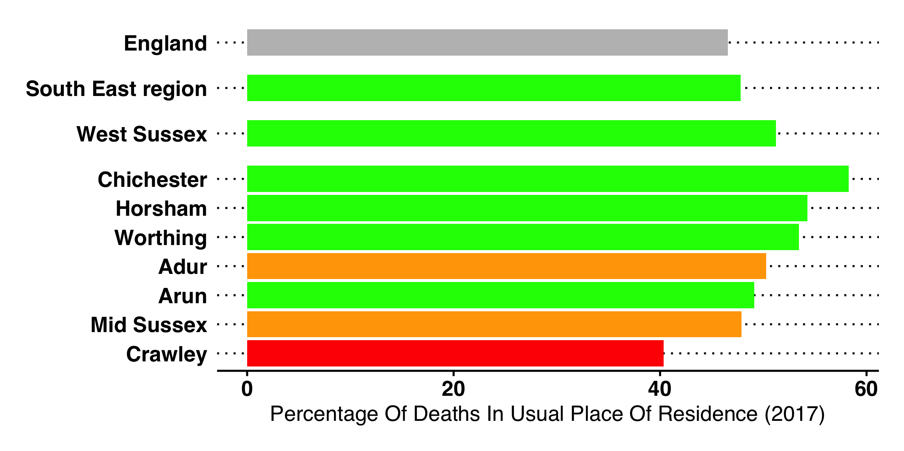

Proportion of deaths occurring in the usual place of residence, West Sussex and local authorities, 2017.

### Excess Winter Deaths

The Excess Winter Deaths Index (EWD Index)[108] is the ratio of extra deaths from all causes that occur in the winter months compared with the expected number of deaths, based on the average of the number of non-winter deaths.

West Sussex Excess Winter Deaths. An asterisk indicates periods when excess winter deaths in West Sussex were significantly higher than England.

|  | Excess ratio | Number |
| --- | --- | --- |
| Aug 2001 - Jul 2002 | 19.2 | 568 |
| Aug 2002 - Jul 2003 | 12.8 | 376 |
| Aug 2003 - Jul 2004 | 13.5 | 392 |
| Aug 2004 - Jul 2005 | 17.6 | 499 |
| Aug 2005 - Jul 2006 | 20.0 | 556 |
| Aug 2006 - Jul 2007 | 17.6 | 487 |
| Aug 2007 - Jul 2008 | 12.2 | 342 |
| Aug 2008 - Jul 2009 | 23.7 | 644 |
| Aug 2009 - Jul 2010 | 17.0 | 457 |
| Aug 2010 - Jul 2011 | 21.7 | 570 |
| Aug 2011 - Jul 2012 | 26.0* | 688* |
| Aug 2012 - Jul 2013 | 17.2 | 473 |
| Aug 2013 - Jul 2014 | 10.6 | 284 |
| Aug 2014 - Jul 2015 | 29.8 | 843 |
| Aug 2015 - Jul 2016 | 14.3 | 409 |
| Aug 2016 - Jul 2017 | 28.9* | 815* |
| Aug 2017 - Jul 2018 | 35.4 | 997 |
| Aug 2018 - Jul 2019 | 15.4 | 430 |
| Aug 2019 - Jul 2020 | 14.9 | 440 |

Looking at a longer period of time at a county level, we can see that the mean number of excess winter deaths in West Sussex is 574. In some years, deaths have been as high as 1,000 (in 1997) and as low as 280 (2014).

Figure 44 shows the number of excess deaths in each year since 1992. The black line shows the long term mean. The red lines represent the upper limits to the data (the dotted line being one standard deviation (SD) from the mean, and the solid red line being 2 SDs). The green lines show the lower limits. In 1997, 2000, and 2018 the number of excess deaths were unusually high.

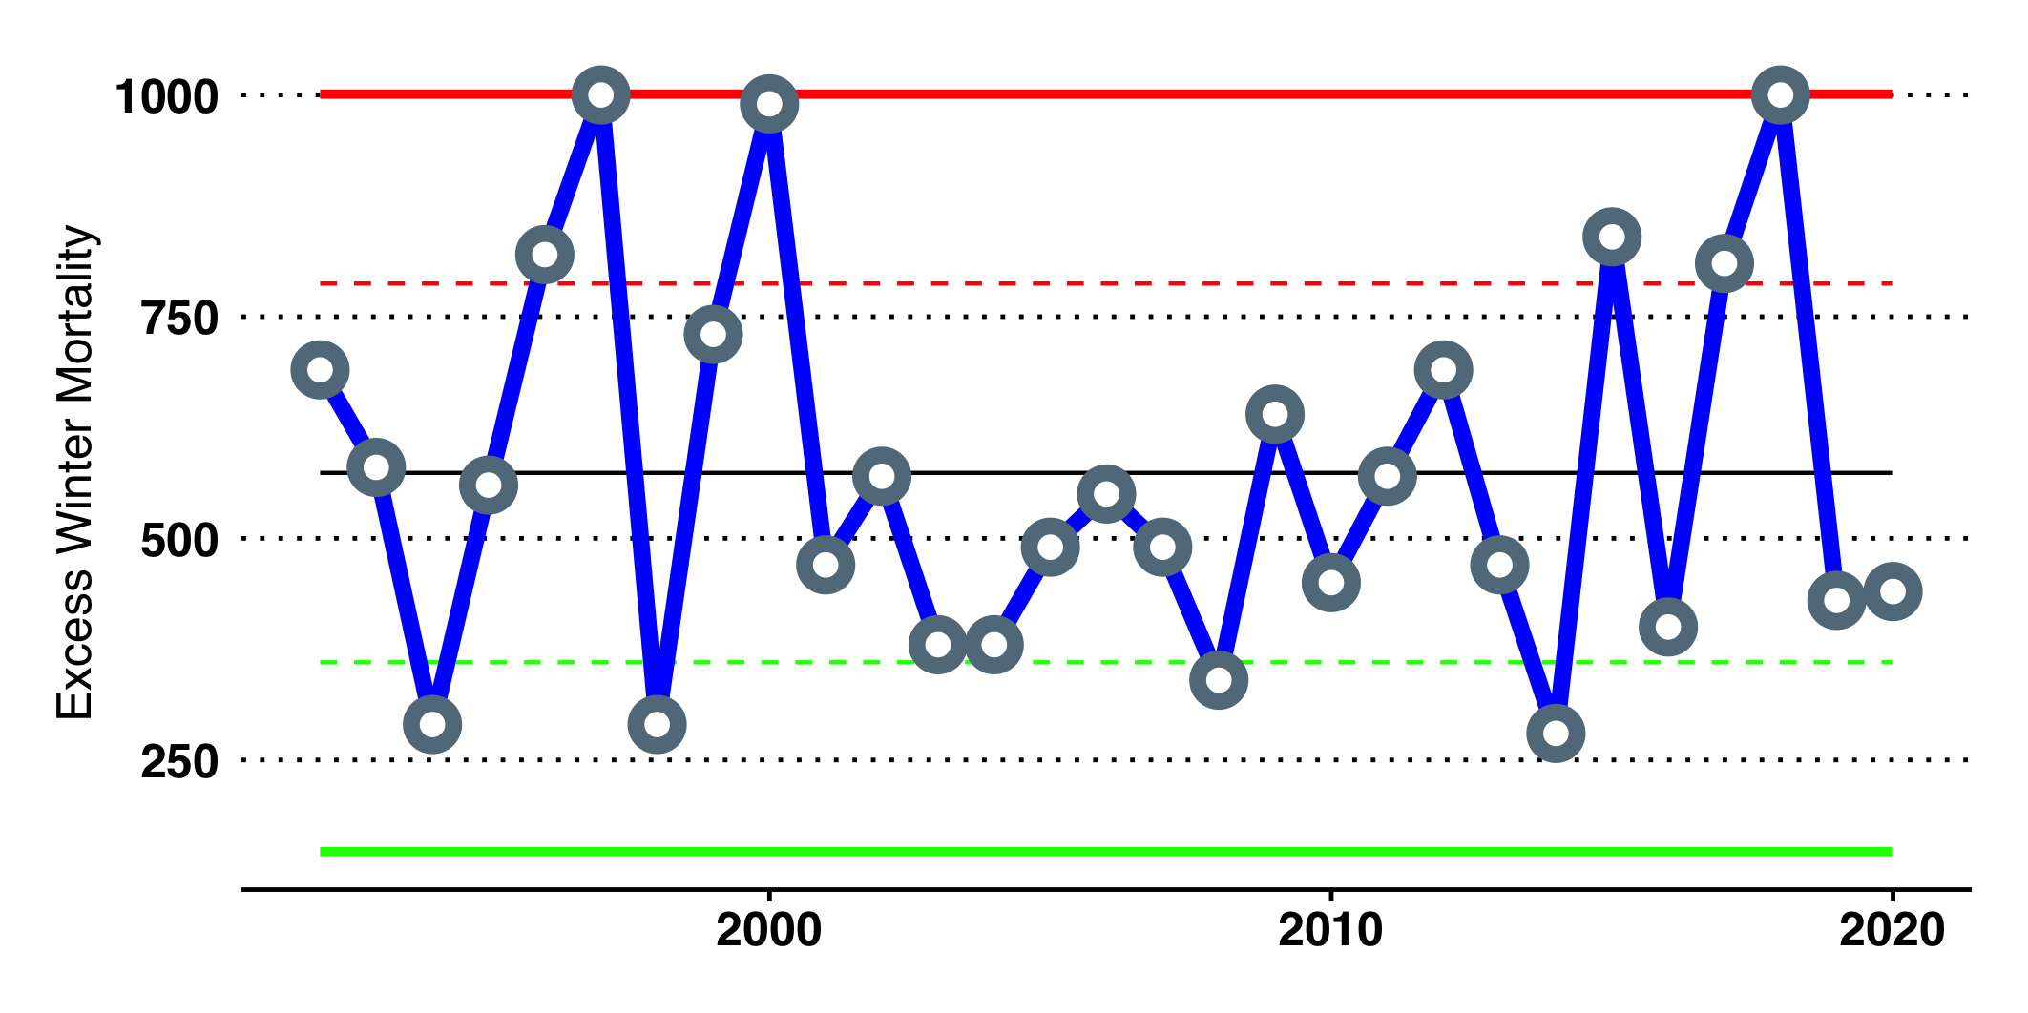

Control chart of excess winter deaths in West Sussex, 1992 to 2020

1. Note: ONS publish subnational population projections annually and WSCC also produce a local set of projections which are able to incorporate more up-to-date knowledge relating to residential development. There are some differences between these sets. For the purposes of this document we have used ONS projections to provide an indication of the overall scale of change, but for more detailed or localised work we would advise contacting WSCC for locally calculated projections.
2. Lower quartile ratios rather than average ratios provide a better understanding of entry to the housing market.
3. <https://lginform.local.gov.uk/reports/lgastandard?mod-metric=105&mod-period=2&mod-area=E10000032&mod-group=ADASSRegions&mod-type=comparisonGroupType>
4. This PHOF indicator was replaced in 2019 (by 1. Number of households owed a duty under the Homelessness Reduction Act and 2. Number of Rough Sleepers), although remains a relevant measure.
5. PHOF reference B15c (the rate of households in temporary accommodation, per 1,000 households).
6. Source: Department for Levelling Up, Housing & Communities. Suppressed values have been replaced by 5 as an upper bound and 0 as a lower bound, the middle of that range is given here.
7. Sources: ONS Mid Year Estimates, and small area estimates. Estimates are updated annually.
8. Sources: ONS Mid Year Estimates, and small area estimates. Estimates are updated annually.
9. Sources: Nationally - Family Resources Survey (FRS). Locally refer to the West Sussex JSNA for more detailed information.
10. Sources: Various at service provision level. ONS / Census for population level data. Includes ethnic or national origins, colour or nationality
11. Includes lack of belief. Sources: Census, infrequent collection mainly via national surveys.
12. Sources: Assumptions from Annual Population Survey, national research.
13. Sources: National research
14. Sources: Registration data. Census for sub national information
15. Sources: Maternity Services Data Set, ONS Births data.
16. PHOF reference B16. Information is obtained from a survey conducted by Natural England, Monitor of Engagement with the Natural Environment (MENE).
17. Data collected as part of the National Travel Survey (NTS) and the Active Lives Survey (ALS) mid-Nov 2017 to mid-Nov 2018. Statistics from the ALS will refer to those aged 16+. Data relate to information from table CW0303.
18. Travel purposes include going to work, but also shopping, visiting friends, going to a health facility, college etc. This is a useful distinction, as it relates to building walking into everyday needs/functions as opposed to specifically walking activities, such as rambling and hiking for leisure.
19. PHOF reference D01. Fraction of annual all-cause adult mortality attributable to particulate air pollution (measured as fine particulate matter, $PM_{2.5}$). $PM_{2.5}$ means the mass (in micrograms) per cubic metre of air of individual particles with an aerodynamic diameter generally less than 2.5 micrometers. $PM_{2.5}$ is also known as fine particulate matter. Note that this indicator is calculated using a new method. In 2019, under the previous method, 4.9% of mortality in West Sussex was attributable to particulate air pollution.
20. PHOF reference A02a - Inequality in life expectancy at birth.
21. For background information: <https://assets.publishing.service.gov.uk/government/uploads/system/uploads/attachment_data/file/833947/loD2019_Research_Report.pdf>.
22. PHOF reference A01b
23. PHOF reference A02a
24. Note from OHID: Circulatory causes include heart disease and stroke
25. PHOF E01, 2018-2020.
26. For more details, please see the 2019/20 JSNA Strategy.
27. PHOF reference E01, defined as the number of deaths in infants aged under 1 year per 1,000 live births.
28. PHOF reference C04.
29. NOTE: these comparable authorities are not the standard CIPFA neighbours, but rather the Children’s Services Statistical Neighbours as provided by LAIT.
30. PHOF reference C06. Note: the method used to calculate this outcome was changed in April 2017, excluding women with unknown smoking status from the denominator when calculating the proportion of women smoking at the time of delivery.
31. PHOF reference C05b.
32. PHOF reference C07. All infants and their families are eligible to receive a visit led by a health visitor within the first two weeks from birth, as part of the Healthy Child Programme and to ensure continuing support following midwife visits, which usually end at day 10. For 2020/21, this indicator was scaled up from three quarters worth of available data.
33. PHOF reference C08a. For 2020/21, this indicator was scaled up from three quarters worth of available data.
34. PHOF reference D03l.
35. **The definition of "disability" in the Family Resource Survey is** used to describe people who identify themselves or have been identified as having any physical or mental health condition or illness that lasts or is expected to last 12 months or more, and acts to limit the ability to carry out day-to-day activities. While this will capture most people under the definition used in the Equality Act 2010, it should be noted that there will be some people under the 2010 Act who are classified as disabled (and having rights under the Act) who have a long-standing illness or disability which is not currently affecting their day-to-day activities e.g. some people who have a diagnosis of cancer will not be included.
36. NHS Digital: Mental health of children and young people in Great Britain (2004)
37. As part of the PHE CYP mental health and wellbeing profile (Fingertips)
38. NHS Digital: Mental Health of Children and Young People in England (2017)
39. <https://digital.nhs.uk/data-and-information/publications/statistical/mental-health-of-children-and-young-people-in-england/2021-follow-up-to-the-2017-survey>
40. Kurtz, Z. (1996) Treating children well: a guide to using the evidence base in commissioning and managing services for the mental health of children and young people. London. Mental Health Foundation.
41. NHS Digital: The Mental Health of Children and Young People in England, 2017 survey
42. The WAY survey data has been replaced by NHS Digital: Smoking, Drinking and Drug Use (SDD) in England as a PHOF indicator (previously 2.09i). However lack of local data in the SDD means the WAY survey remains the most recent estimate of smoking in young people in West Sussex.
43. PHOF reference D02a.
44. PHOF reference C02a.
45. PHOF reference C10. The recommended physical activity is an average of at least 60 minutes moderate-vigorous intensity activity per day across the week.
46. PHOF references C09a and C09b.
47. This is a West Sussex Plan priority. Refer the WSCC website for the latest data and commentary. The combined known and unknown status of NEET 16-17 year-olds is a PHOF indicator (B05).
48. PHOF indicators B02a and B02b
49. Office for Students. POLAR - Participation of Local Areas. 2017.
50. PHOF reference C12. Strengths and Difficulties Questionnaire (SDQ) scores come from the SDQ questionnaire, a survey required to be completed by for each child looked after aged 5 to 16 years. It has five sections (emotional difficulties; conduct problems; hyperactivity or inattention; friendships and peer groups; and positive behaviour) plus an "impact supplement" to assist in the prediction of emotional health problems. The questionnaire is completed by the child’s main carer. A score of 0 to 13 is considered normal, 14 to 16 borderline, and 17 to 40 is a cause for concern.
51. This relates to enquiries where there is reasonable cause to suspect the child is suffering, or is likely to suffer significant harm. Local authorities carry out an assessment under section 47 of the Children Act 1989 to determine if steps are needed to safeguard the child. Where concerns are substantiated, and the child is judged to be at continuing risk, an initial child protection conference should be convened within 15 working days.
52. Note: This indicator uses a new method, and trend will now differ from that previously published. However, as recently as 2016/17 rates of hospital admissions for alchol-related conditions for people under 40 based on this method have been higher than England.
53. PHOF reference A01a
54. Under Universal Credit a broader span of claimants are required to look for work than under Jobseeker’s Allowance. As Universal Credit Full Service is rolled out in particular areas, the number of people recorded as being on the Claimant Count is therefore likely to rise.
55. PHOF references B08a, B08b and B08c.
56. PHOF references B08a, B08b and B08c.
57. Note that direct patient care staff includes therapists, health care assistant, social prescribing link workers etc. FTE = Full Time Equivalent.
58. <https://www.skillsforcare.org.uk/adult-social-care-workforce-data/Workforce-intelligence/Home.aspx>
59. PHOF reference C18.
60. PHOF reference C17a. These are adults (aged 19+) who meet CMO recommendations for physical activity (150+ moderate intensity equivalent minutes per week).
61. PHOF reference C17b. These are adults (aged 19+) that are physically inactive (<30 moderate intensity equivalent minutes per week).
62. PHOF reference C15.
63. PHOF reference C16.
64. Source: Public Health England, The Public Health Burden of Alcohol and the Effectiveness and Cost-Effectiveness of Alcohol Control Policies An evidence review, 2016
65. <https://fingertips.phe.org.uk/profile/local-alcohol-profiles>
66. PHOF reference C21.
67. PHOF reference E06b
68. PHOF reference C19d
69. PHOF reference C19c
70. PHOF reference C19b
71. PHOF reference C19a
72. Source: RSPH Taking a New Line in Drugs <https://www.rsph.org.uk/our-work/campaigns/taking-a-new-line-on-drugs.html>
73. PHOF reference D07. Late diagnosis is the most important predictor of morbidity and mortality among those with HIV infection.
74. PHOF reference C02a.
75. PHOF reference C01. This measure excludes LARC injections.
76. PHOF reference D05. These are individuals from age six months to under 65 years, excluding otherwise ’healthy’ pregnant women and carers.
77. Note: These figures have not been updated since 2018/19.
78. PHOF references C26a, C26b and C26c
79. PHOF reference C25b
80. Cervical cancer screening, PHOF reference C24b. Breast cancer screening, PHOF reference C24a. Bowel cancer screening, PHOF reference C24d.
81. Note that the national estimate is a synthetic estimate. Note also that a synthetic prevalence estimate of 14.4% exists for West Susssex, which is equivalent to approximately 102,600 people based on current population estimates.
82. PHOF reference C28a
83. PHOF reference C28b
84. PHOF reference C28d
85. PHOF reference C28c
86. PHOF reference E04a
87. PHOF reference E05a
88. PHOF reference E06a
89. PHOF reference E07a
90. PHOF reference B12b
91. PHOF reference B12c
92. PHOF reference B11. Note that local authorities are allocated the rate of the police force within which they sit.
93. PHOF reference B10.
94. <https://www.ageuk.org.uk/our-impact/policy-research/loneliness-research-and-resources/loneliness-maps/>
95. The POPPI website from IPC has been used for the estimates.
96. The estimated dementia diagnosis rate in over-65s is a PHOF indicator (E15)
97. PHOF reference C27
98. Visual acuity (VA) of less than 6/18 (moderate or severe) is largely used as the point which approximates to the statutory threshold for qualifying as registered severely sight impaired (blind) or registered sight impaired (partially sighted).
99. Hearing loss is measured by assessing the quietest sounds someone can hear using tones with different frequencies. In hearing tests, a person is asked to indicate when they can hear a tone; the level is then adjusted to find their threshold, when they can just hear it. Thresholds are measured in units called dBHL: dB stands for ’decibels’ and HL stands for ’hearing level’. The greater the threshold level in dBHL, the worse the hearing loss. People with thresholds between 0 and 20 dBHL across all the frequencies are considered to have ’normal’ hearing. The threshold of 25 dBHL indicates some hearing loss; the threshold of 65 dBHL indicates severe hearing loss. (adapted from POPPI Source: IPC)
100. All patients registered with Crawley, Horsham and Mid Sussex CCG GPs in 2015, excluding people identified as living in a care homes (2.2% of the sample)
101. http://www.selfcareforum.org/
102. Data can be accessed and analyzed at <https://gp-patient.co.uk/>
103. PHE note that: People counted as a permanent admission include: Residents where the local authority makes any contribution to the costs of care, no matter how trivial the amount and irrespective of how the balance of these costs are met; Supported residents in Local Authority-staffed care homes for residential care independent sector care homes for residential care and registered care homes for nursing care. Residential or nursing care which is of permanent nature and where the intention is that the spell of care should not be ended by set date. For people classified as permanent residents, the care home would be regarded as their normal place of residence.
104. PHOF reference C29
105. PHOF reference E13
106. PHOF reference D06b
107. PHOF reference D06a
108. PHOF reference E14. Note that 2020 figure excludes deaths from Covid-19. ONS also provide estimates inclusive of Covid-19 deaths.